Attention Retailers! 30 Certified Organic Products to Choose From!
We Will Double Your First Stocking Order FOR FREE!*
That's right, we will double your first stocking order FOR FREE. We know that stocking your shelves is expensive, and to help with this expense, we are doubling your first stocking order FOR FREE! (up to 6 FREE bottles per SKU). For example, order 3 bottles, and we will send you 3 extra bottles For Free (6 bottles total*). Order 6 bottles, and we send you 6 extra bottles For Free (12 bottles total*)

Why buy from us?

- Dozens of Certified Organic Products to Choose From!
We specialize in Certified Organic Products, giving you a wide variety to choose from.
As certified organic product move to the front line for most shoppers, having a large
variety of USDA Organic Products well help capture those sales!

- 60-Day "Servings Per Bottle" / 120 Veggie Capsules!
We provide customers with 120 veggie capsules per bottle, giving customers 60-Day
servings per bottle rather than just 30. That’s more product for their money!
We also use paper tamperproof seals, NO ALUMINUM!

- Eye-Catching Product Visibility, with Real Botanical Pictures!
We use a bold and attractive 300cc bottle (packer) with a larger label for easy visibility, and
an attractive label designed with colorful pictures. So your customers can see exactly what
they're getting and see just how beautiful the product of nature they're purchasing really is!

- We Support Retailers with Complete Price Exclusivity!
Unlike other companies that sell you product to put on your shelves, only for you to find out later
that many of your customers are going online to buy that same product at a discount. With Unique
Products of Nature, we do not sell to online websites, i.e., Amazon, Google, or any online
supplements stores. So NO MORE losing customers to online discount stores! We also mark our
website prices up by 25%, to deter your customers from buying from us instead of you!

- Made with Astragin, Patented for "Enhancing Nutrition Bioavailability"!
Astragin is a natural, plant-based, proprietary compound, comprised from highly fractionated
Astragalus Membranaceus and Panaz notoginseng that enhances nutrition bioavailability.

- Easy website re-ordering!
We also provide a 1-page “60% Off Wholesale Re-Order Page", which list every product we have
on just 1 re-order page, making re-orders fast and simple. Orders ship out in 24 hours USPS Priority
Mail, so you receive it in 2 to 3 business days. You also receive free shipping on all orders over $100.

* Up to 6 free bottles (per SKU) of any product on our website. Limited time offer. Prices may change without prior notice.

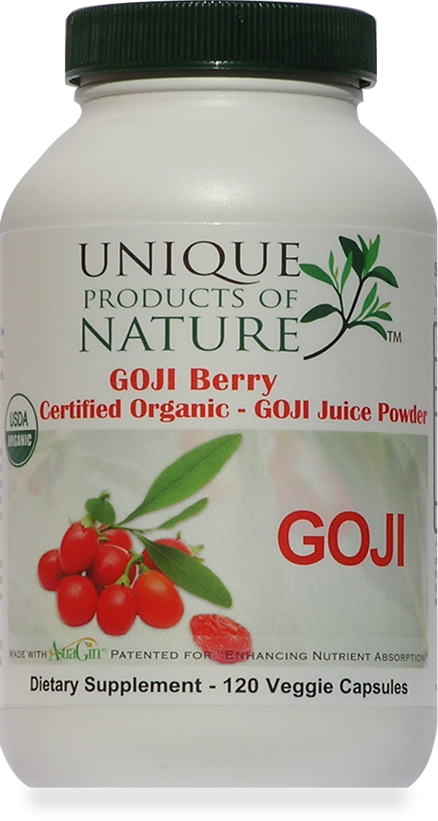

Call Today - (877) 606-3195 Or Fill Out Our
“Retailers Application” Page Online At
www.UniqueProductsOfNatureUSA.com

Product Name | Cost | Retail | Product Name | Cost | Retail
Certified Organic  Acai Berry Juice Powder | $11.19 | $22.38 | Certified Organic  Goji Berry (Wolf Berry) Powder | $8.70 | $17.39
Certified Organic  Alfalfa Juice Powder | $7.96 | $15.92 | Certified Organic  Kelp Powder | $8.16 | $16.32
Certified Organic  Amla Powder | $8.50 | $16.99 | Certified Organic  Maca Root Powder | $7.26 | $14.52
Certified Organic  Apple Cider Vinegar Powder | $9.06 | $18.12 | Certified Organic  Lucuma Powder | $8.24 | $16.49
Certified Organic  Ashwagandha Root powder | $7.98 | $15.96 | Certified Organic  Mangosteen Super ORAC | $10.86 | $21.72
Certified Organic  Astragalus P.E. 10:1 Powder | $11.94 | $23.88 | Certified Organic  MaquiForza Freeze Dried | $13.55 | $27.10
Certified Organic  Barley Grass Juice Powder | $7.86 | $15.72 | Certified Organic  Moringa Powder | $6.27 | $12.55
Certified Organic  Beet Root Juice Powder | $7.98 | $15.96 | Certified Organic  Noni P.E. 5:1 Powder | $9.60 | $19.20
Certified Organic  Camu Camu Powder | $9.49 | $18.98 | Certified Organic  Pomegranate Juice Powder | $8.79 | $17.58
Certified Organic  Cat's Claw Powder | $7.62 | $15.24 | Certified Organic  Reishi Mushroom P.E. 4:1 | $13.74 | $27.48
Certified Organic  Blueberry Juice Powder | $9.64 | $19.28 | Certified Organic  Organic Salad in a Pill | $7.80 | $15.60
Certified Organic  Chlorella Powder | $8.24 | $16.48 | Certified Organic  Sea Buckthorn Juice Powder | $8.43 | $16.86
Certified Organic  Ceylon Cinnamon Powder | $8.16 | $16.32 | Certified Organic  Spurulina Powder | $6.35 | $12.70
Certified Organic  Ginger Powder | $7.30 | $14.59 | Certified Organic  Turmeric Powder | $7.08 | $14.16
Certified Organic  Green Balance Alkalizing Blend | $8.87 | $17.75 | Certified Organic  Nutra Grass (Wheat Grass Juice Powder) | $10.55 | $21.10

Unique Products of Nature 2905 Lake East Dr #150 Las Vegas, NV 89117
Check Out These Prices! 60 Servings Per Bottle/120 Caps Each

Address:

Call Today - (877)-606-3195
Or Fill Out Our “Retailers Application” Page Online at www.UniqueProductsOfNatureUSA.com

