WHO WE ARE
Employee Owned and It Shows.
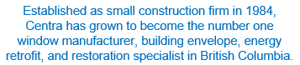


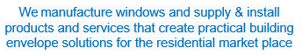



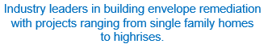

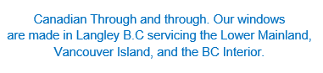

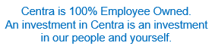
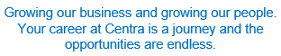






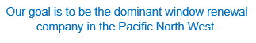
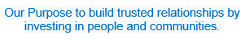

Why choose us?
- Excellent Opportunities for advancement
- To be part of an amazing values driven organization
- Pride of ownership
- A strong commitment to supporting community
- Comittment to challenging and supporting individuals to reach their goals

Career Oportunities:
- Trades & Technical
- Operations & IT
- Sales & Marketing
- Finance & Accounting
- Estimating & Projects
- Installations & Service

Our values:
Our culture is built on our FERST Values, which provide us with guidance in our daily work. FERST stands for Family, Entrepreneurial Spirit, Respect, Safety, and Teamwork. Everything we do is aligned with these values.

