Logo Design

The Brief
Macarthur Insurance Brokers is an Insurance broker that handles all types of insurance cover for Business in the local area. A town called Camden is the heart of the Macarthur region.
Our Logo would like to represent the Macarthur region.
History of Macarthur – Founded by John Macarthur as primarily a sheep and cattle farming area with Fields and bush lands now the fastest growing area in Australia consisting of industry, shopping centres & restaurants
The Macarthur region is also well known for its Jacaranda trees .

First Logo Concept
- This logo needs to be scalable
- Have buildings and countryside in the logo
- Simple and easy design
- Colour (Blues primary)

Pictures Ideas Only:-
Macarthur, Industrial estate at the forefront, Fields at the rear
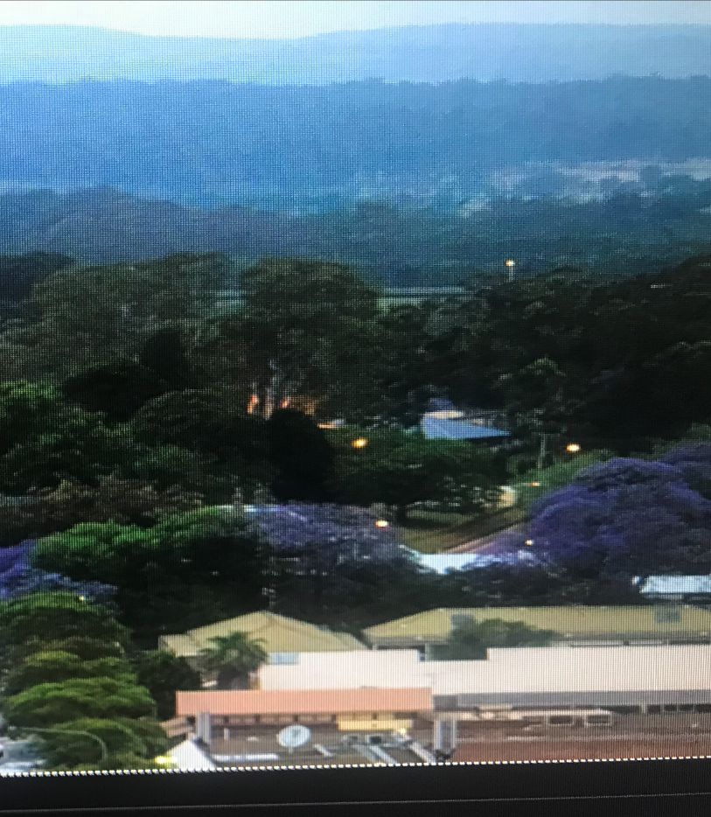

Two distinctive areas 1. Country 2. Industrial.
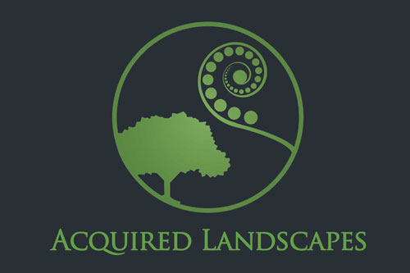

Missing the Industrial buildings


Note :- Our Existing colours for AMGI and our Existing company logo’s below.
Orange
- CMYK: C:3% M:66% Y:98% K:0%
- RGB: R:237 G:119 B:37
HEX: #ed7725
Blue
- CMYK: C:80% M:49% Y:4% K:0%
- RGB: R:56 G:120 B:182
- HEX: #3878b6




