Name of Restaurant: Seletar or SELETAR
Location: New Zealand – New Plymouth
Contact: Rhys
Type of Restaurant: Singapore Restaurant

General Structure Of Logo

EMBLEM-WORD MARK



No. 9 for casual style; I quite like the script fonts

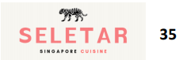

No. 35

- layout and, font and colours (more formal).
- for casual style; I quite like the script fonts

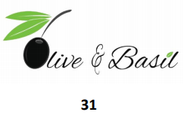

No 31

- clever use of the olive image to tie in with the words

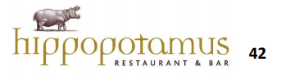

No 42

- Interesting font / name and placement

Emblem

I really love my national orchid flower;


Text

Sans serif

- No. 11 has a nice welcoming feel to it also with it the restaurant name being lowercase; like placement of the bird


11

- No 20 has a modern feel to it and I also quite like the serif



20

Slab Serif

May be ideal for the signages. It need to be a bold font due to the fact that I will have a shared street facing signage (see images below). The current one by the previous owner doesn't stand out at all maybe it's because it's multi coloured and also because we're literally a door as we're an upstairs restaurant, people tend to not notice this signage even though there are a few of them

My theme and decor is around the black and white sort of feel, i still want it to stand out.

Colours
I really am not sure about this at the moment. Except for the fact that I'd mentioned, the decor is based around the simple black and white classic colonial houses of Seletar.

Some images of the homes that were behind this theme and inspiration for me. I guess the feeling I want to evoke for my customers is a relaxed, warm and friendly atmosphere.
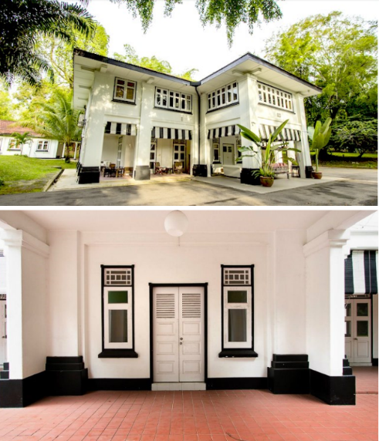

Location Of Signage

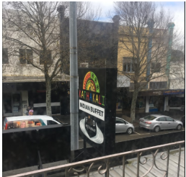
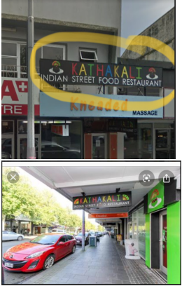

Image of Current Restaurant Signage

