TRAVEL PORTFOLIO

LOGO brief.

Travel Portfolio
We are a travel agency based in Zimbabwe, specialising in African Safaris and Adventures. Tag line “Let’s explore Africa together”.

Current Logo

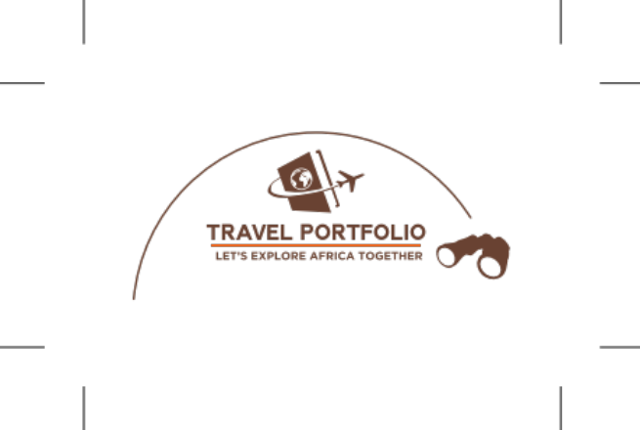

The logo:
We would like our current logo to be re-designed. The single-minded idea is to take us back to the Colonial David Livingstone days with an oldy worldly, sepia look and feel.

It ticks so many boxes in terms of travelling back in time - to a time when things were made properly, done properly and everything, but most especially, memories were made to last. Service was of a premium.

It also speaks of travelling back in time both figuratively – ala the good old-fashioned days of silver service etc.

In this regard, the logo could be like a real postage stamp ala those in that era that were printed in sheets that you could tear off each stamp and you then lick and stick onto the traveller’s itinerary.

SUMMARY
Design a logo that is like an old-fashioned postage stamp including some Big 5 animals and other animals plus some African landscape.

REFERENCES

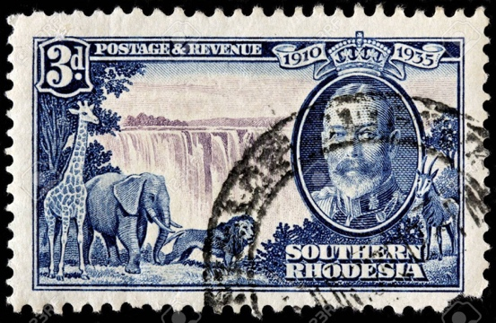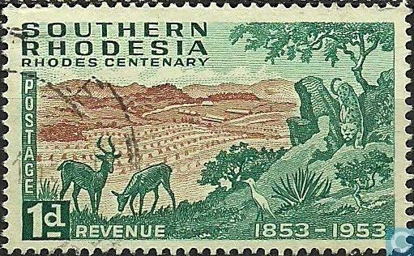

A similar background with African animals and an African landscape (don’t use the falls as shown in the example) similar to these two examples. Keep the colours/shading light as we will be using a Post Office stamp over the top. Try different iconic African symbols instead of a face of a famous person, possibly use an emblem using an African warrior shield.
The wording on the postage stamp will include:
- Travel Portfolio (being the name of the travel agency)
- Let’s explore Africa together (being the Tag line)
- 5c postage & revenue

