Copy for Poster 1

,,,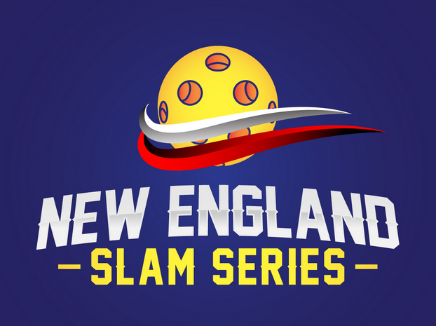
USAPA SANCTIONED Pickleball Tournament
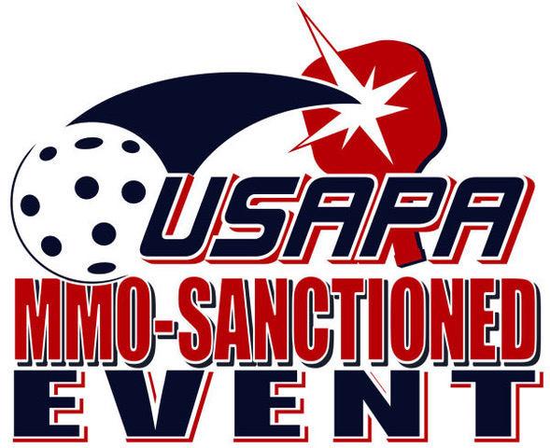
Super Slam
November 23-24, 2019

Starland Slam
February 15-16, 2020

Smash and Slam
September 12-13, 2020

Grand Slam
November 21-22, 2020
Women’s, Men’s and Mixed Doubles
Onix Fuse Yellow Indoor Ball
Cash prizes!
Sponsorship Opportunities Available
Questions: http://newenglandslamseries@gmail.com
Registration: http://pickleballbrackets.com/
Starland Sportsplex, 645 Washington St, Hanover, MA
Venue of the 2019 USAPA Atlantic Regional

