Copy for Poster 2

,,,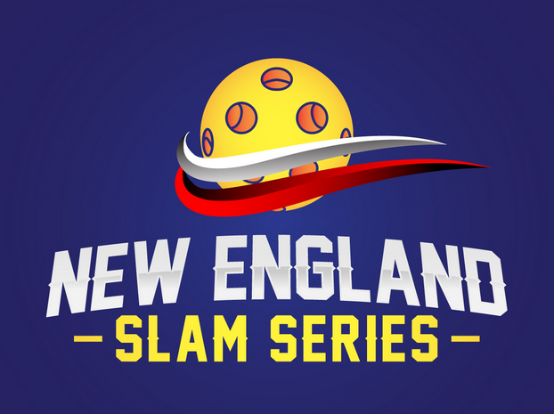
Super Slam
November 23-24, 2019
the weekend before Thanksgiving

USAPA Sanctioned Pickleball Tournament
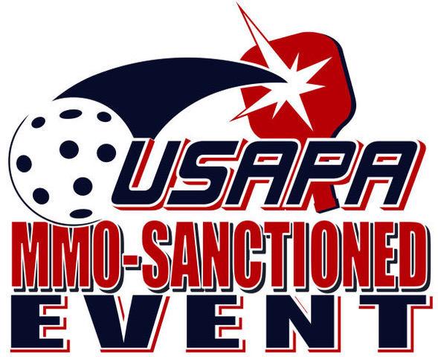

Women’s, Men’s and Mixed Doubles
3.0, 3.5, 4.0, 4.5, 5.0 Brackets
Prizes!
Onix Fuse Yellow Indoor Ball

Questions: http://newenglandslamseries@gmail.com
Registration: http://pickleballbrackets.com/

Sponsorship Opportunities Available!

Starland Sportsplex, 645 Washington St, Hanover, MA
Venue of the 2019 USAPA Atlantic Regional

