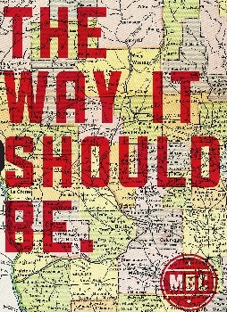
CORE VALUE #1

Overview:
“The Way It Should Be” has been the motto of Milwaukee Burger Company since the day we opened. This saying truly embodies who we are and what we stand for. We take everything we do in our restaurants and put it through the filter of whether or not the way we are doing something is “The Way It Should Be.” If it’s not, then we shouldn’t be doing it.
Examples:
- Should we serve a burger and fries plate with half the portion of fries that we normally give? No, we should make sure that an ample portion of fries are on the plate before sending out to the guest, that’s the way it should be.
- Should our cheese in our cheese curds be Wisconsin cheese? Absolutely, because cheese from out of state would not be the way it should be.
- When a guest walks in the front door should our hosts be on their phones and/or chatting with each other? No, they should be making eye contact with the guest and welcoming them into the restaurant with a smile, because that’s Wisconsin hospitality the way it should be.
- Should we serve a burger with a heaping side of fries, as outlined in our MBC Spec Guide? Yes! Guests love large portions and great value! That’s the way it should be!
- Should the cheese we use be Wisconsin cheese? Yes! Wisconsin is known as the Dairy State! in 2019, Wisconsin brought home 122 medals from the American Cheese Society Competition, more than any other state. Wisconsin cheese is the best cheese, and it’s the way it should be!
- When a guest walks in the front door, should we be ready, excited, and smiling our biggest smile at them? Yes! We are ecstatic that of all the restaurants in town, they chose us! We embody Wisconsin hospitality, because that’s the way it should be!
Video Link: The Way It Should Be Video

