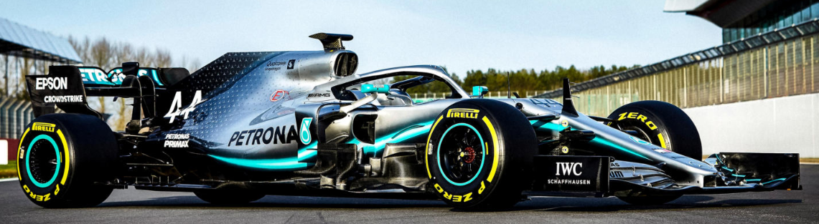

Colours to be used for the logo design.
I would like to use the above colours from Mecedes Petronas F1 team
https://www.mercedesamgf1.com/en/mercedes-amg-f1/
Black Grey silver and bright blue
Estim8 Careers LOGO
Building a brighter future
The strap line “building a brighter future” I want to use the bright colour above for the word estim8.
This colour would then change when the next trading name/division is set up perhaps keeping the word careers the same (Black) only a suggestion.
Estim8 Careers is the first of three trading names of a company called Megalithic Global Ltd based in the UK. Estim8 will provide estimators to the construction industry in the UK and Europe across multiple sectors.

An example of logo and text that I like below.


Text from Linkedin.
Estim8 Careers
The only specialist agency for Estimators.
Whether you’re an estimator looking for a new opportunity or a client in need, our team are here to help. Our consultants have extensive industry experience which guarantees a bespoke and tailored service to your recruitment project.
We are the only recruitment agency in the UK that specialises solely on Estimators and have experience in working with some of the biggest names in the industry.
Please do get in touch so we can understand your current situation and discuss our current Estimator opportunities that may be suitable for you, or to discuss how we can help you identify the next hire for your company on 0203 982 0833.

