These instructions are for a 12 page booklet, that will be saddle stitched along the short side.

I will to the best of my ability write a page by page summary of the contents I want along with tagged files corresponding to the pages. Layout should be on 11 x 17

Specifically we are looking for a professional catalogue style booklet showing our products and services.

Outside Cover
Right Side “Front” PAGE 1
- Our Logo and Text
- Photo of a home with new windows
- Color themes that follow our logo design
Left Sid “Back” PAGE 12
- Contact information
​ Window Gurus LTD 1816 Crowchild Trail NW Unit #700 Calgary, AB, T2A 0R5
Office: 587-329-0844
thewindowgurus@gmail.com Website: http://windowgurus.ca/
- Better Business Bureau Logo
Inside Cover “Left (PAGE 2)
- Our Story Your locally owned and family operated company providing Alberta families with the highest quality windows and doors. The company has built a reputation of excellent customer experiences and satisfaction. We are dedicated to serving our customers as though they were family.
- We feel our employees are very important to our reputation. As such, we are committed to provide our employees a stable work environment with equal opportunity for learning and personal growth. Creativity and innovation are encouraged for improving the effectiveness of The Window Gurus. Above all, employees will be provided the same concern, respect, and caring attitude within the organization that we give every customer.

Page 3 “right”
Our windows are available in a wide range of styles and sized to meet your specific needs, the clean, simple and uncluttered lines of vinyl windows can complement any type of architecture. No matter where you live, it costs money to stay comfortable. In the summer, you pay to keep heat out of your home; in the winter, you pay to keep it in. New windows have advanced design features that effectively block the flow of heat, saving you money and keeping you comfortable, season after season.
New windows express your personal tastes and priorities. How you care about how your home feels. About its comfort. And about its value. The Window Gurus help you create a living space that is truly your own. Adding beauty to your home should never come with compromise. Selecting windows for your home can be easy if you know what to look for. Our specialists can guide you to the proper windows and styles that will meet your needs.
Page 4and page 5
When they flip to this page they will see both pages at once…..
Title TYPES OF WINDOWS
This will be a series of 9 pictures with a brief description beside each one
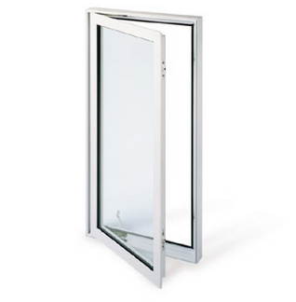
Example:

Casement windows
Hinged on one side, the earliest form of a moveable window with hinges that allow the window to operate like a door.

Page 6
Title Window Shapes and Grills
Page 7
Professional Installation
The quality and care of professional installation make a huge difference to life of worry-free windows. Unlike other window companies our installers completely seal the entire opening with a waterproof frame membrane (Blueskin) prior to installing the window. We then caulk completely around the outside and low-pressure foam insulate the inside.
When installed incorrectly, they can cause a lot of problems. Installed correctly, they are a beautiful touch offering you sunlight, a charming exterior, great insulation along with leak free and a draft free experience.
Page 8 + 9
DOORS
Our door systems are tailored to withstand the extreme Canadian climate, providing a range of design and material options to suit your specific needs. Our doors are crafted using only high quality components – designed with the consumer in mind and will provide lasting beauty and durability.
Doors not only add beauty and security to a home, they also increase energy efficiency and comfort.

Page 10 + 11
Glass Options and Patio Doors

