Brochure Instructions
- Additional images are attached for use if wanted but not necessary
- Use the colour on our logo (logo attached .ai file)
- Two sides with two languages (English and Vietnamese)
Front cover (side 1) is in English with: Our name (Hampshire Dental Surgery)
Logo and address (219 Hampshire Road, Sunshine, VIC 3020)
Phone: (03) 9311 7353
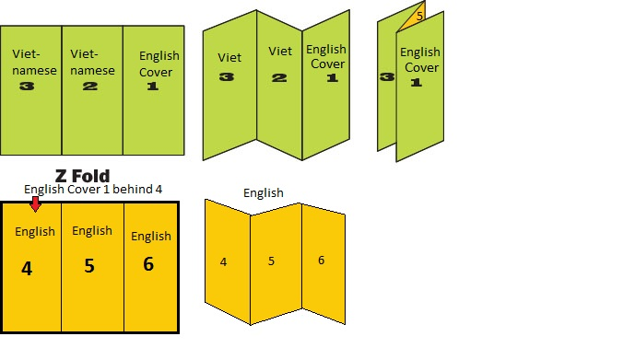
- Flyer content English side (this can also be found in brochure translation document)
- Side 4 (please see picture instruction above) to include:
Heading: Child Dental Benefits Scheme
Text: A dental benefits program is available for eligible children aged 2 to 17 and will receive $1000 for dental treatments.
Text: To check if your children are eligible call us on 9311 7353.
Picture: Add a picture of children at the dentist (see attached photos for use)
- Side 5
Heading: Special Promotions
Text: Gap free dental check-up, clean & x-rays for all health
insurances**
Text: At home whitening kit now $199 limited time only (normally $395)
Text: Braces, dentures and implants are available at our clinic
Text: **Conditions apply—Ask staff for more information
- Side 6
- All of the dentists' names:
Dr Trang Pham BDSc (Melb), ICCDE
Dr Liem Dang BDSc (Melb), FICCDE FRACDS, PGradDipCD Implants (Melb)
Dr Huyen Hoang BHsc Mdent (Latrobe)
Dr Peter Le BHsc Mdent (Latrobe), FRACDS
Dr Kym Le BDS (Adl)
Map/address of the clinic (map attached)
Address/details to be included
219 Hampshire Road
Sunshine, VIC 3020
Phone: (03) 9311 7353
Email: admin@hampshiredental.com.au

- Side 2 (Vietnamese)
Heading: Child Dental Benefits Schedule
Text: Chúng tôi nhận chương trình Medicare $1000 mỗi 2 năm cho thíếu nhi tuổi từ 2 đến 17.
Text: Xin vui lòng liên lạc văn phòng số ₫t (03) 9311 7353.
Picture: Add a picture of children at the dentist (see attached photos for use)
- Side 3 (Vietnamese)
Heading: Special Promotions
Text: Khám răng, chụp hình x-ray và clean răng chỉ nhận bảo hiểm**
Text: Giá Đặc biệt 1 Bộ Tẳy Trắng Răng $199 thông thường là $395
Text: **Gọi nhân viên để biết thêm

