A5 portrait brochure for Permitintel (enterprise software solution) (www.permitintel.com) 8 pages. Must be print ready – full bleed and 3mm crop lines
______________________________________________________________________
Permitintel logos:


Strapline: The oil and gas compliance tool

Imagery: oil and gas industry / legal / intelligence / software / global e.g.



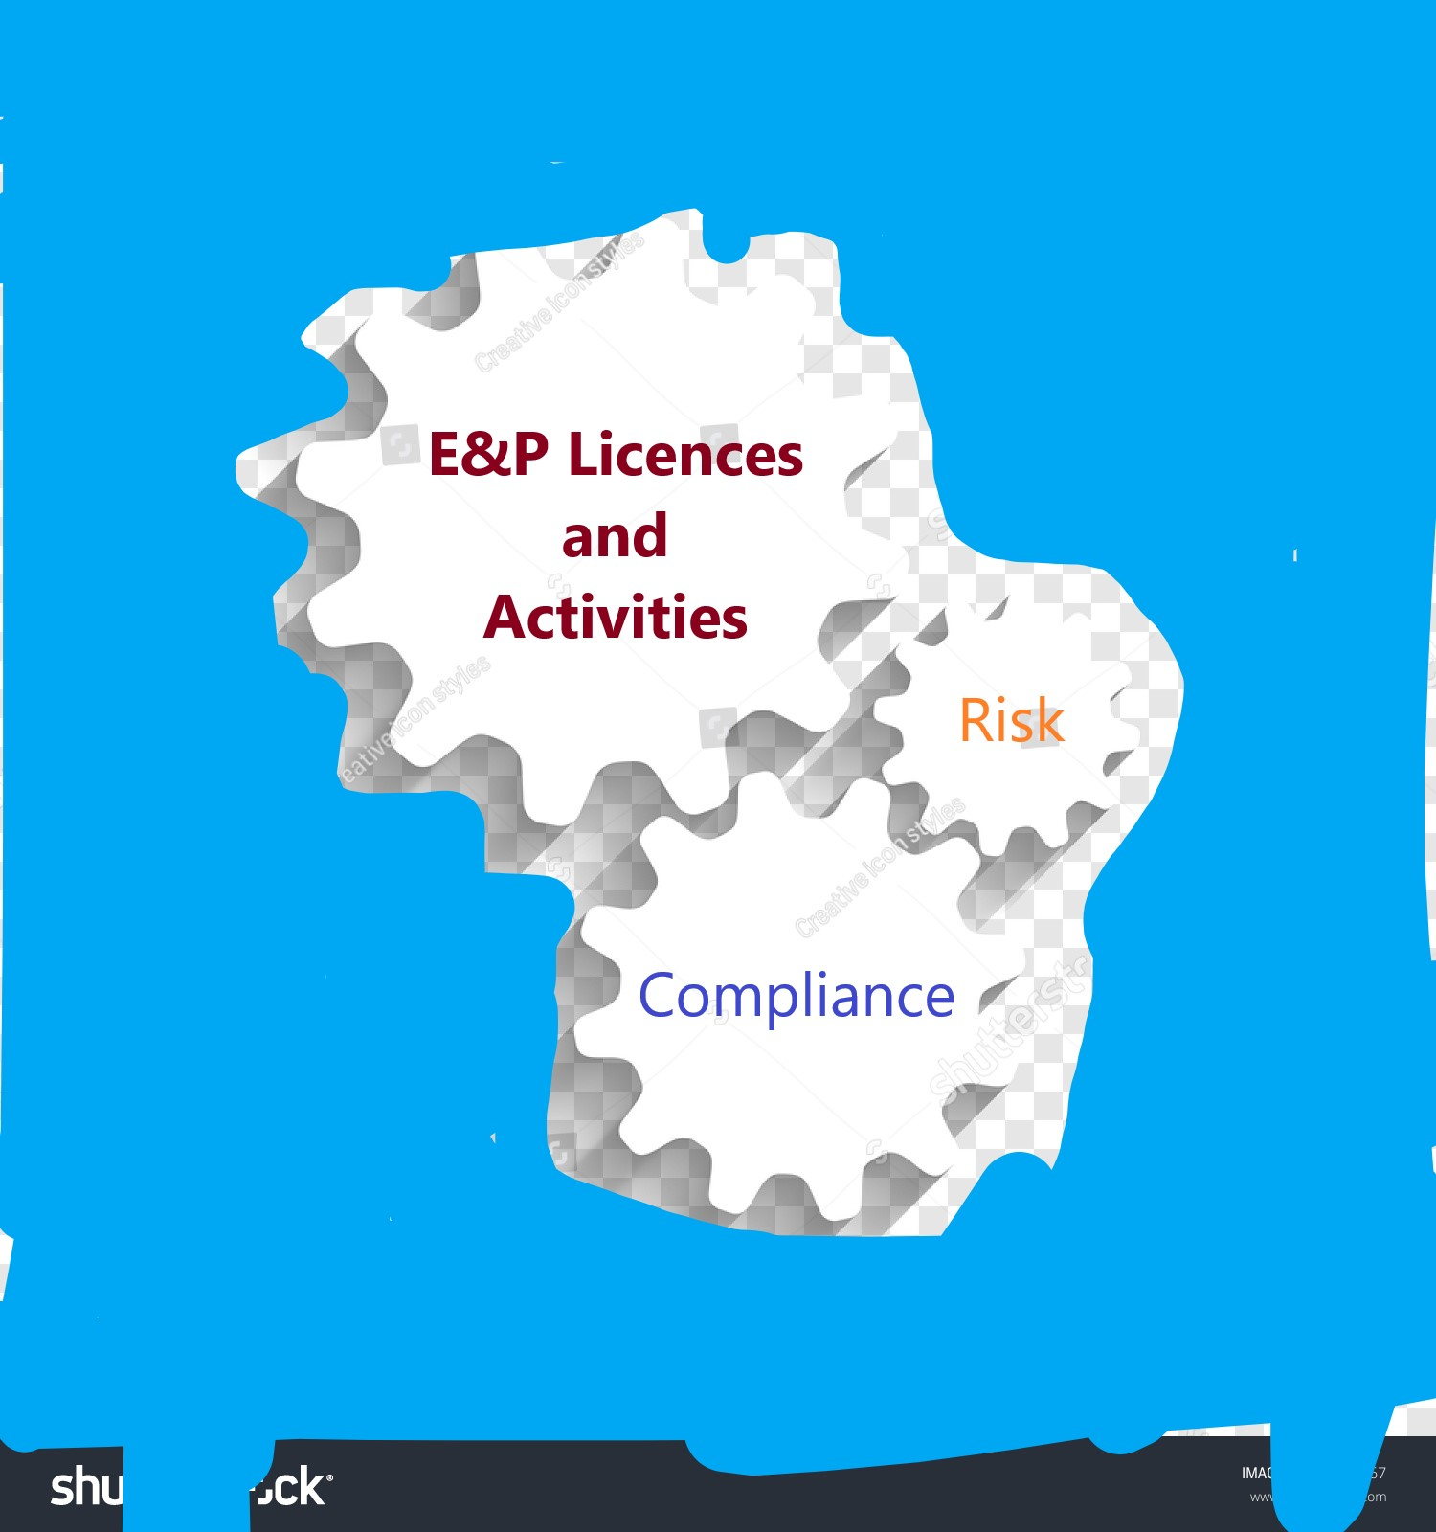





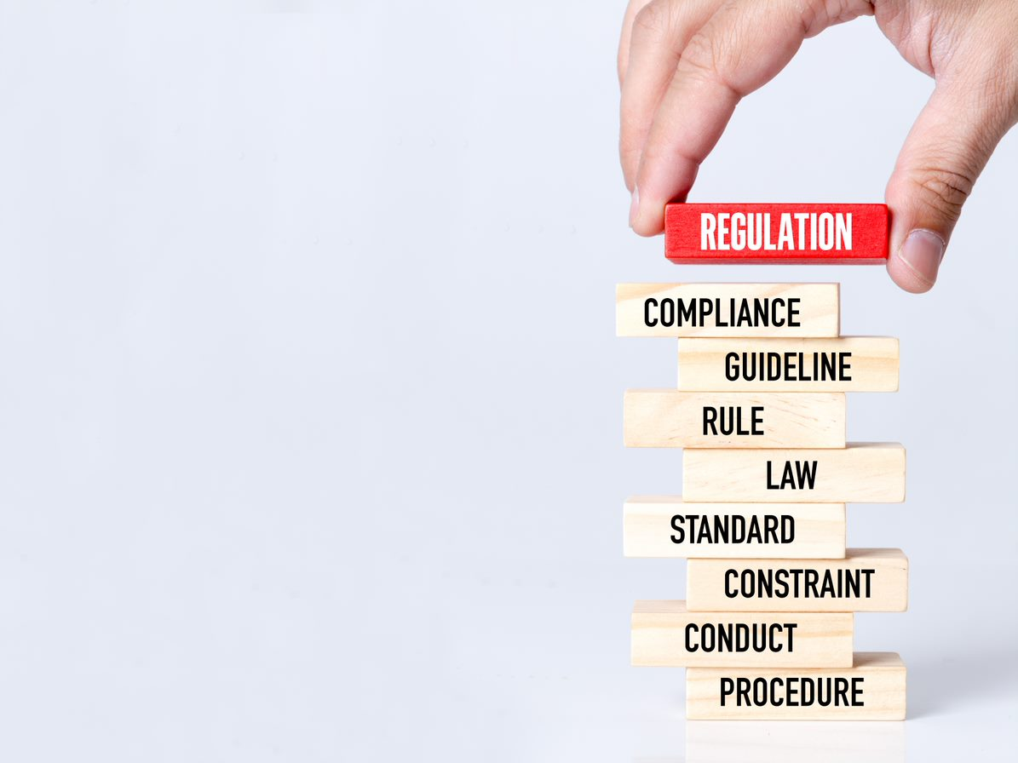
Screenshots: (if required, not essential)
(Licence Management)
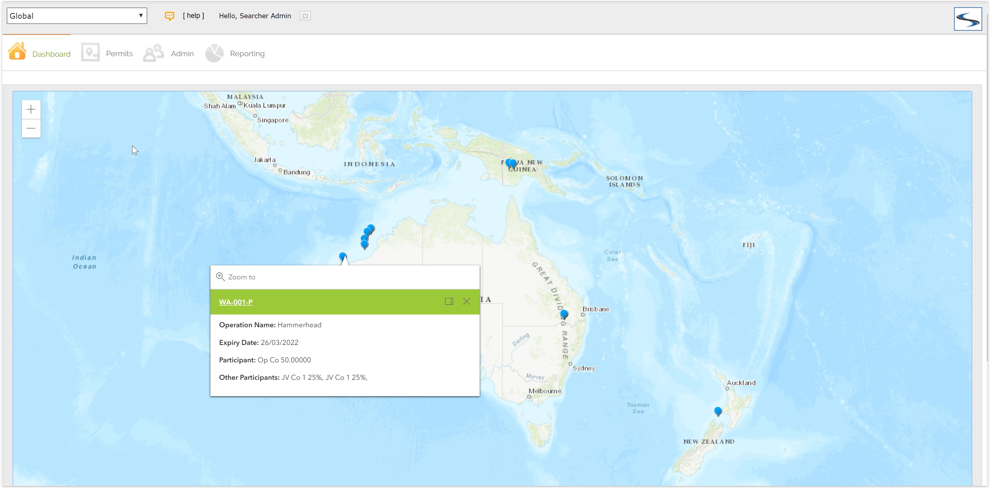

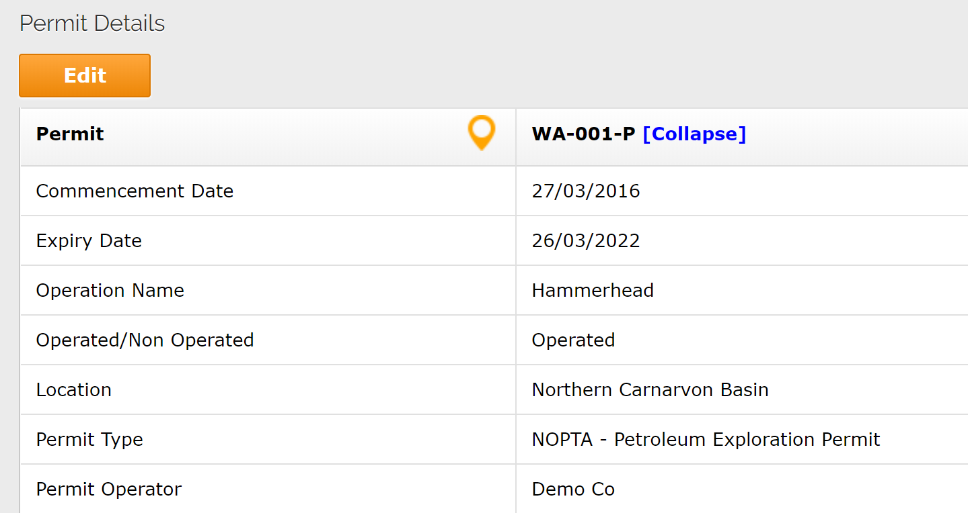

(Risk Management)
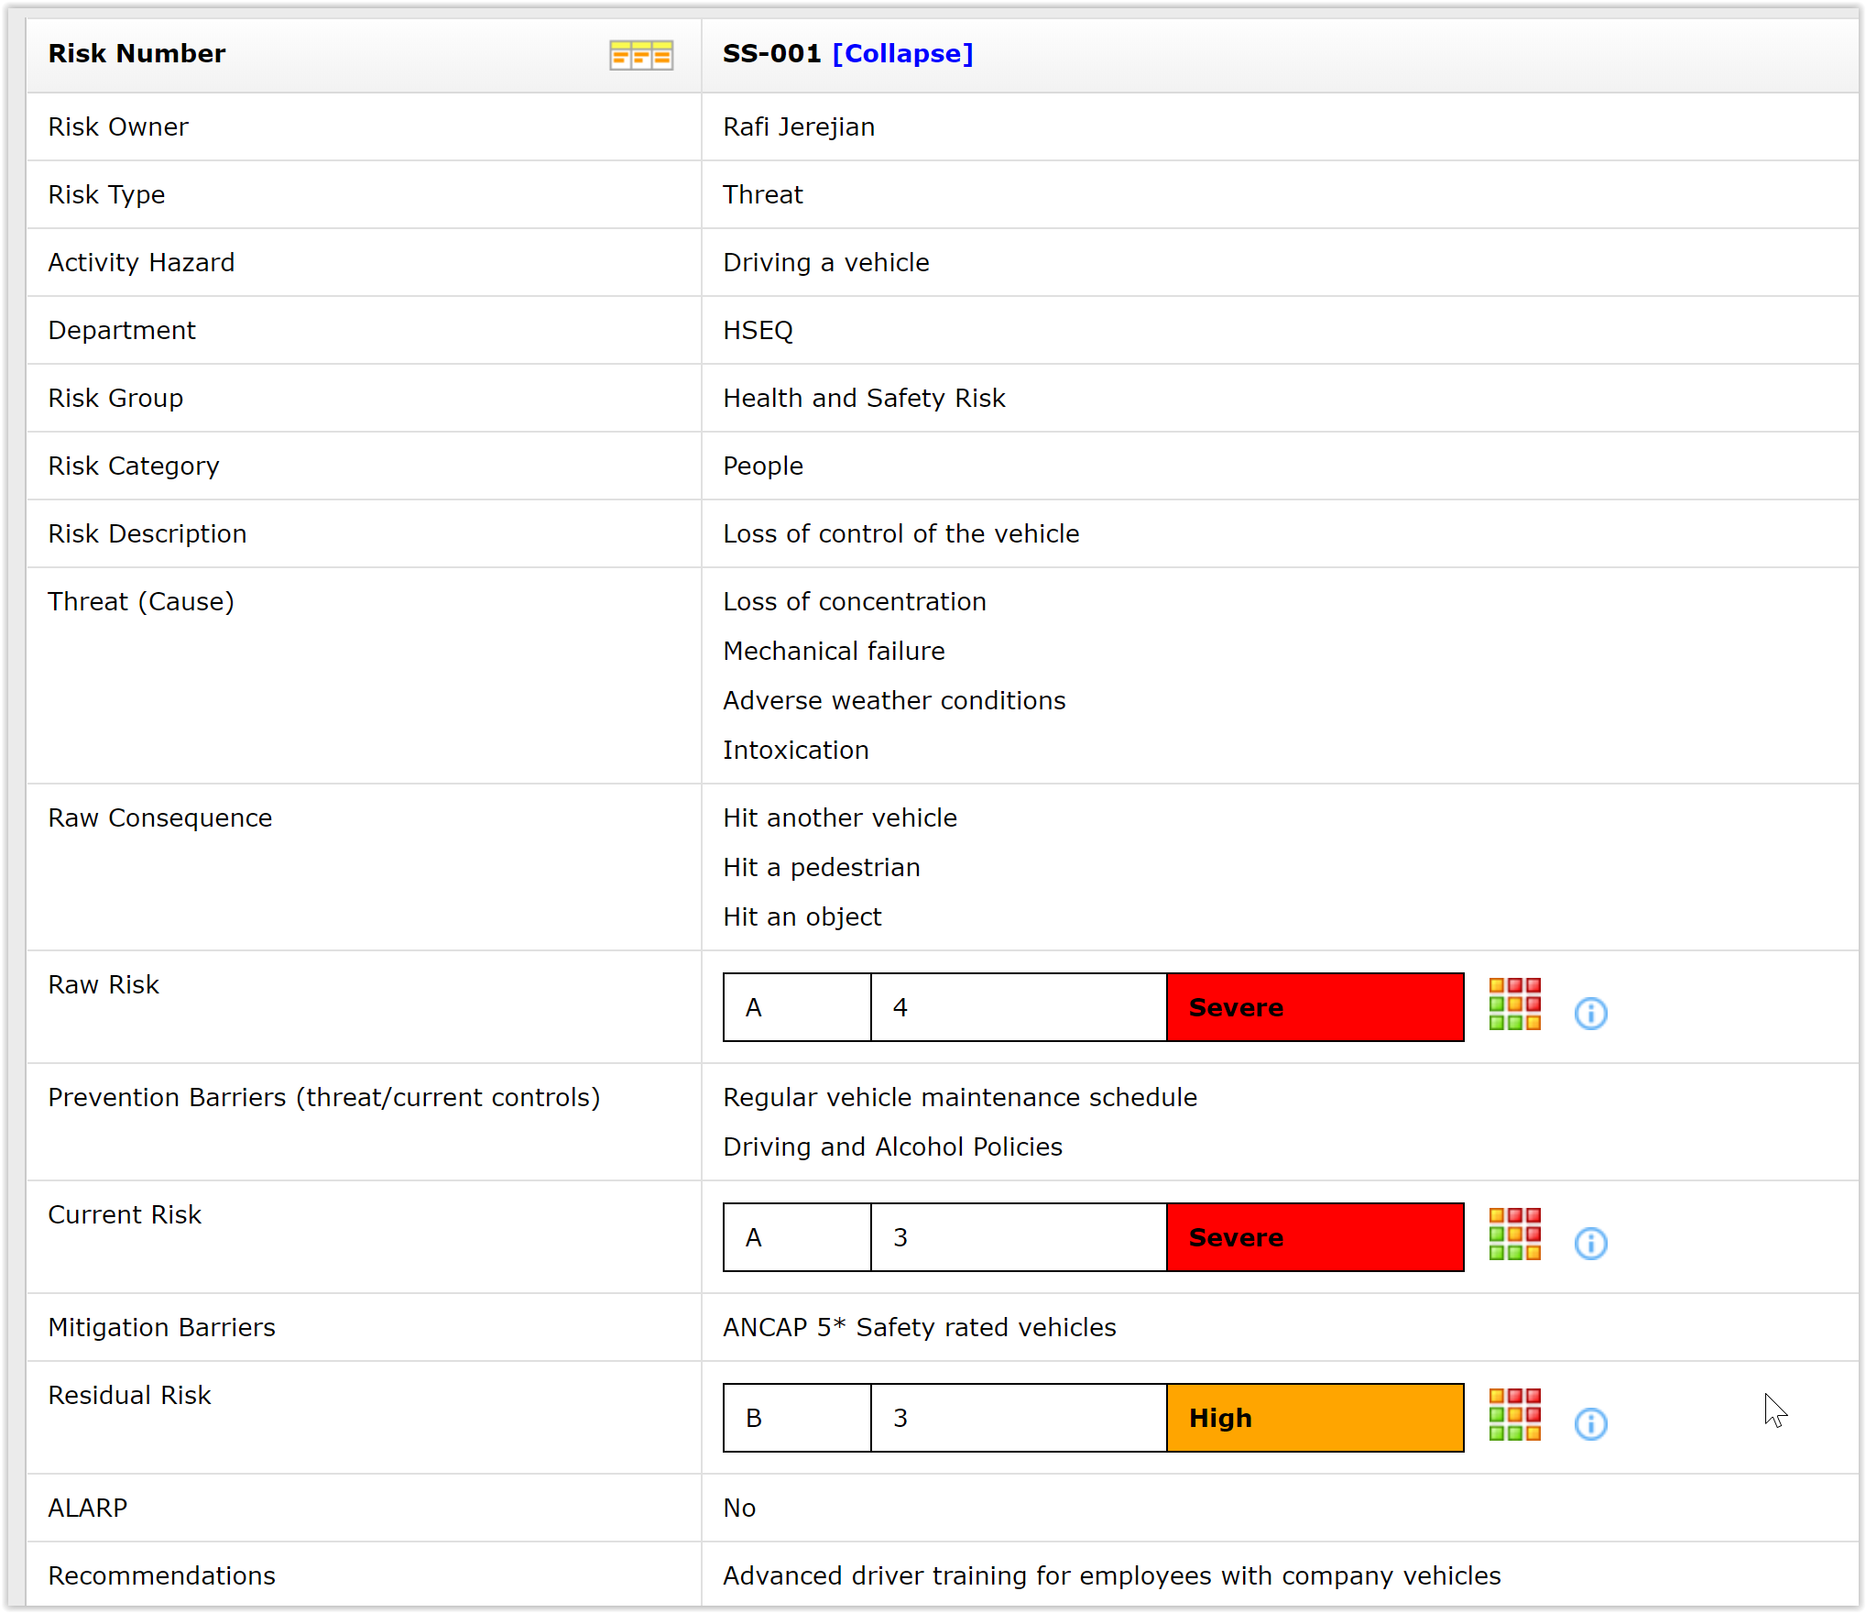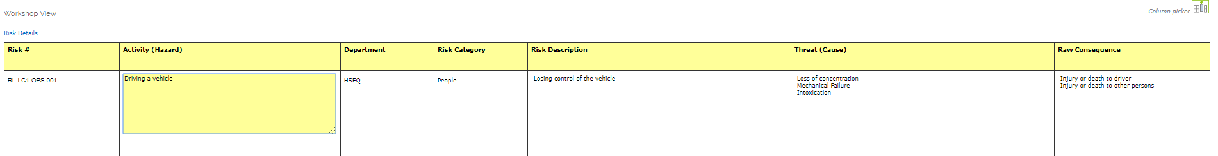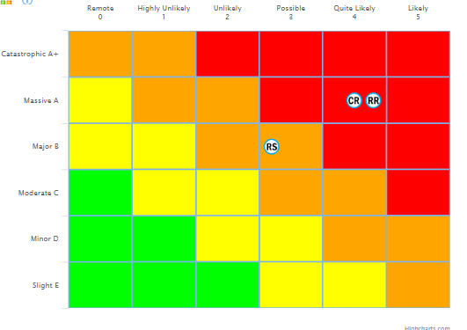
(Reports)
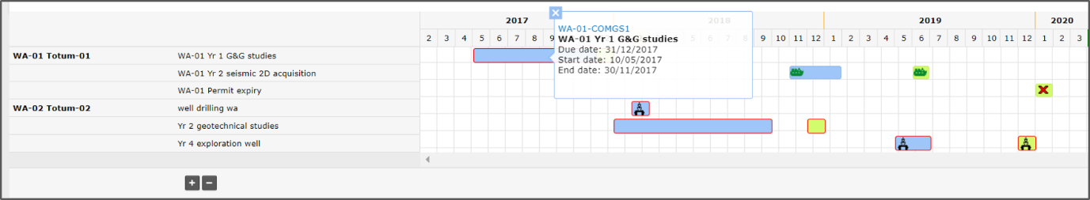
Quotes: (can be used anywhere)
“The activity planning and look ahead we get from Permitintel means we are able to be pro-active but also respond and adapt more quickly when things do change.” - HSE, Risk and Compliance Manager

“Permitintel allows me as a manager to get status reports on every permit's compliance against regulatory deadlines. It has kept us out of trouble a number of times.”- Exploration Manager

Page 1 (cover):
Logo and strapline plus imagery
Text: The cloud solution for compliance and risk in the oil and gas industry
_______________________
Page 2/3 – Section “Our difference”
Imagery
Heading: Our difference
Text:
Managing an upstream oil and gas portfolio is complex, with regulatory and contractual obligations differing across locations and operations.
Developed by industry experts, Permitintel has been designed specifically to address the unique challenges faced by oil and gas operators. Bringing together your licence information and commitments with the regulatory, contractual and internal process requirements and risks associated with your operations, Permitintel gives you a holistic view of your E&P assets and activities.
Prominent text: We understand your business.
Permitintel has in-built compliance intelligence, empowering your operational teams to confidently manage compliance in the context of their day-to-day activities.
Our unique data architecture delivers compliance information to the people who need it, when they need it.
Prominent text: Compliance intelligence.
Page 4/5/6 – Section “Our solution”
Imagery
Heading: Our solution
Subheading: E&P licence and activity management
Text: Any type of licence, anywhere in the world, can be managed in Permitintel including exploration and production licences and concessions, oil and gas leases, production sharing contracts and all ancillary licences such as facility / infrastructure licences and pipeline licences.
Permitintel enables you to manage work program commitments and E&P activities, fees and royalties and reporting requirements, as well as licence events such as transfers of participating interests, notifiable incidents and licence variations.
Prominent text: Your global assets at your fingertips.
Subheading: Compliance management
Text: Permitintel brings together your contractual, regulatory and company requirements in a single, accessible repository, ensuring access to the most up-to-date information for all who need it.
Whether it is PSC obligations, environmental approval conditions, JVOA requirements or internal approval processes, Permitintel has it covered.
Prominent text: A single source of truth of the company’s obligations.
Infographic: To show relationship between an activity (eg drilling) and all of the relevant obligations eg:
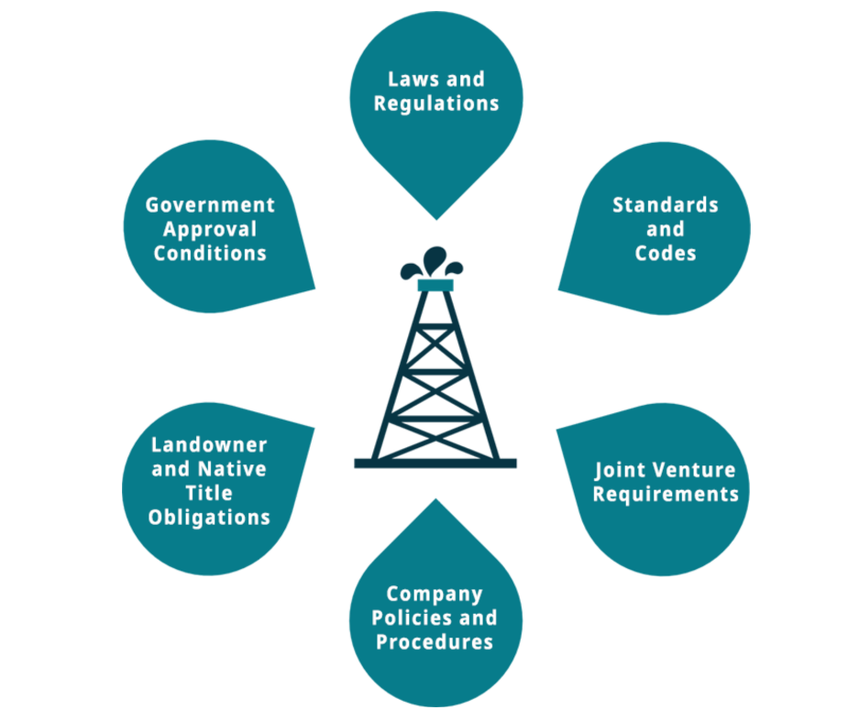

Prominent text:

Subheading: Risk management
Text: Permitintel integrates risk management with your assets and obligations, to deliver a holistic view of risk across the business operations, positioning you to identify and manage issues early and respond quickly as things change.
Prominent text: When it comes to managing risk, context is everything.

Page 7: Section “Our promise”
Our customers experience a range of benefits from using Permitintel and we promise that you will too.
Your return on investment in Permitintel comes from three main sources: efficiency gains leading to operational cost reduction, avoidance of costs associated with compliance breaches and realisation of benefits from pro-active compliance and risk management. In addition, as Permitintel is a software-as-a-service solution, there is no capital outlay or IT overhead.
With in-built GIS capability, Gantt timelines, automated task generation, email reminders and reporting, Permitintel saves you hours of data entry and data manipulation of bringing together multiple sources of information from different systems.
(icons can be changed)







Simplify due diligence and audit
Avoid fines and penalties
Reduce stress and reliance on key staff
Increase operational efficiency
Single source of truth
Maintain legal and social licence to operate

Prominent text: Safeguarding your licence to operate.

Page 8: (back page) Contact details
Level 6, 117 Lambton Quay
Wellington 6011
New Zealand
+64-4-234-1014
sales@permitintel.com
www.permitintel.com

