Flyer:
Detailed below is how I envision the flyer. There are some aspects to add to the flyer. If more info is required, please don’t hesitant to ask.
The name of my company is Therapia Software LLC, the logo is attached. One stock photo is also attached. The color scheme should be greens/turquoise, and whites mimic the current color schema of my software/one-page flyer. Flyer should be clean. Please also refer to our Flyer design as guidance. Looking for four pages long flyer.
-Header- incorporates Therapia logo and our slogan ‘An EHR developed by physicians and healthcare professionals with decades of experience working in behavioral health’.
‘How Therapia helps you’ text with 3 phrases - Organic Documentation, Risk Management/Quality Improvement, Patient Engagement -
Organic Documentation- Therapia set out to provide behavioral health clinicians a familiar platform to engage in chart level documentation for their client care. By focusing on the established paper documentation that has been proven over the years to provide efficient and valid information about each patient, Therapia is built using this recognized foundation for each company it encounters. We do this by encouraging active participation and involvement with our Hospital Partners to address their individual needs. Specifically, we use the documents that have already been created and pay the utmost attention to the flow of that documentation from Intake to Discharge. By keeping that familiar flow, we minimize the disruptions that many clinicians feel burdened by switching to electronic documentation. The software functions in a very organic manner. We then add a modern functionality and feel to further enhance the capabilities of the software. This modern functionality allows the established documents to work seamlessly with both clinicians who are new to EHR’s and clinicians who are already accustomed to electronic documentation. Overall, Therapia achieves the feel of an actual chart with the functionality of electronic records.
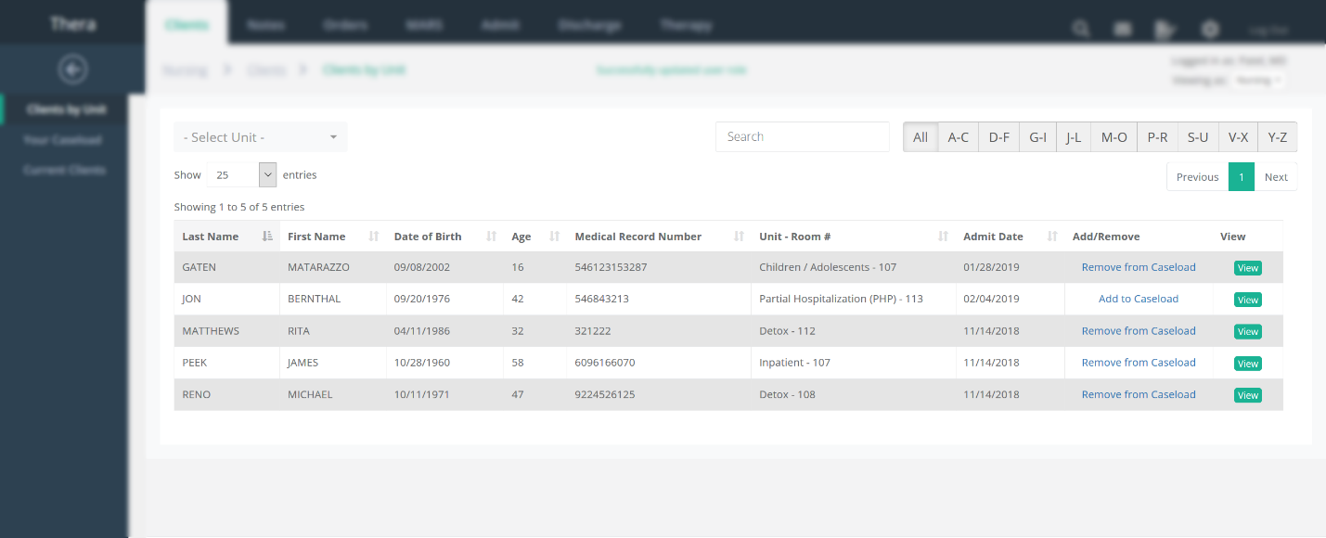
a. Patient Engagement- Therapia felt the opportunity to use an EHR to provide the next level of patient engagement was vital to the overall value of our software. Using our proprietary Therapia Modules, we seamlessly digitalize therapy for use in both individual and group therapy. An optional function of the software, Therapia Modules allow the clinician to individualize therapy in a hospital setting. This is especially helpful for those clients that do not attend group. The results are incorporated as chart level documentation and strengthen the overall subjective component from the client’s point of view. This permits the client to feel more engaged in their treatment and connected to the overall process of improving while in the hospital. Furthermore, we incorporate a Family Portal through the software so that therapy can involve the entire family during the client’s hospitalization. This allows the client’s support system to become an integral part of the client’s improvement in the hospital.
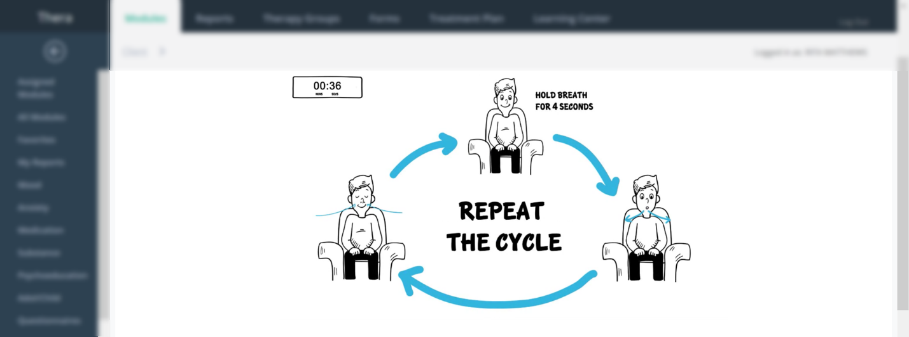
b. Risk Management/Quality Improvement –Therapia fully understands the highly regulatory environment that behavioral health care functions within. To help facilitate and navigate the ever changing regulatory environment, Therapia built tailored risk management/quality improvement tracking into the software. This real time data supports managers’ and leaderships’ daily duties by tracking deficiencies in the documentation within the hospital. By observing trends in real time, the hospital can actively engage in risk improvement measures. Furthermore, the software helps provide the data required for Quality Measures. Therapia feels this risk functionality will help identify potential errors and issues before they become systemic- further ensuring the hospital can perform efficiently with safety in mind. By utilizing this function, we feel the overarching goal of patient care with emphasis on safety can be strengthened by our software.
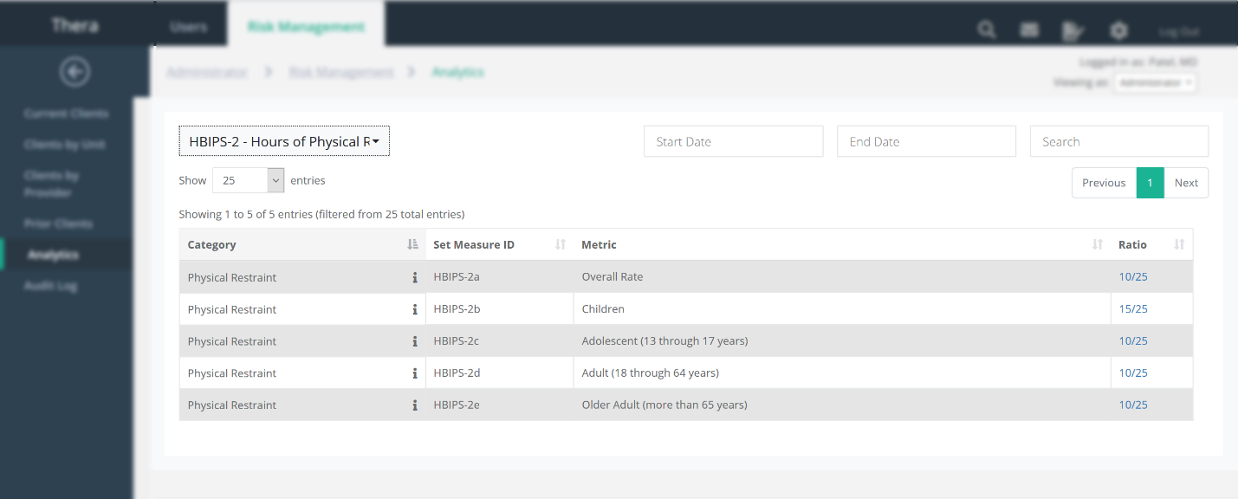

c. Security-
Therapia Software is built with the highest security standards in mind. Our software is housed in HIPAA compliant Amazon Web Services virtual private clouds that are geographically located in different parts of the country with associated recovery backup servers. This will allow us to appropriately scale to meet the needs of all our clients without the need for expensive capital investments.
Our Story-
The Present
When Therapia set out to develop an EHR for behavioral health facilities, we wanted to create software that would support and complement what various healthcare entities have previously established. We feel we have accomplished that very goal by building upon the foundation of how behavioral health documentation currently functions. Developed by psychiatrists and healthcare clinicians, Therapia appreciates and incorporates the core principles of what feels familiar to behavioral health clinicians.
The Future
While the birth of Therapia appreciates and strengthens the past, building upon that is where Therapia truly grows. We incorporate optional Patient Engagement within the software using our proprietary Therapia Modules. Now, the client actually becomes an active participant within the chart. The subjective nature of their own documentation further strengthens the validity of the story being presented. Furthermore, we have built-in Risk Management and Quality Improvement analytics to address the regulatory needs of both Joint Commission and CMS. This allows our partners to use their resources more efficiently and focus on patient safety. Also, our EMR resides in the cloud allowing for a secure HIPAA environment with lower capital costs.
We truly believe we have built an EHR that not only feel familiar and accessible, but also an EHR that brings behavioral health into the next phase of care and engagement.

Contact Us
- 404-977-2493
-www.therapiasoftware.com
-info@therapiasoftware.com

