Horizontal Layout
18 cm x 12 cm

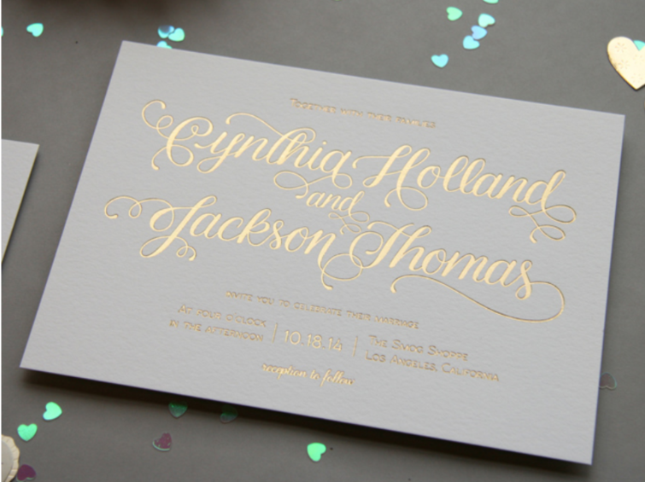

Design

Front (Gold foil)
We like 2 simple designs given below. Monogram consisting Couple’s initials, nice Border, First Names and date of the wedding (Sample is given below)

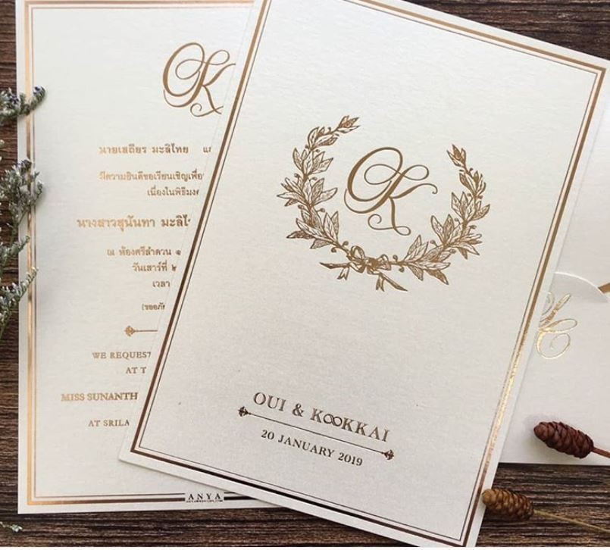
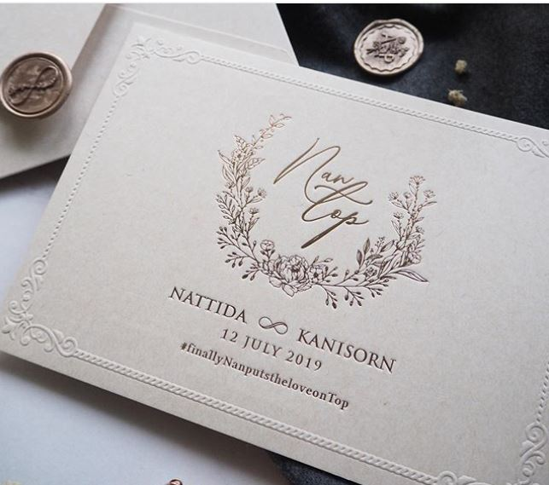

Back (letterpress)
Same Monogram, Same borders, Details of Wedding Ceremony, letterpress (black & gold), Guest names to be handwritten so there should be a dotted line for it. Sample is given below

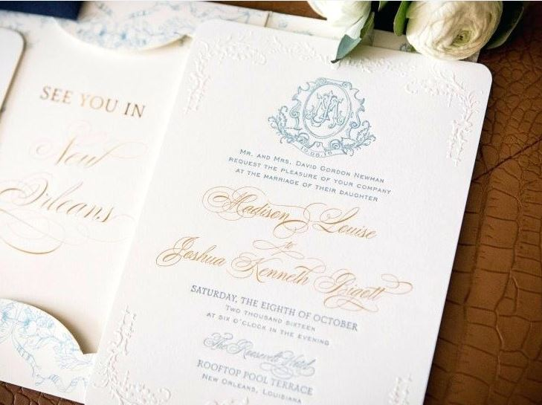

RSVP Card
Same design, small include Contact details. Details given below

Envelope/Envelop liner
19cm x 13cm Envelopes. You are free to pick the envelope and envelope liner according to the design.

Color Scheme

CMYK or best scheme for printing invitations.

Foil Color

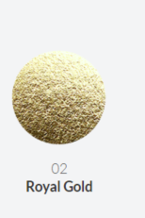

Paper Color

Light Ivory or Ivory Pearl (No.5)

Paper Weight - 320-350gsm
350gsm should be fine considering both sides of the paper need to be printed with effects without any problems.
