Teazana - Visual Briefing

The requirements:
- Graphic:
  - Attached is the photshop document: Teazana_Graphic_V02.psd
  - One .jpeg file with the graphic in the gray color Teazana_Graphic_V02.jpg
  - Black is only work in progress color and it is expected to be changed based on the requirements of the final design
- Style: Modern Pop Art (the examples can be found in the document below)
- Restriction: CMYK 4.0 color spectrum
- Colors: Shiniest, brightest and happiest colors (but still CMYK 4.0)
- Painting: Final design should look like as it is painted. So, look like a painting
- Background: White background
- Outline:
  - Lines in the graphic (motives) can stay on final design but it is not obligatory
  - Two version one with and one without would be perfect
- Examples of the modern pop art paintings can be found below in the document

Examples – Modern Pop Art
- Modern-Pop-Art-Nielly-Francoise-Oil-Paintings.jpg
Pros – good things about this example:
    - Diversity of the colors
    - pink (under the eyes) is working great with other colors but still it is not dominant
Cons – not wanted
    - too dark on the sides
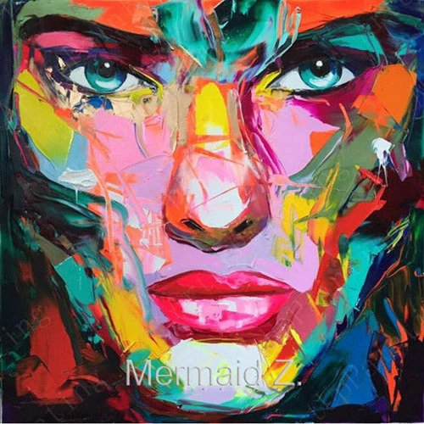
Example 1

- Modern-Pop-Art-Oil-Painting-Marilyn-Monroe.jpg
Pros – good things about this example:
    - Diversity of the colors
    - Warm colors
    - White background
Cons – not wanted
    - Light brown/beige color
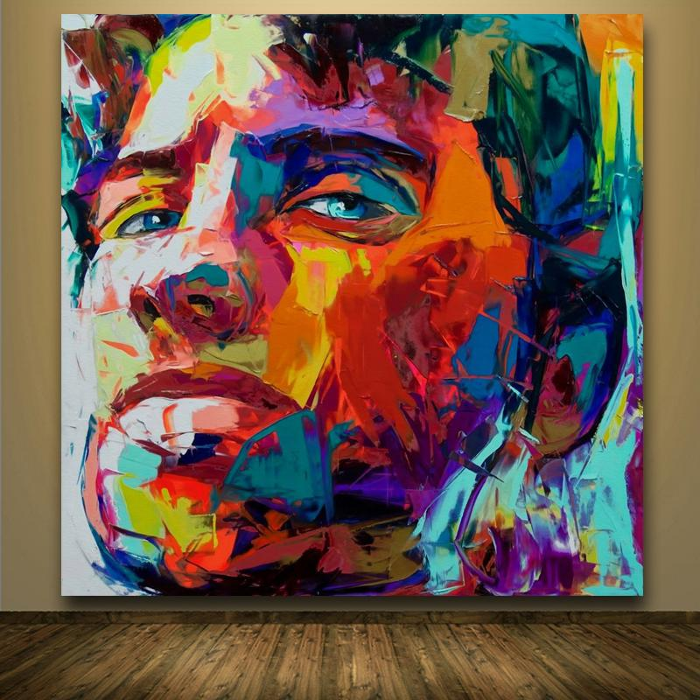
Example 2

- Modern-Pop-Art-Oil-Painting-Jazz.jpg
Pros – good things about this example:
    - Beautiful red color (red definitely must be present)
    - Nice shades of blue
Cons – not wanted
    - Not enough colors
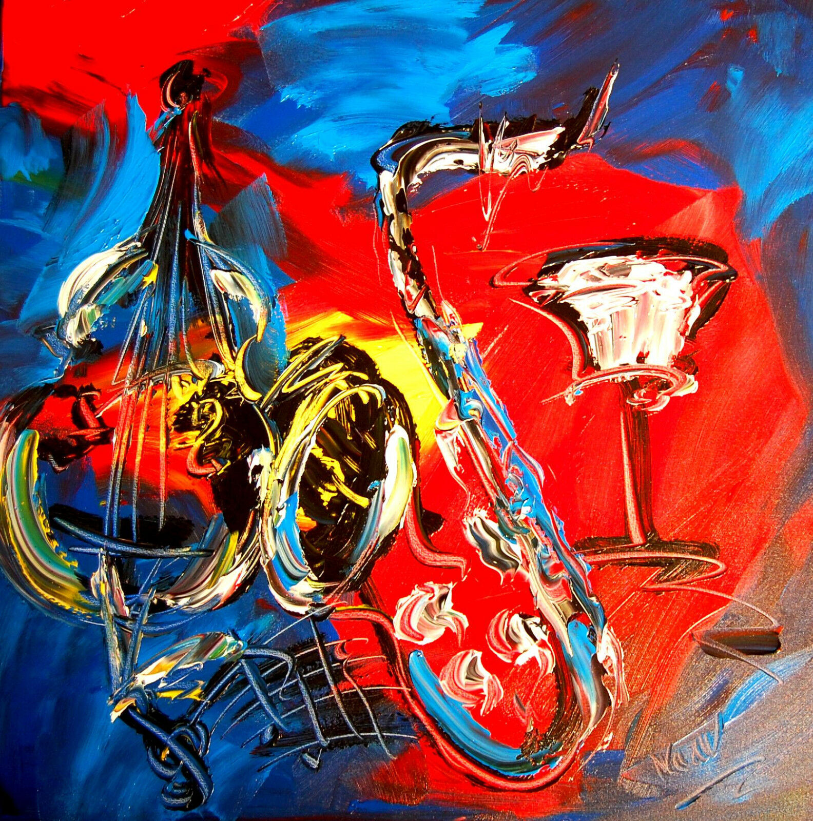
Example 3

- fantasy-village-contemporary-pop-art.jpg
Pros – good things about this example:
    - little bit darker colors but still looks good
Cons – not wanted
    - Too dark on the sides
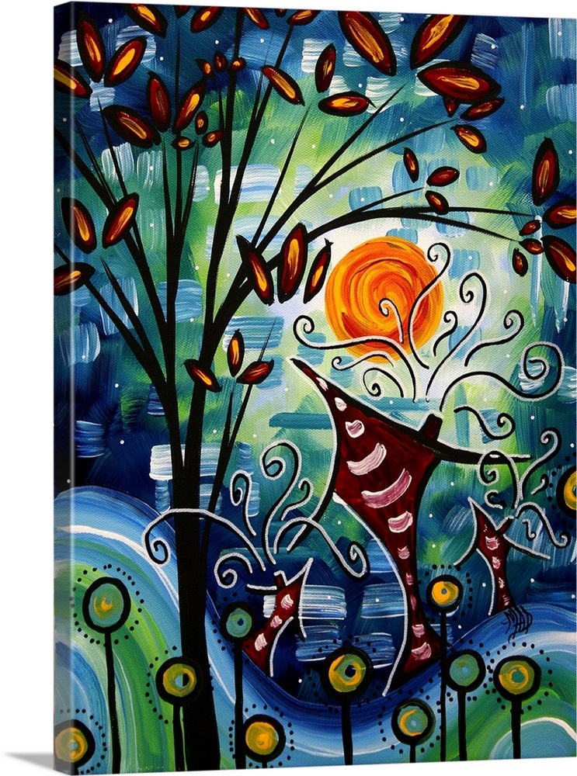
Example 4

- Modern-Pop-Art-Painting-KLSJPA.jpg
Pros – good things about this example:
    - Divers colors
Cons – not wanted
    - Not such nice transformation between the colors
    - Too dark on the sides
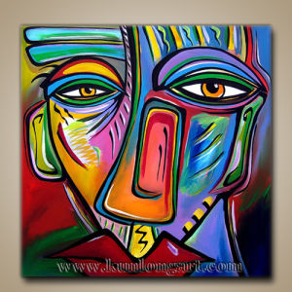
Example 5

