Trustee Services Group Brochure

Size:
Bi-fold 7x7 folded, or something similar – open to a different size

Brand Voice/Personality:
- Character/Persona = Warm, Authentic, Professional, Relatable
- Language = Simple, Serious
- Tone = Personal, Humble, Honest
Project Look & Feel:
- Upscale, professional and unique
- See Brand Guidelines
- Brand colors:
  - Orange: CMYK 0, 31, 87,3 or PMS 7409C
  - Steel Blue: CMYK 51, 18, 0, 47 or PMS 7470U or 5405CP
  - Bone: CMYK 0, 3, 8, 3
  - Coal: CMYK 4, 0, 0, 81 or PMS 412C
- Logo font: Fontin Regular and Bold weights https://www.fontsquirrel.com/fonts/fontin
- Should match look and feel of website – https://trusteeservicesgroup.com
- Logos attached
- Choose from photos here: https://photos.app.goo.gl/CBu3RKwqsTBhimAt8
- Size: Not a traditional 8.5x11 trifold. Can recommend size based on content but should be easy to hold.

Text to Include:
Cover:
Helping families protect and enrich a multi-generational heritage.
TSG Logo
Inside:
We understand that wealth and families is very complex. As families try to transfer wealth it can be an incredible blessing or, if done improperly, can be incredibly destructive. Often a neutral third party is needed to come alongside the family’s advisory team to provide guidance as families go through their wealth transition.
Our relational focus, and Open Architecture™ approach, helps families to successfully navigate through the complexities of wealth, family and trusts. We believe a family “legacy” is about more than just money.
Steve Marken, J.D.
Founding Principal

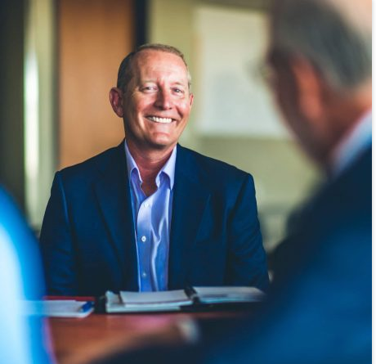
This is Steve – you can choose a different photo if you’d like
What Makes TSG Unique
1. Responsive
The family deals directly with decision makers instead of being subject to committees with whom the family may never have the opportunity to interact or engage.
2. Family Focus
We help families successfully navigate the complexities of family wealth, not just perform trust administration.
3. Independent
To avoid any conflicts of interest, we have no formal affiliations with wealth management firms or financial advisory practices.
4. Customized
Together we develop a customized approach that will best suit the family’s needs.
5. Collaborative
We work collaboratively with the family’s team of trusted professionals.

Trustee Services Group
Client/Family Centered Team


Image attached – you can recreate if you’d like

Back/Separate Panel

OUR SERVICES
What We Offer
We specialize exclusively in the delivery of trustee and estate fiduciary services.
Who We Serve
Families
Professional Advisors
Foundations
How We Serve
Our expertise and experience is in family wealth. In this regard, we serve in the following ways:
- Trustee (Trusts)
- Executor and Personal Representative (Will)
- Agent for Financial Affairs (Power of Attorney)
- Trust Protector
- Special Independent Trustee
- Consultant
- Expert Witness

Trust Specialties
The general types of trusts on which we serve as trustee:
- Family Trusts
- Charitable Trusts
- Family Foundations
- Life Insurance Trusts
- Retirement Trusts
- Special Needs Trusts

TSG Logo
Trusteeservicesgroup.com
719-358-8478
info@trusteeservicesgroup.com

