



ALL-IT

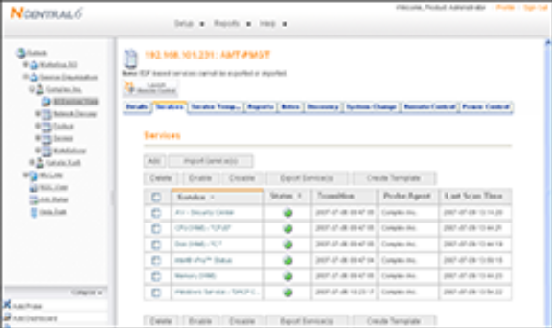
Stop Buying Downtime – Invest in Uptime
One of the major challenges in maintaining a
computer network is trying to predict what will
fail and when. With our ALL-IT solution, we can prevent many network failures from ever happening. By combining regular and comprehensive preventative
maintenance and robust real-time monitoring of
your critical network and desktop devices, we
ensure the reliability and stability of your IT
assets.

This solution is so effective, our customers see
almost immediate results. A regularly maintained
network means fewer failures, yielding higher
productivity and savings on support costs for you.
At the same time, your exposure to security risks
is dramatically lessened, and frustration from
unstable IT resources almost vanishes. We allow
our customers to focus on their core business
functions by taking the worry out of owning a
computer network.

An IT partner not provider. We understand
why your critical business services are so
important to your daily operations. This is why
we spend so much time aligning our technology
support with just such business services.
Building a program that relies on 24x7x365
network monitoring coupled with an aggressive
preventative maintenance component to ensure
optimum uptime for your business.

A True IT Partnership

Do these issues plague your business?

• Network neglected? Is yours perceived as a "necessary evil" and not as integral to improving business performance?

• Downtime impact? Are IT outages distracting your staff from their core focus, or prohibiting them from working efficiently?

• Distracted employees? Do your staff rely on other non-IT employees to deal with distracting IT problems?

Program Advantages:

• Increased productivity: Continuous insight into your network lets us reduce the business impact of IT failure by shortening the time from network failure to issue resolution.

• Reduced business impact from IT failures: Combining preventative maintenance and remote monitoring means we minimize failures that could impact your business. Your network behaves in a stable and reliable manner.

• Reduced network downtime through proactive maintenance: Through regular, preventative maintenance activities designed to keep your network operating efficiently, we reduce the number of emergency incidents you encounter.

©2011 MSPName - All Rights Reserved.

Stop Buying Downtime – Invest in Uptime
Stop Buying Downtime – Invest in Uptime
©2010 Sample I.T. Group - All Rights Reserved.

ALL-IT PROACTIVE IT SUPPORT

