Looking down at the food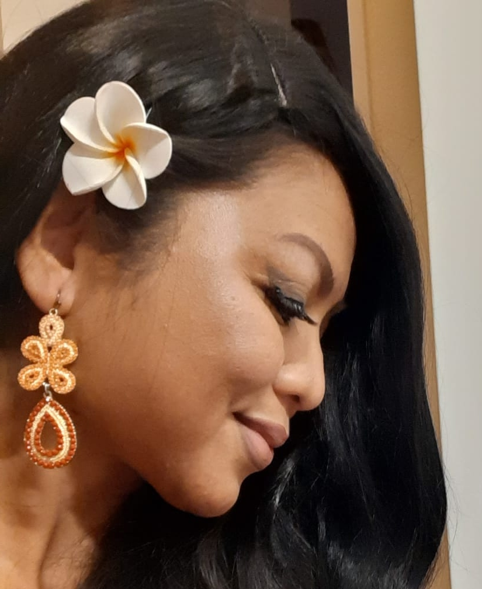 4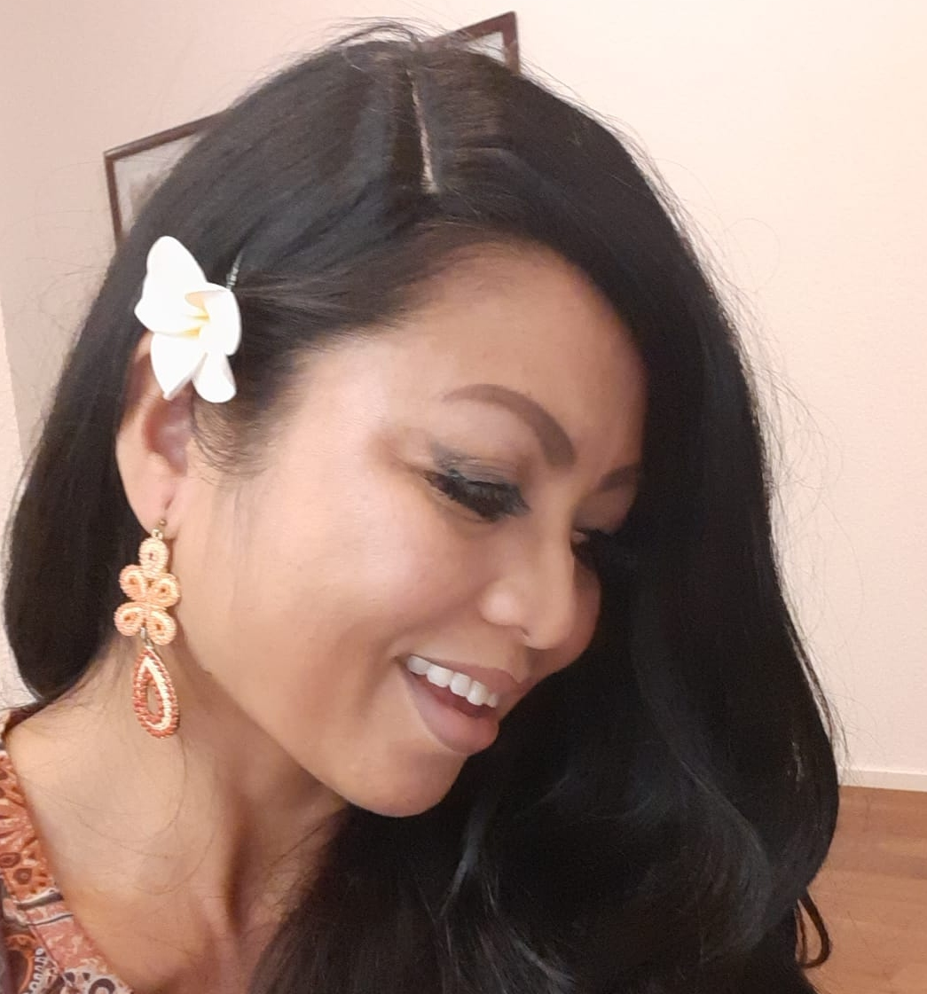 5

Image 6 (just for illustration of the bowl placement)
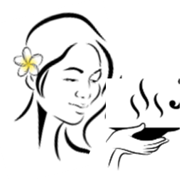
Image 7, please add a rice paddy under the subtagline



