Focusing on You:
At Aspire Skin Care, we understand that every patient is unique, and treatments should reflect the individual nuances, sensitivities, and needs of your skin. At each of your visits, we are committed to understanding you as a person, and you as a patient -to ensure you enjoy a unique experience and have the best results possible.
To facilitate our mission, Aspire carries a dynamic and comprehensive arsenal of sciences and technologies: from advanced, widely adjustable lasers, top quality injectables, to clinically proven non-invasive treatments.
At Aspire, we believe that a consult should be comfortable and exciting, not pressured and rushed. We only recommend treatments that are right for you, and dedicate ourselves to developing a customized treatment plan just for you!
For your customised treatment plan, Book with Aspire today!
Aspire Signature Treatments
Your skin is unique, and Aspire treatments are designed to be personalized solutions catering to all skin types.
Facial Revitalization Gentle, customized treatments combining traditional techniques with innovative skin technologies
- Aspire Glo Facial
- Aspire Enzyme Resurfacing
PhotoRejuvenation Light-based treatments that help reduce extra pigment, uneven complexion, scarring, unwanted hair, and other types of skin damage
- Diolaze by Aspire
- Lumecca by Aspire
Injectables Procedures reducing wrinkles, and smoothing away unwanted lines
- Neuromodulators (Botox)
- Fillers
Body Treatments -a safe nonsurgical option to redefine loose skin or body fat (belly skin, “batwings”, back fat, doulble chin)
- Aspire Skin Tightening
- Aspire Body Contour
- Aspire Submental Series
How we can help?
People can be beautiful and healthy at every stage of life!
We all have one thing or another that we feel self-conscious about, or something we would rather change. Please ask us about any of the conditions below, or even others!
- Hyperpigmentation
- Fine lines and Wrinkles
- Acne
- Acne Scarring
- Scarring
- Loss of Resilience and Collagen
- Enlarged Pores
- Rosacea
- Collagen Depletion
- UV Damage
- Hair Loss
- Anti-Aging Protocols
- Lax Skin
- Unwanted Hair
- Tone and Texture
- Body Treatments
- Women’s Health
Aspire Memberships and Packages
Laser Hair Removal Services
At Aspire, patients can be treated virtually pain free with our advanced laser technology. Safely and effectively eliminate unwanted hair!
Lip / Chin - 50
Underarm - 90
Bikini - 100+
Brazilian - 150+
Neck – 70
Full Leg 300
Full Leg w/ bikini 350+
Arms - 200+
Back with Shoulders and neck 300+
Chest – 200+
Healthy Skin is Important to Us
At Aspire we carry Medical Grade products for all of your skin care concerns. Smooth and refine your skin with targeted active ingredients -let your skin glow!
DID YOU KNOW …
Exclusive memberships and Packages are available. Completely tailored to your needs.
You can book your complimentary consult online at aspireskincare.ca or via Facebook @aspireskincareca
Better Skin Starts Here
BIOS

Dr Charles is an Airdrie and Carstairs based physician specialising in medical procedures and cosmetics of the skin. He has also served as an author and peer reviewer for various scientific journals, such as the journal of Cosmetic and Laser Therapy and the Journal of Cutaneous Medicine and Surgery. In his personal life, Dr. Charles is avid Star Wars fan.
BIOS
Chantal has over 15 years of clinical experience, as well as 8 years of experience as a Clinical Educator and Director of Cosmetics Skin Education. Chantal was born and raised in the Balzac area and loves what she does: passionately working with patients and achieve their desired results.

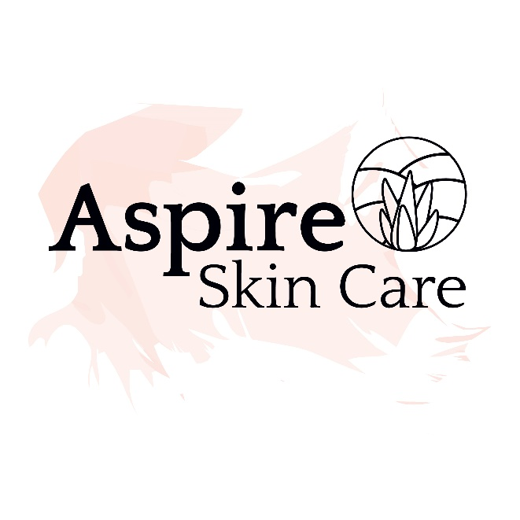
Cosmetic & Laser
587 -966-SKIN (7546)

Beauty and Health at Every Stage of Your Life
But First …
Skin Care

