Logo Design Brief

Date: 8 September 2019

Company Name: Love Is Love

Positioning: Young, fun & personable celebrant choice

Background: I am an Authorised Celebrant. I want to be known for my upbeat, fun & carefree wedding ceremonies. I am professional and I am well presented and I would like my logo to convey that image.

Company Values:
I aim to treat others the way I would like to be treated. Love is non gender discriminative. You should be able to choose who you love and want to share the rest of your life with.

Target market:
Couples who want to have a fun, relaxed style wedding ceremony.

Brand
I would like to encapsulate the values in our brand as well as evoking feelings of:

- Fun
- Memorable
- Classy
- Contemporary
- Straight forward

I want to provide a ceremony that caters to each couple’s unique personality and ceremony ‘vision’.

Colour Palette:
Pink Salmon, royal green, gold or rose gold

Design:
I would like to see options of logos with a Loveheart somewhere.
Another option with two love hearts interlocked together side by side.

Requirements:
- I would like to develop a logo that I can use on my business cards, website, social media, letterhead.
- I would like to get a shirt designed – Love is Love
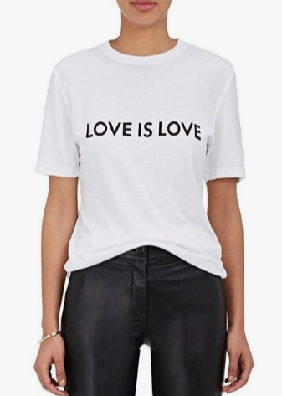

- I will also require something that can be scaled up and wrapped on my company car (2 years time)

