You can visit our website for reference: www.k9acres.ca
Logo to be included on the sign
Sign 1:
K9 ACRES (logo) – PET RESORT
ALL BREED FRIENDLY
Boarding – Daycare – Training
Full-Service Salon – Pet Taxi & More
905-251-5658
www.k9acres.ca
our business cards for reference
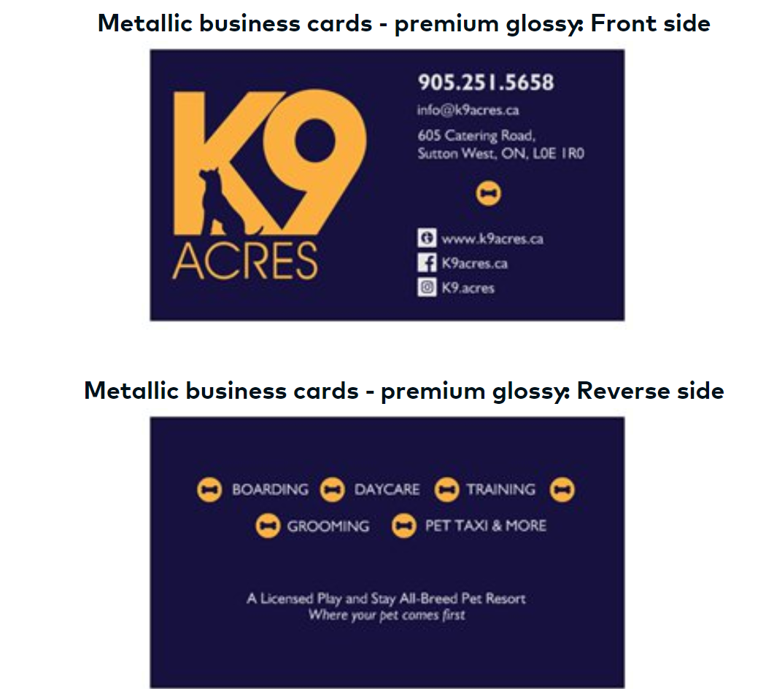

Sign 2:
K9 ACRES (logo)
East Gwillimbury Campus
Home to the Social Club
437-244-3321
www.k9acres.ca
