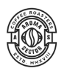
We really like a badge shape like this

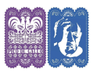
Certainly not the images in this paper picado, but paper picado as inspiration as well to include somewhere like where the A and S are on the badge above.

For inspiration, see some of the logos from other clubs that we have liked:

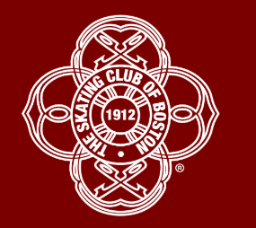

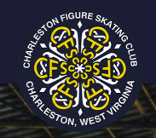

More on next page
