Royale Mobility:
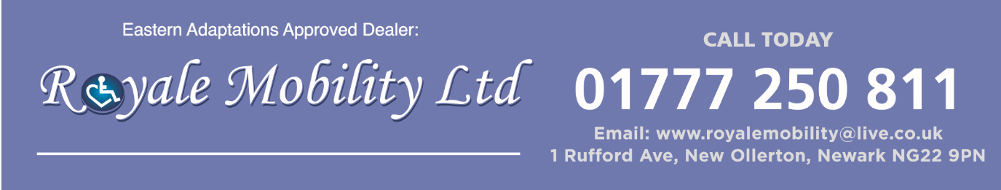
Prime Comfort:
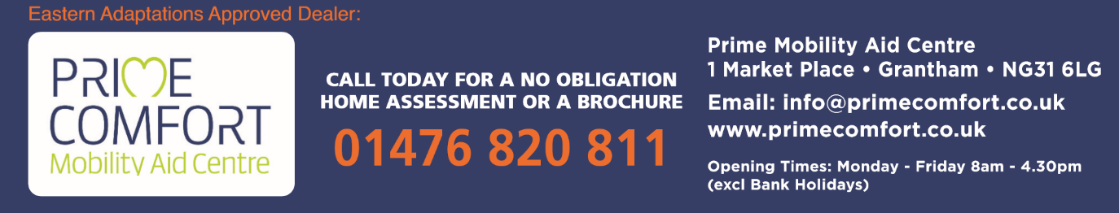
Mobility Superstore:
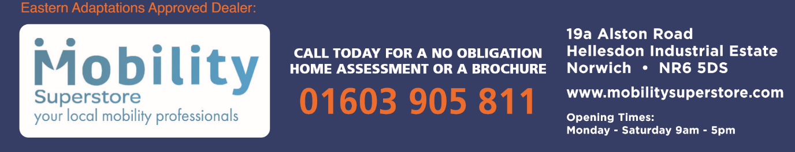
Mobility Centre Midlands:
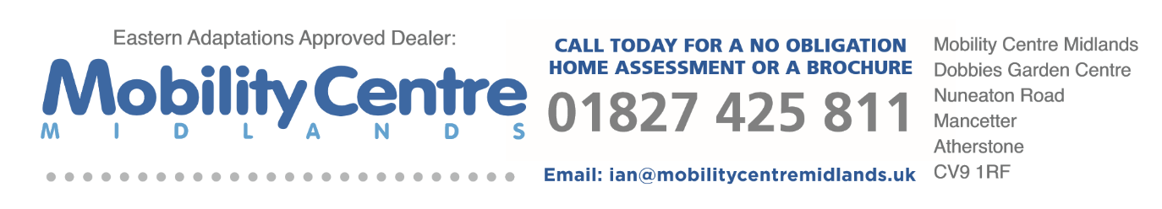
Lifestyle & Mobility:
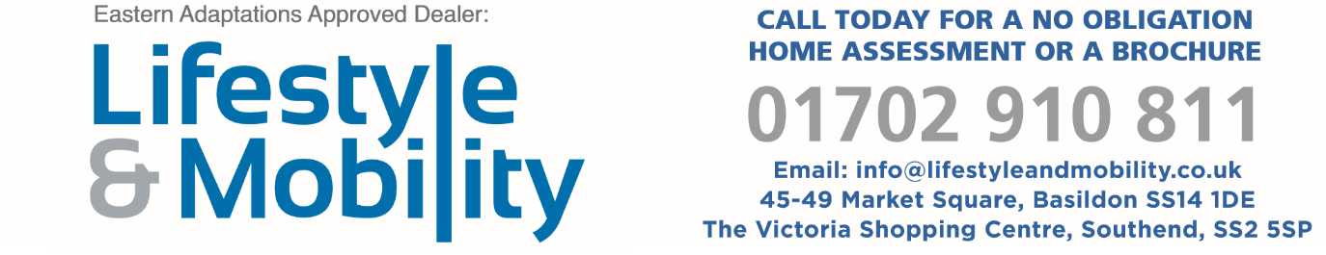

Felgains:
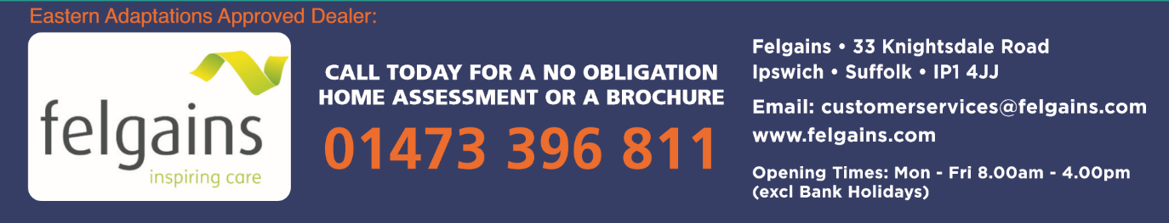
Easy Mobility Services (Maldon):
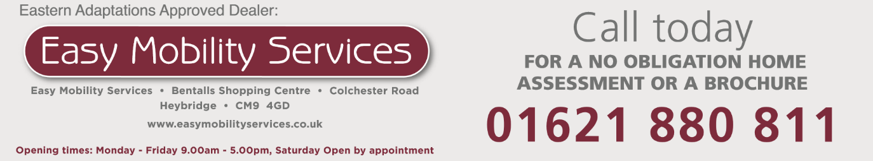
Easy Mobility Services (Clacton On Sea):
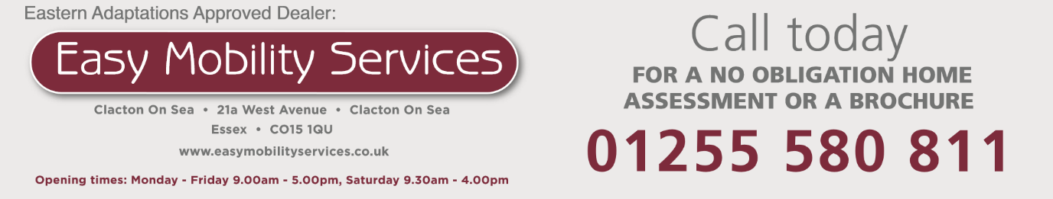
Easy Mobility Services (Colchester):
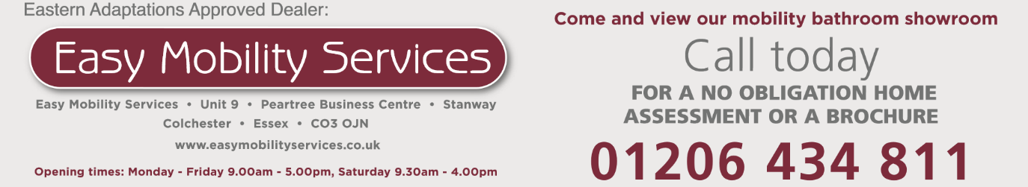
Easy Mobility Services (Braintree):
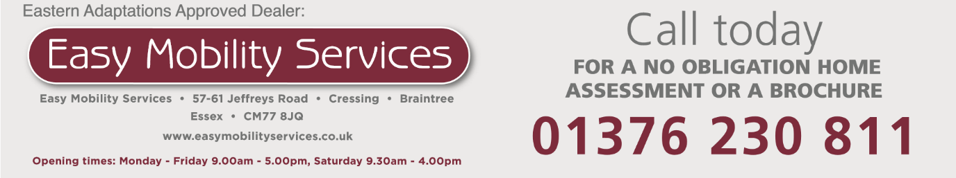

Easy Mobility Services (Chelmsford):
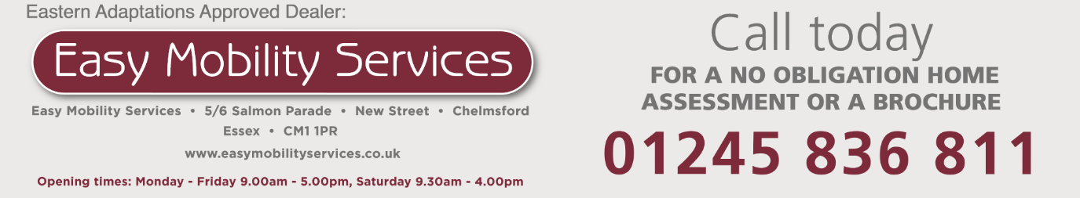
Eastern Adaptations: the following have no address, just different numbers for each advert.
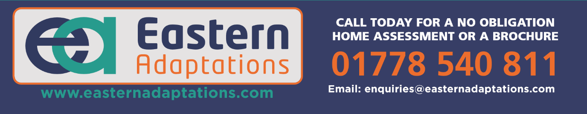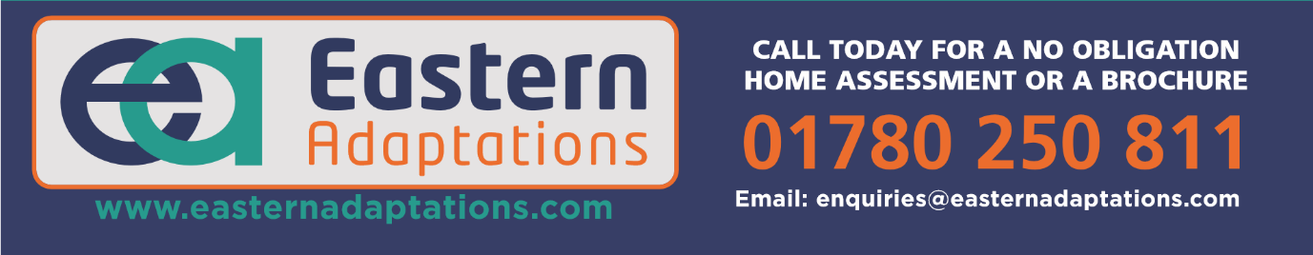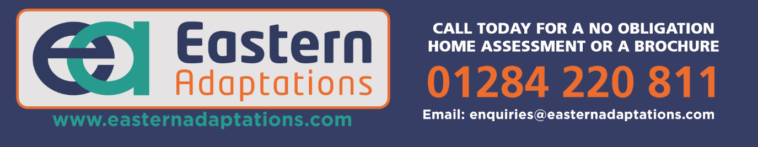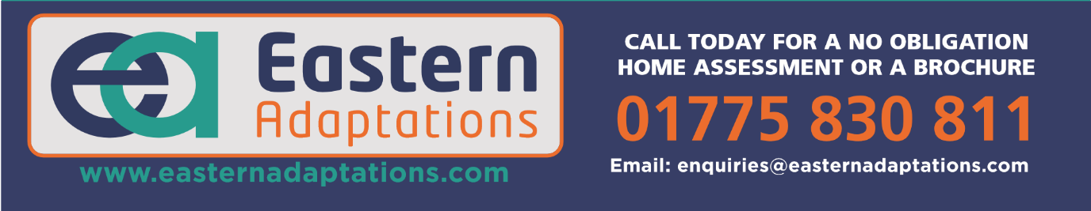

Bentley:
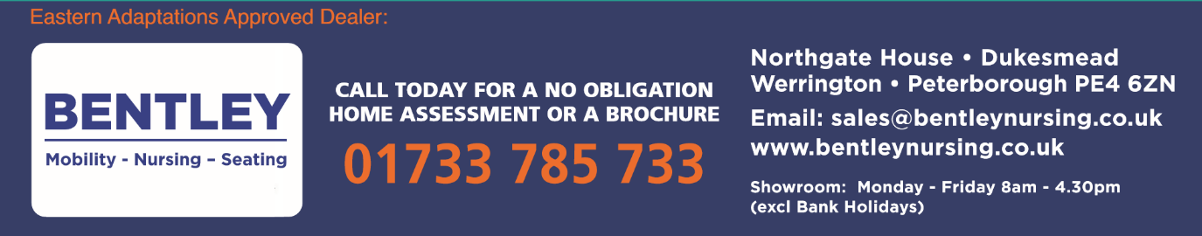
Action2Mobility:
