Page 1

Non-Destructive Seam Inspection Systems

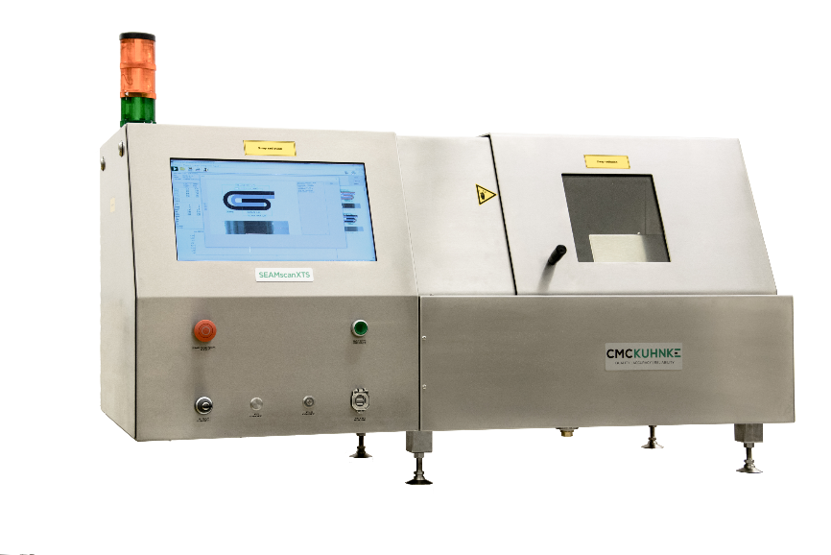
SEAMscan XTS III & AUTO XTS

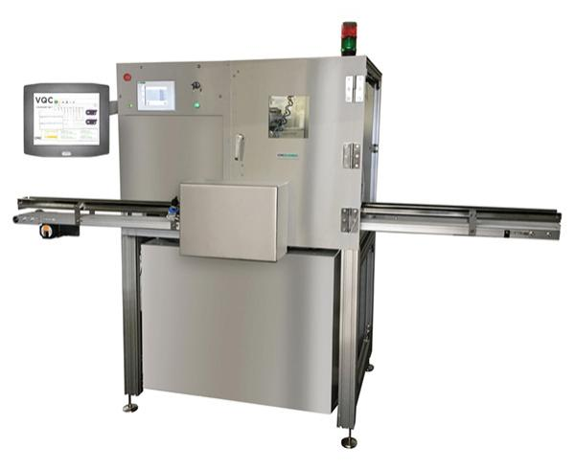

www.cmc-kuhnke.com


Page 2
Benefits of XTS technology
- Saves time - Eliminates time consuming work like emptying, rinsing, drying, cutting seams and tearing down seams for tightness inspection.
- Saves money - Saves significant amount of money by reducing test time and wasted packaging and product.
- Increased accuracy – truly operator independent, seam not destroyed. Removes all human error, Eliminate teardowns and subjectivity.
- 100% seam safety - The unique non-destructive technology gives 100% seam safety. Improve the efficiency of your quality assurance methods by using CMC-KUHNKE’s unique non-destructive technology.
- Less spoilage – The non-destructive technology enables tested cans to be used for further testing.
- Increased safety – No cutting or tearing down thanks to the non-destructive technology.
- Certification – Every single unit is TÜV-certified.
- Fully automatic version available – The AUTO-XTS saves even more labor and waste. From full, on-line automation to benchtop workstations – we have a solution to match your needs and budget.

What do we measure with XTS (X-ray Tightness Scanning) technology?
- Seam cross-section:
Identifying and measuring the external parameters of the seam via a virtual seam image.
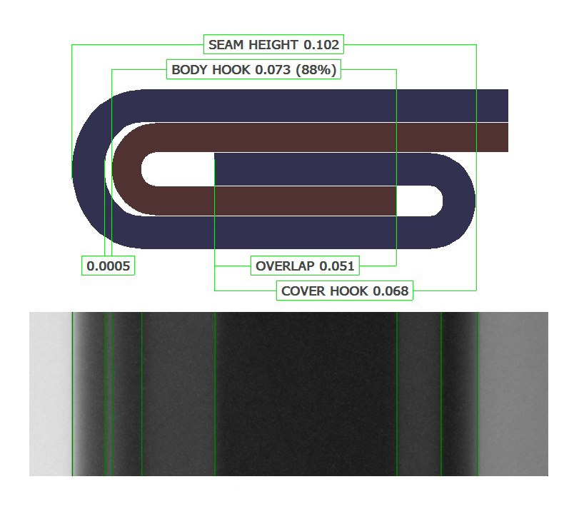
- Seam tightness:
Detecting potential tightness issues (wrinkles) in the seam, and rating the percentage of tightness.

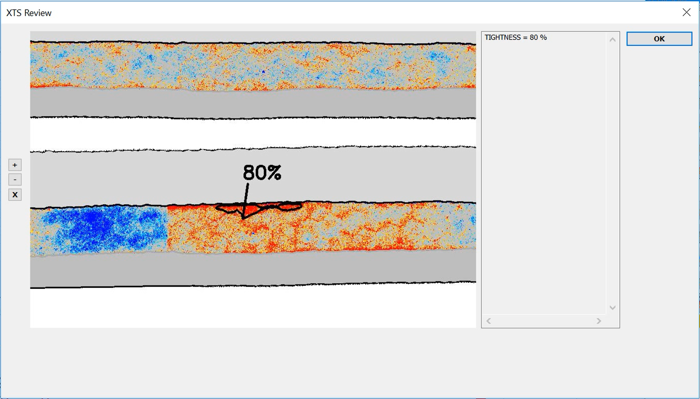
OR
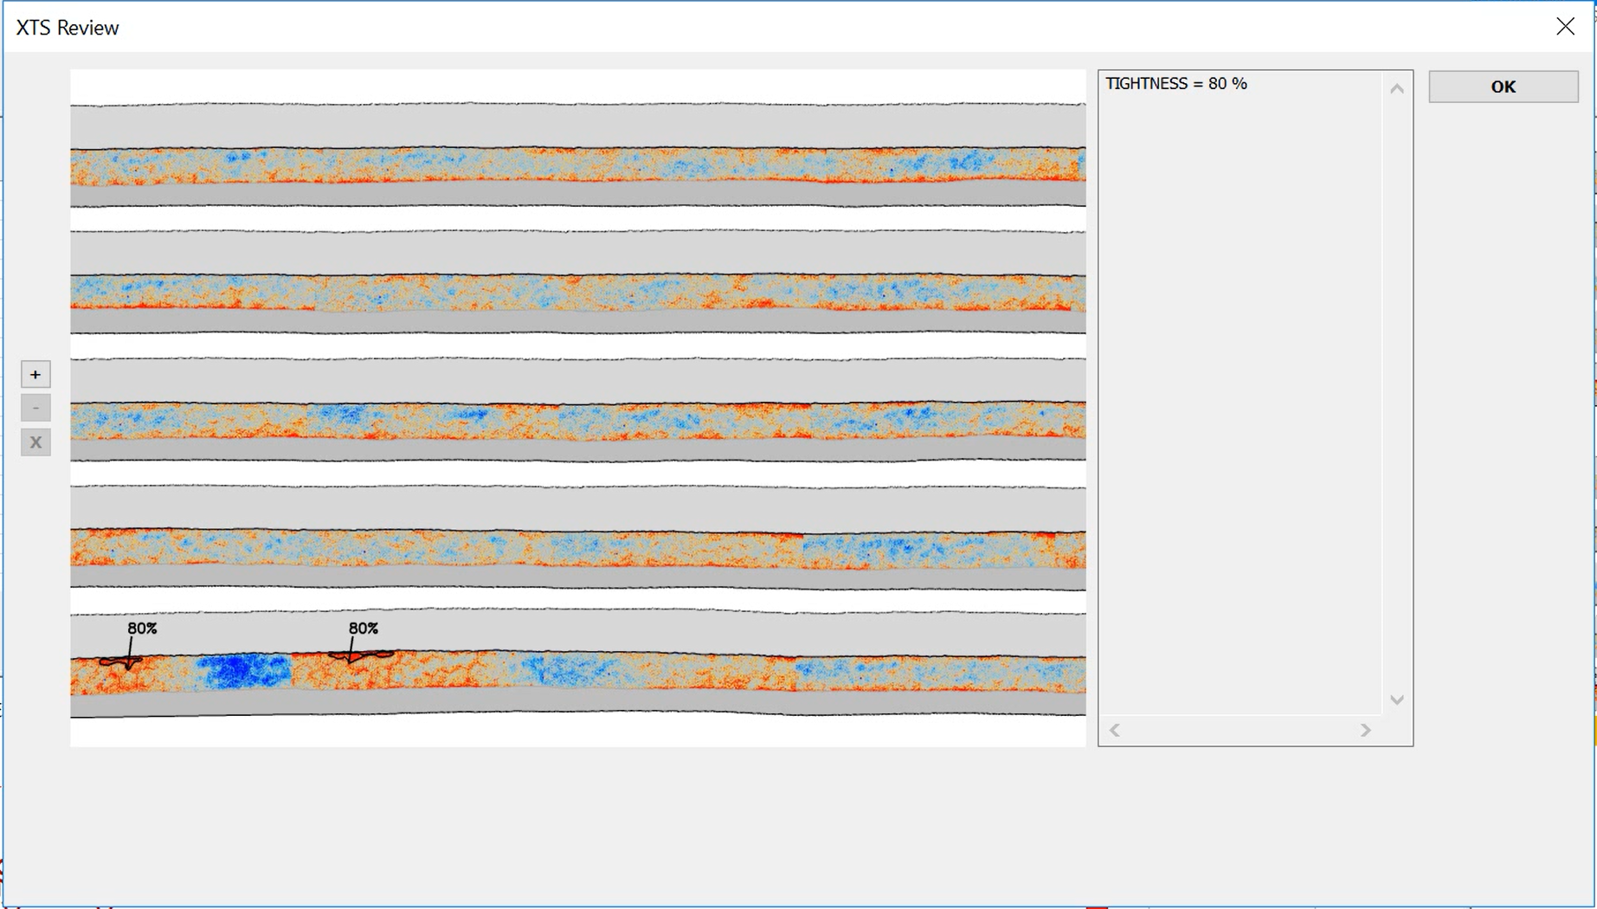

Page 3
How does X-ray seam measurement work?
- X-rays are sent through the seam sideways. A detector reads the remaining radiation.
When X-rays are travelling through several layers of material, less radiation is going through the material, meaning that some percentage will be absorbed by the material depending on density. This results in a darker region within the image, which, in turn, allows a precise measurement of the individual layers of the seam.
- For a better understanding and visualization, the virtual seam image translates the X-ray image into a classic cross-section image.

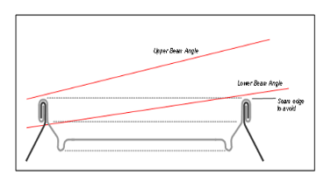
Need a better quality image

X-Ray projection (radial)

Classic cross section view (tangential)
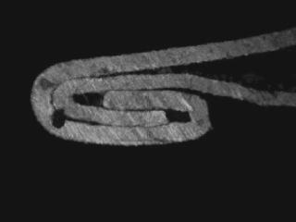
Conversion of X-Ray image to „virtual seam“

Wrinkle rating with X-ray
- Non-destructive wrinkle measurement
- 360° scan of the can seam
- Automatic detection and calculation of tightness percentage
- Number of anomalies in the cover hook are clearly visible
- Leakers will be found thanks to the 360° scan
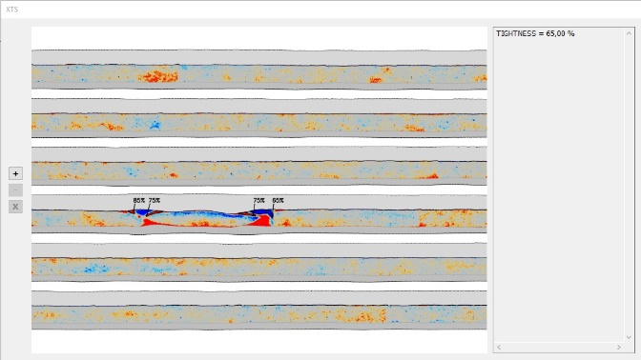

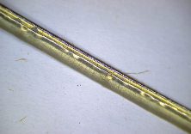
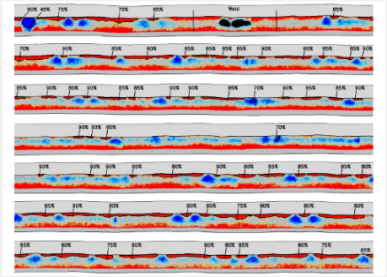

Page 4

OUR PRODUCTS:
SEAMscan XTS III
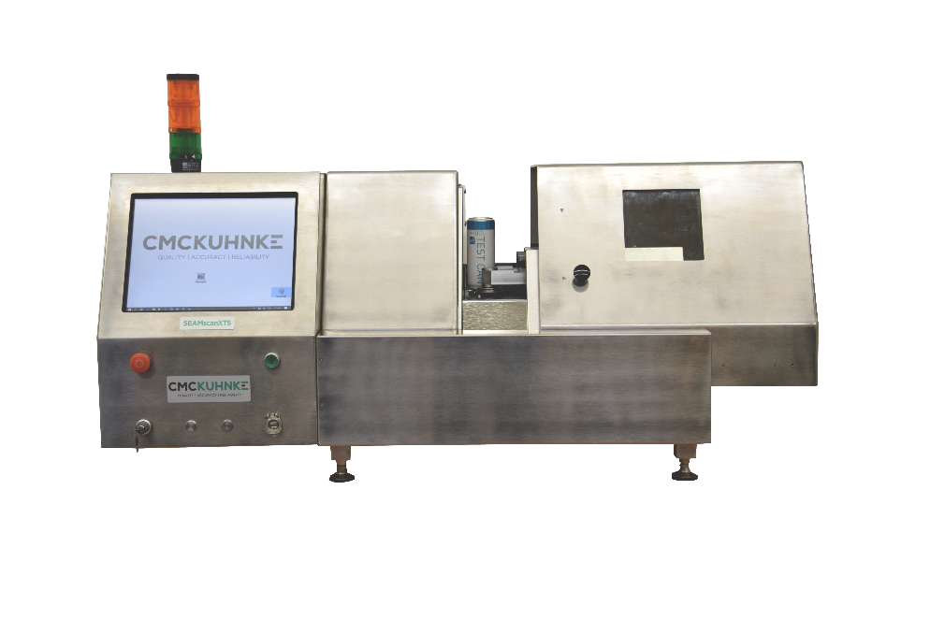
The new 3rd Generation XTS is a stand-alone measurement system that provides non-destructive, double seam inspection for aluminum or steel cans. The gauge performs both non-destructive cross-sectional measurements and a 360° tightness scan. The system provides faster inspection results, and reduced labor costs.

Cans are manually loaded into the device, then all measurements are performed automatically. Cans may be held for additional testing or be sent back into production. XTS virtual seam teardown technology provides highly accurate double seam inspection data, while dramatically reducing product spoilage.

Measures: Double Seam Inspection (Seam Height, Body Hook, Cover Hook, Overlap, Seam Gap, % Body Hook Butting) and Wrinkle Rating (% Tightness)

Features

- Automatic wrinkle identification
- Automatic dimple detection
- Automatic tab detection
- Automatic weld-seam detection
- Excellent X-Ray-shielding (each unit is tested by TÜV Rheinland and certified to < 0.1 mSv per year)
- Easy to use calibration / verification mode (with calibration piece)
- Improved handling and increased versatility, speed and precision, enabled by new generation image processing
- Fast and high accuracy dosage X-ray exposing system
- Easy to set up thanks to intuitive user interface
- Large touchscreen for controlling the gauge and the data
- Compact design with integrated PC - no external connections, only power cable required
- Intuitive wrinkle visualization
- Multi-diameter quick can clamp reliably handles a wide range of can sizes and types
- 270° access for easy access for maintenance and cleaning
- Drainage for easy cleaning
- Includes Visionary QC™ SPC Software – for details turn to page 6

Technical details

Diameter Range: | 50-153 mm (200 to 603) or 40-127 mm (109 to 502)
Characteristics Measured: | Seam Height, Body Hook, Cover Hook, Overlap, Seam Gap, % Body Hook Butting, % Wrinkle Rating (% Tightness). 360° Scan for tightness and amplitude
Max Height: | 246mm / 9.69‘‘ (911)
Measurement Units: | In, mm, %
Electrical Power Required: | 100-240VAC, 50/60 Hz
Max Measurement Positions: | Virtual SeamTM: Up to 99 positions around the can, Virtual TeardownTM (Wrinkle): 360
Operating Dimensions: | Width: 1240mm (48,6”) and with open door: 1650mm (65”)  Depth: 780mm (30,7”)  Height: 850mm (33,5”)
Resolution: | Virtual SeamTM: ±0.003mm, Virtual TeardownTM (Wrinkle): 1%, Graphical: 5%
Languages: | English, German, Chinese, French, Italian, Polish, Russian, Japanese, Hungarian, Latvian, Portuguese, Thai, Dutch, Spanish. Other languages available upon request

Page 5

OUR PRODUCTS:

AUTO XTS

The AUTO-XTS is a fully-automated, on-line or stand-alone measurement system that provides non-destructive, complete double seam inspection for beverage fillers. The fully-automated AUTO-XTS combines the internal X-ray seam measurements of the SEAMscan XTS with the Combination SEAM Gauge for external measurements into one robust unit, providing faster inspection results, and reduced labor costs.
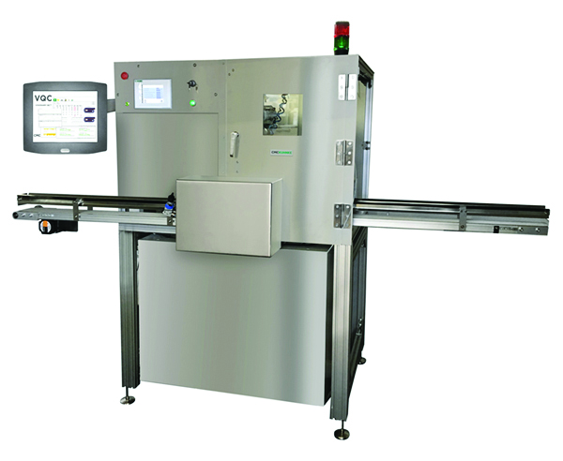
When connected directly to the production line, cans are automatically delivered to the AUTO-XTS in-feed conveyor. Cans may be held for additional testing or sent back into production. Alternatively, cans may be manually placed onto the same conveyor in order by head number. XTS virtual seam teardown technology provides highly accurate double seam inspection data, while dramatically reducing can seam inspection costs.

Measures: Double Seam Inspection (Seam Thickness, Seam Height, Body Hook, Cover Hook, Overlap, Seam Gap, % Body Hook Butting) and Wrinkle Rating (% Tightness)

Features
- A robot handling system moves a complete range of filled beverage cans through the measurement stations.
  - Station #1: The can is automatically carried to Station #1 for measurement of Countersink Depth and Seam Thickness using CMC-KUHNKE’s TSG Gauge series. Measurements are made in up to 36 locations around the can.
  - Station #2: Patented XTS technology uses safe, low-power X-ray imaging to measure internal parameters of the seam, including tightness. The content is not affected by the X-ray.
  - Station #3: Measuring the height of the can.
  - Out-Feed: Once the double seam inspection has been completed, the cans are placed in order by head number either onto a conveyor for online systems, or into a carrying basket for manually loaded systems.
- Automatic wrinkle identification and percentage calculation
- Automatic dimple detection
- Automatic tab detection
- Excellent X-Ray-shielding (TÜV Rheinland tested to < 0.1 mSv per year)
- Easy to use calibration/verification mode (with calibration piece)
- Includes Visionary QC™ SPC Software – for details turn to page 6

Technical Details
Can Specifications: | 1 seam diameter, varying heights and body diameter
Air Pressure Required: | 6-8 bar (90-116 psi), filtered dry air, max flow 35 SCFM
Electrical Required: | 100-240VAC 50-60Hz, average power consumption 600W
Resolution: | 0.01 mm (0.0004 in)
Dimensions: | 260 x 200 x 120 cm (102 x 79 x 48 in)
Weight: | 480 kg (1058 lbs)
Crated Dimensions: | 300 x 180 x 150 cm (118 x 71 x 60 in)
Crated Weight: | 600 kg (1323 lbs)
Measurement Units: | mm, in
Output Interface: | RS232
Languages: | English, Spanish, Chinese, German
Characteristics: | Seam Thickness, Countersink Depth, Seam Height, Body Hook, Cover Hook, Overlap, Seam Gap, % Tightness, % Primary Sealing Area, Wrinkle Amplitude, Can Height, 360° scan for tightness
Connectivity Required: | Connection to LAN (RJ45), 1 fixed IP Address (for external database access)

Page 6
Visionary QC™
data collection and evaluation software

- A complete quality control data acquisition solution
- Easy-to-use Statistical Process Control for quick analysis of can inspection data
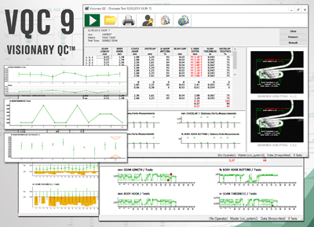
- Flexible, secure database
- Intuitive inspection reports may be shared and exported
- Track trends and statistics with SPC Graphs
- In use at hundreds of canmakers and canners around the world
- Available in 3 versions: Light – SPC – Pro

- Visionary QC™ Light:
  - Universal gauge interface
  - Fully-customizable inspections
  - Seam images (integrates with SEAMview)
  - Individual operator logins
  - Switchable language
  - Graphical view of specification limits
  - Customizable reports for single test evaluation
- Visionary QC™ SPC:
  - Basic statistical reporting
  - Track trends and statistics with SPC Graphs
  - Basic key functionality (Product Code, Can Code etc.)
  - Seam control Sheet
  - Recheck capabilities
  - Data-export
- Visionary QC™ Pro:
  - Expanded statistical reporting
  - Expanded key functionality (Product Code, Can Code etc.)
  - Automatic reporting (E-Mail)
  - Views
  - Assessment
  - Networking
  - Scheduled tasks
  - Event-triggering
  - Dashboard
  - Background data-export and import
  - Additional read-only License

Page 7
Providing Solutions/ROI Justification Example: SEAMscan XTS Case Study
The following are actual justifications made by facilities for introducing SEAMscan XTS to replace traditional destructive systems.
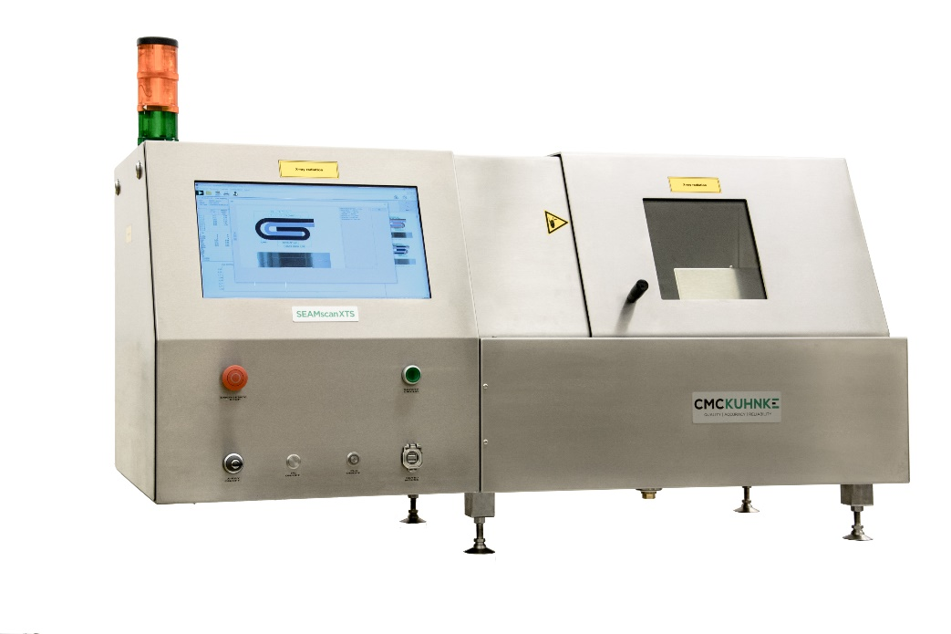
Case Study 1: Cost Savings
Based on reduction of package spoilage at a Beverage Facility after change to Non-Destructive Testing.
Cans Tested: 288 per day (Four 12-head seamers, with cross section test made every 4 hours, running 24 hours a day)
Production days: 350 days per year
Customer valuation of filled can:$1.00 per can
Total Savings: $100,000 per year
NOTE: cost savings do not include additional cans destroyed for rechecks or line setup and adjustment

Case study 2: Time Savings
Based on reduction of inspection time at Beverage Facility after change to Non-Destructive Testing.
Cans Tested: 12 cans
Inspection time to measure 12 cans (3 locations) with traditional destructive testing
= 35-50 minutes (depending on operator)
Inspection time to measure 12 cans using SEAMscan XTS
= 15-20 minutes. (operator independent)
Total reduction in Inspection Time: 65%
Additional savings are generated from superior process control and labor reallocation when utilizing fully automatic version [AUTO-XTS]

Service and Support
- Almost 50 years of experience in developing and delivering test and inspection equipment
- Factory-trained technicians available in key locations around the world
- Remote and on-site training and maintenance



Page 8
Frequently asked questions

- Why is it important we measure tightness?
  - XXX
- How do results compare to traditional cross section measurements?
  - With our X-ray method, we create a virtual seam image based on the overlapping materials in the seam captured by the x-ray. We looking through the seam at the material distribution
  - With the traditional, destructive method, the seam is cut open and we look at the seam from a 90° angle. This means looking on the seam, as opposed to through the seam
  - The non-destructive method is more accurate, as the seam is not affected by influence of force (e.g. saw blades pressure)
- Define what is considered a “good”, “acceptable, “bad” tightness rating? Show examples of good and bad cans (30%, 60%, 100% tightness?)
  - XXX
- Which kinds of wrinkles and seam anomalies exist?
  - Leaky can, false seam, ghost wrinkles, etc.
- Which cans can be measured?
  - Round cans with the combination aluminium can and aluminium end, i.e mostly beverage cans
  - Round cans with steel cans and steel ends, i.e. mostly food cans
  - Alu / steel combination for cross section only (not for wrinkle)
  - Can sizes from diameter 40 mm to 153 mm, all can heights
- What can sizes can be measured with the SEAMscan XTS?
  - All can sizes ranging from 40 mm to 153 mm diameter can be measured, and heights ranging from 12 mm to 240 mm
- How long does it take to measure one can? What is the speed?
  - Between 80 and 210 sec, depending on the diameter of the can:
    - 45 sec for 52mm end (202) -- 3 positions, cross section and wrinkle (202)
    - 80 sec per 200 diameter end ?? Use mm – for consistency
    - 210 sec per 609 diameter end
- Is it possible to integrate the device into a filling line?
  - Yes, the AUTO-XTS can be place on-line with an infeed and outfeed of a number of cans for testing
- What is the maximum weight of a can to be measured?
  - 5 kg
- Does the SEAMscan XTS need to be placed in a laboratory environment?
  - The gauge should be placed in an appropriate location, such as a laboratory
- How do you calibrate?
  - Initial calibration while set-up by CMC-KUHNKE for cross-section measurement.
  - Wrinkle calibration can be done manually or automatically by the administrator locally:
- How often to you calibrate?
  - Suggested calibration of cross-section measurement by CMC-KUHNKE technician annually, and after repairs
  - Wrinkle: After any seaming process changes (when changing the can type, end type, seamer adjustment tooling, etc.)
- How easy is it to set up a new can?
  - The supervisor, who has been trained by a CMC-KUHNKE technician, can set up a new can
  - For large changes in the geometry of the seam, CMC-KUHNKE supports, either remotely or on-site.

WWW.CMC-KUHNKE.COM
GERMANY  Tel. +49 30-2300-66-0  sales@cmc-kuhnke.de | United States  Tel. +1 518-694-3310  sales@cmc-kuhnke.com | MEXICO  Tel. +52 55 4203 6820  sales@cmc-kuhnke.com.mx | CHINA  Tel. +400-821-0694  info.china@industrialphysics.com

