IMPORTANT: The icons in this document are ONLY to illustrate ideas and concepts for the layout of the icon.
NOT the design style of the icon. The design style is included in the project description.

On average, each icon will be about One Inch Wide

Company Credentials Icons
These are to show our clients that the companies we work with have have their credentials checked

Qualification Icon

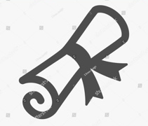

I.D



Company Registration


Insurance



Home Page Icons 1
These icons are to illustrate the difference between our staff and typical agents and concierges

- 1. Travel Agent
This needs to be a fairly simple icon (similar to below) Blue
You can use more than one shade of blue to give depth

- 2. Hotel Concierge
The same style as above, but with a desk in front of the person. Green
You can use more than one shade of Green to give depth

- 3. Travel Concierge
The same style as above. This icon needs to be much more fun, colorful & superior to the other 2 icons Blue & Green
(Maybe with sun glasses, palm trees, hammock or something to indicate ‘Local’ or ‘cool’)

Home Page Icons 2
These are icons to illustrate what we do and how it helps

- Accurate Travel Information
This is to illustrate accurate information about travelling. Good use of map, pin, target or magnifying glass.
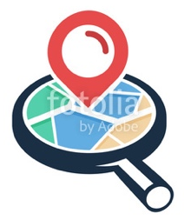
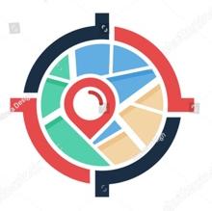
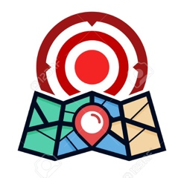

- Simplifying Booking Process
Illustration to indicate a simplified process

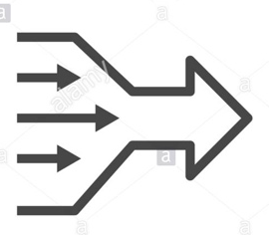

- Heaps of Training

This is to indicate that our team has lots of training. The way we train is by sending our agents travelling to experience all the tours. So a backpacking icon might work here.

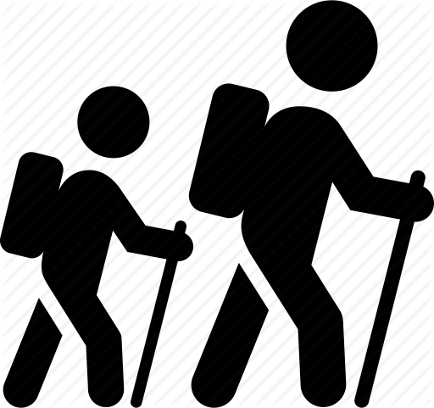

- Best Tour Operators

Icon that illustrate the best, like a medal or a ribbon. Maybe put something tour related in middle.



- Avoid Travel Issues



Tour Partner Page Icons
These illustrations are to show tour operators the benefits of signing up with us

Free Sign Up
Simple dollar in within a ‘no entry’ circle

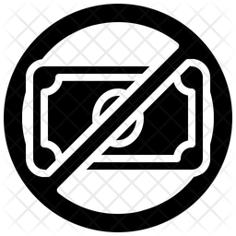

Reach a Wider Market
This is to illustrate widening your market range (Marketing). In this icon, I like how one point has curves reaching out to multiple other points. A simplified version of the world map should be used.



Increase Your Sales



Fill Empty Slots



Protect From No-Shows
This is to illustrate protection from clients that do not show up for their Tour



Promote Your Brand

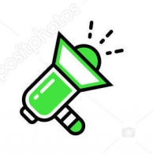

Agents Who Know
This is to illustrate that our Agents have superior experience and knowledge (by experiencing the tours themselves)



Professional Photos



Active Cross Selling
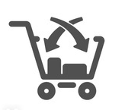

Free Booking Management
Icon to illustrate booking software management
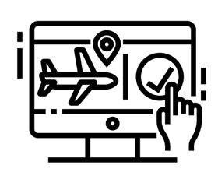

Company Sign Up Icons
This is to illustrate the sign up process for new tour operators

Edit Your Profile



Set Up Payment Method

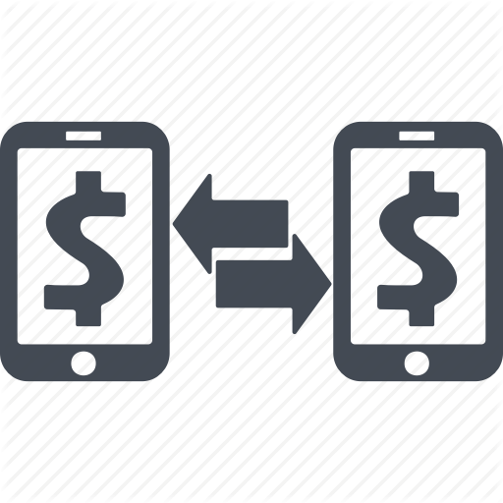

Take Bookings
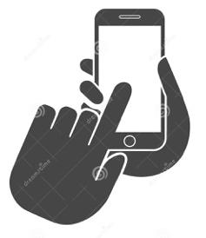

Wow Your Guests



Get Paid
