Purist Foods Logo
The mission of Purist Foods is to create healthy plant based snacks (for example a ready to eat flax seed snack) that taste great and have the highest quality organic ingredients. In a crowded marketplace of snacking options, we want to offer a great choice for healthy diet and snacking that appeals broadly to both health conscious and mainstream consumers of all ages
Key Attributes:
- Impressionable in the consumer’s mind
- Pale orange, green and blue colors preferred
- Evoke a feeling of clean and healthy on the go snacking
- Only include the word “Purist”
- Not tied to a product (flax) but more so to the brand name
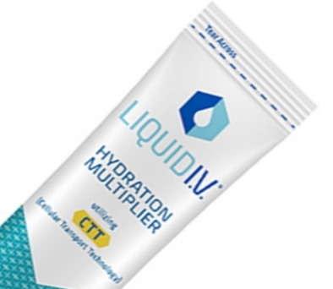
Inspiring examples:

