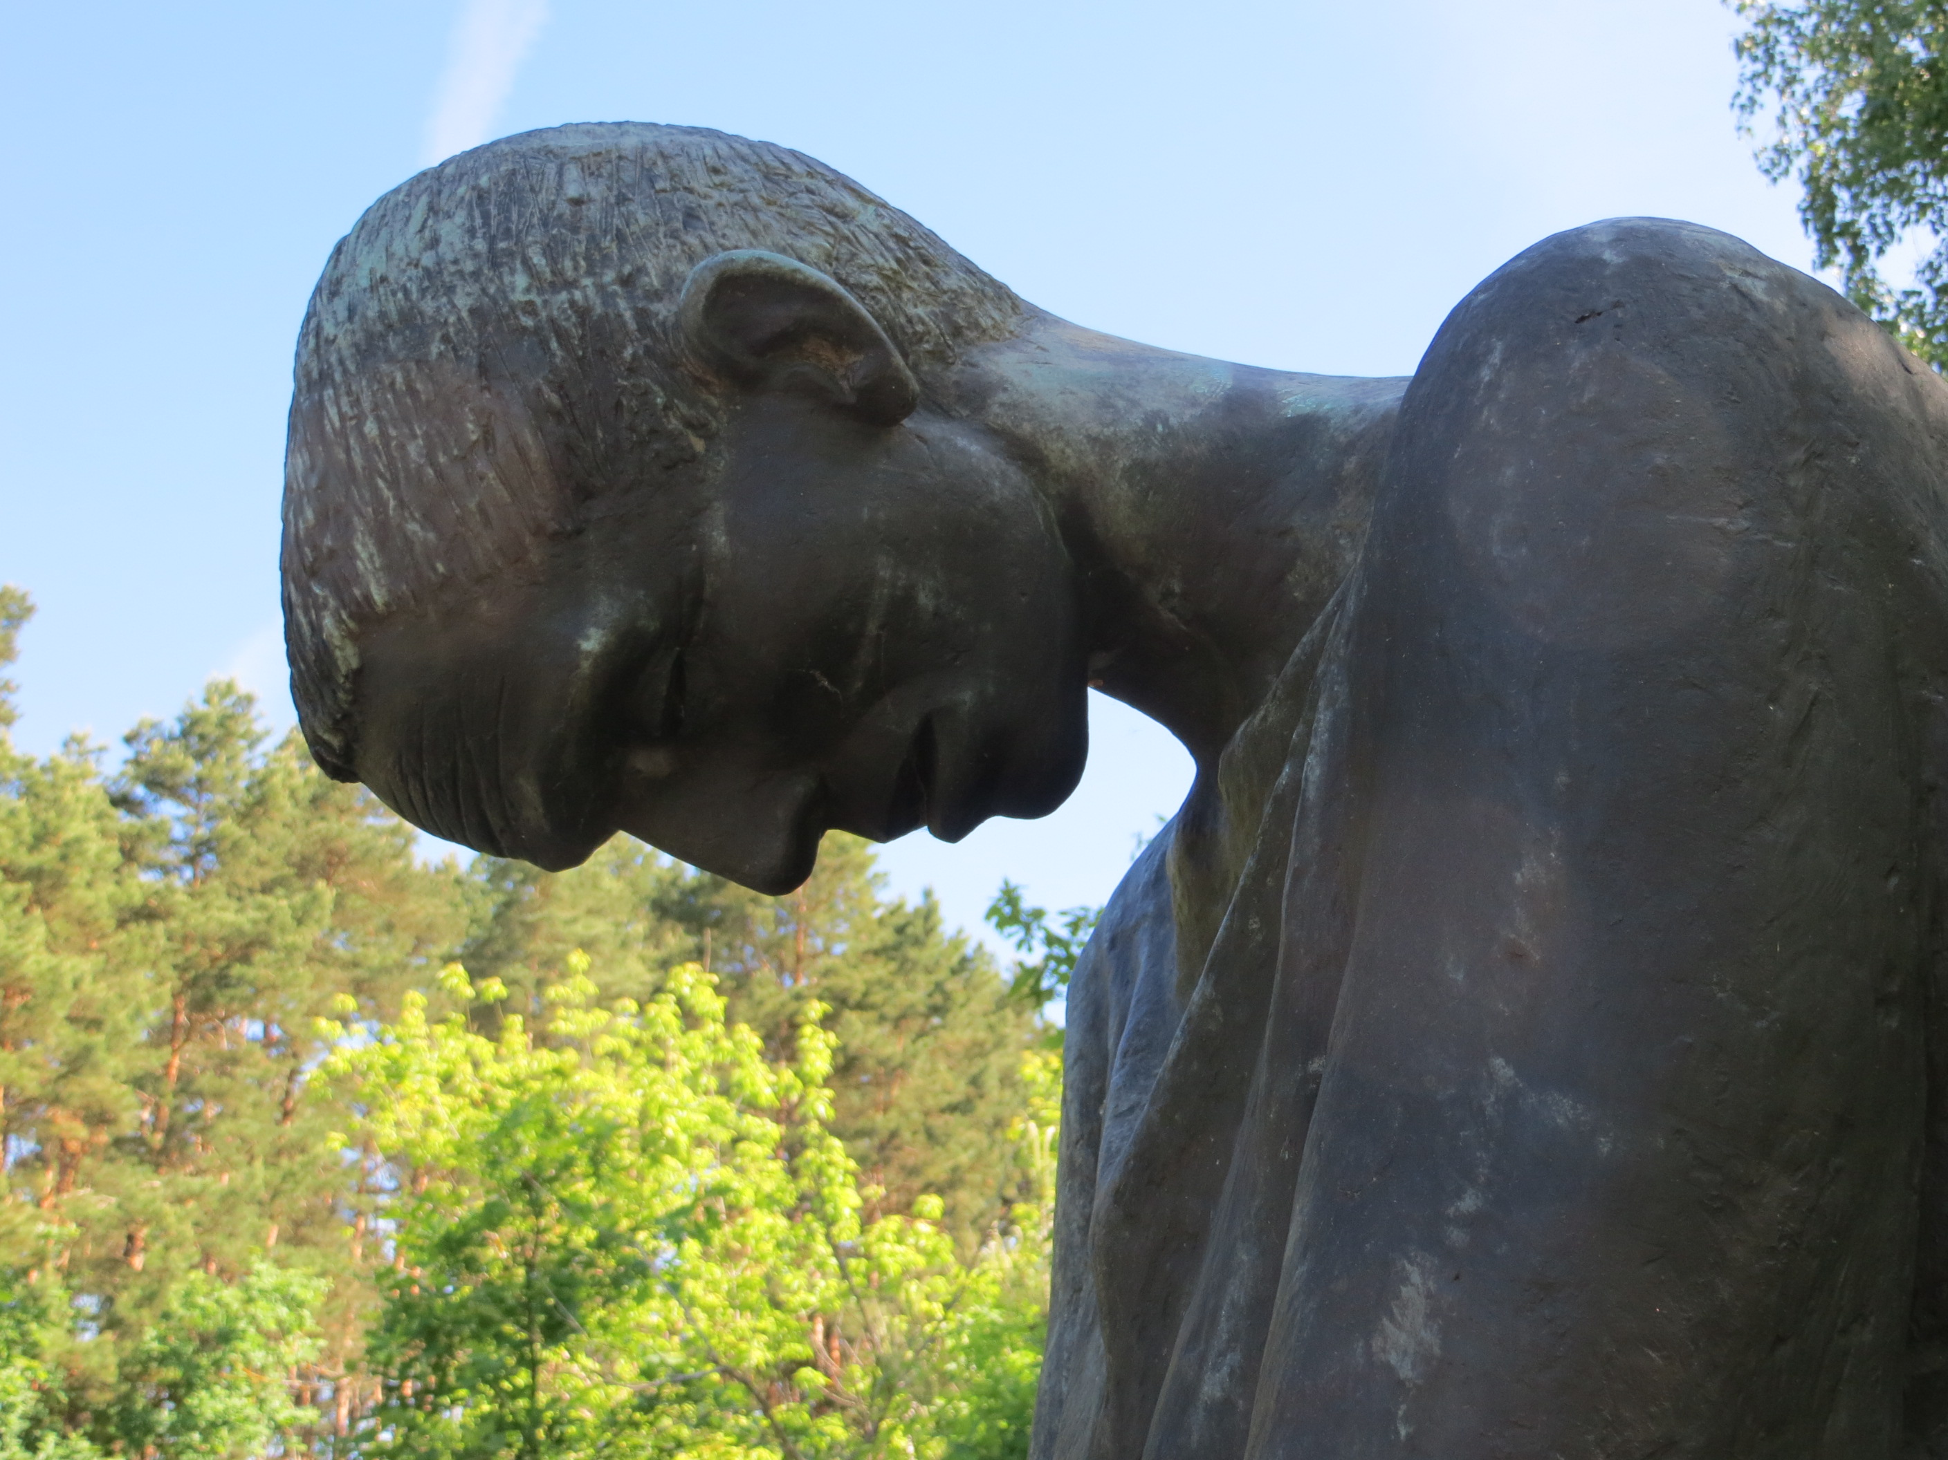
Holocaust Learning and Education Fund, Inc.
The Craig and Barbara Weiner Holocaust
Reflection and Resource Center

