ELASTRONICS

PUBLIC SUMMARY
“ELASTRONICS -enabling the future of wearable electronics project develops stretchable/elastic electronics technologies and builds out manufacturing capacity, supply chain and infrastructure into Finland. Elastic electronics enables novel form factors for novel applications opening new global business opportunities. ELASTRONICS will focus on cost-effective stretchable and ultra-thin Hybrid Printed Electronics to overcome the challenges of current bulky and uncomfortable wearable electronics. The project will focus on two significant areas of wearable electronics: 1) Body worn plasters (skin patchable devices, ultra-thin and conformable) and 2) Smart textile (integration of various sensors and electronics on textile).
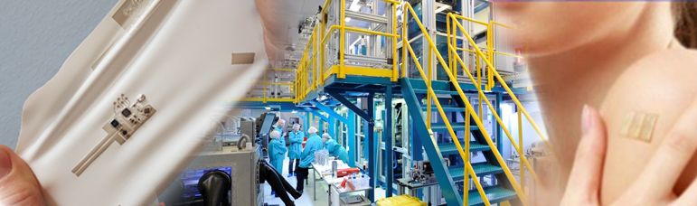

Further information:
Current wearable electronics are based on rigid (or in special cases) flexible circuit boards. The circuit board defines the size, shape and form factor of the unit, leading typically to bulky and clumsy wearable systems. The stretchable solutions developed in this project will provide an unobtrusive way to co-integrate electronics onto reusable textile clothing, or the fabrication of disposable patches, like plasters, for medical, sport, and work sectors. This will critically enable the creation of new products and the creation of the related business ecosystem in Finland.
ELASTRONICS will enable the transformation of envisioned stretchable devices into a mass-producible reality. The key technology developments include the component integration (ICs, LEDs, passives) into printed stretchable conductor patterns so that all-critical durability are achieved. Printed stretchable sensors together with ultra-compact and thinned silicon components will play a key role in this development.
ELASTRONICS will provide
- Stretchable electronics technologies suitable for mass manufacturing
- Comprehensive understanding of failure mechanics, testing methods, and practical ways to improve the reliability
- Design and manufacturing guidelines
- Manufacturing value chain for stretchable/soft electronics including assembly of thin circuits.
The ELASTRONICS consortium, including partners covering the full vertical value chain, is at the precipice of launching such an enabling leap: the possibility for unobtrusive, anytime-anywhere patient monitoring will transform the healthcare sector radically into a more effective and efficient direction. Similarly, the envisioned intriguing products with more facile form factors for comfortable wearability in sports, whether professional or amateur enthusiast, or well-being sector for personal fitness, will be enabled via the novel hardware solutions that comply with the harsh wear-comfort and durability requirements.
The consortium includes the companies Inkron, Screentec, Flexbright, Forciot, Suunto, Nexstim and GE Healthcare.

The ELASTRONICS Consortium Structure
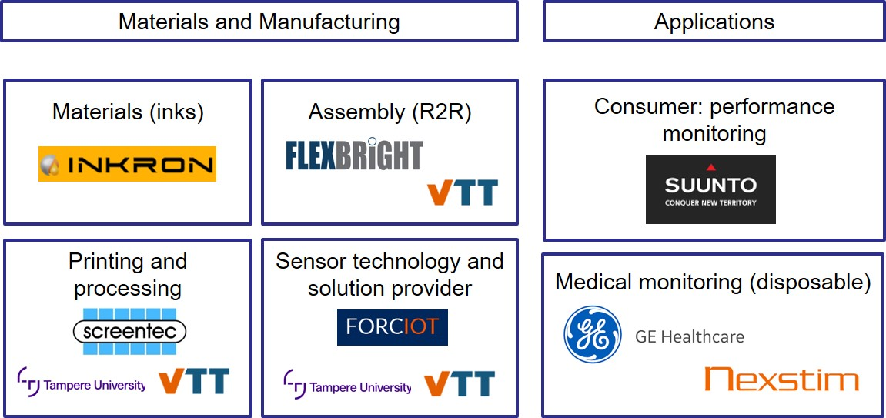

VTT logo


Tampere University logo


Business Finland logo


Project activities

Temperature Logger
Flexible, stretchable and washable temperature tag based on hybrid assembled ultra-thin Flex-NFC chip and bare die LEDs on soft substrate. Tag is activated via NFC and is capable for temperature monitoring.
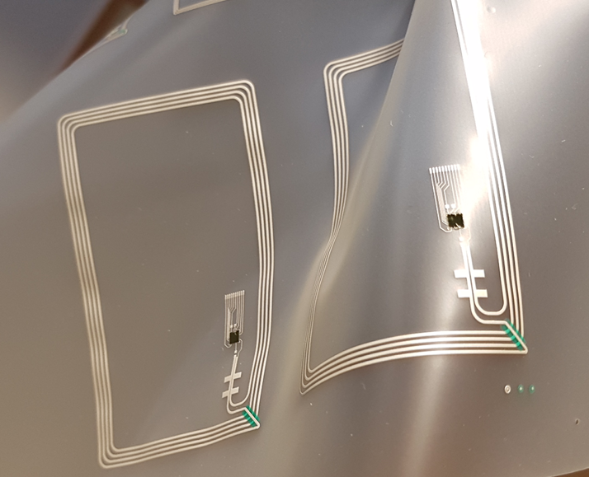

Wireless Sensor Patch
Flexible, stretchable or compact sensor platforms with e.g. accelerometer, temperature ambient pressure and humidity sensors. Bluetooth LE communication, possibility for wireless charging or flexible batteries.
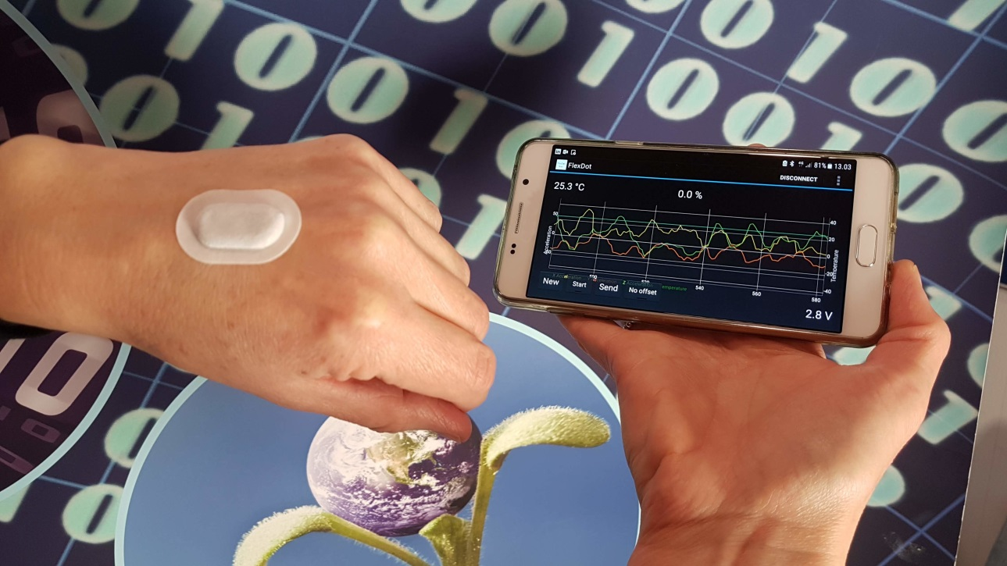

Stretchable skin-integrated patches