…healthy and well lives undiminished by service related health concerns…

wwww.wchf.us

OUR STORY

Make good on America’s promise…”To care for those who shall have borne the battle." (adapted from Abraham Lincoln)

PURPOSE

WCHF envisions a world in which ALL veterans and their families live healthy and well lives undiminished by their service related health concerns.

VISION

- Amplify the veteran community voice in their battle for health and wellness
- Facilitate the advocation of equitable healthcare for veterans and their families
- Develop, gather and disseminate information and education regarding veterans’ health, healthcare and wellness to veterans, their families and the communities in which they live
- Develop, implement and evaluate education and training designed for healthcare professionals that facilitates and enhances their understanding of the unique health and wellness needs of veterans and their families
- Continuously refine the Veteran Medical Neighborhood Consortium™ model to safeguard the mission.

STRATEGY

Join forces with the Warrior Centric Healthcare Foundation and be a CHAMPION to our Heroes and their Families

Having committed their lives to our country, Veterans leave military service with a host of potentially debilitating health conditions—not just PTSD and traumatic brain injury, but autoimmune disorders, hearing loss, lung disorders, chemical exposure related heart problems, musculoskeletal injuries, and a host of other potential problems many that remain unknown for years after discharge or retirement.
Then they enter the veterans’ and/or civilian healthcare system largely unprepared to diagnose, treat and manage their service-related health issues.

Warrior Centric Healthcare Foundation (WCHF) is a non-profit 501c3 charitable entity established in 2013 by military veterans with expertise in healthcare, for the express purpose of addressing systemic inequities regarding access to and quality of care for veterans and their families.
​


Children in military families insured by Tricare are more likely to have special health care needs, and more likely to have a behavioral health diagnosis compared to their civilian peers, according to a new study.

Quality Care for Children of Veterans
Military children have more healthcare needs, but less access and lower quality

Healthcare Education

and Training
Contributing to our healthcare education and training initiatives will directly impact healthcare providers, allied healthcare professionals and veterans themselves.
The WCH Foundation has partnered with Advancing Knowledge in Healthcare (AKH, Inc), BlueSky eLearning, and Warrior Centric Health to provide veteran centric and cultural competency training to enhance their knowledge and understanding of veteran culture and its impact on healthcare delivery and health outcomes of veterans and their families.

Community Health and Wellness Engagement Events
Contributing to community engagement facilitate the sponsorship of projects and events to cultivate awareness and understanding of the unique healthcare needs of veteran and their families.
The WCH Foundation strives to empower veterans and communities to become part of the solution and work to educate others in their communities. Your donation would fund free healthcare screenings, flu shots, medical appointments or a speaker(s) for a community health and wellness forum.

Health and Wellness
Education Forums
Contributing to healthcare awareness and education forums and events that facilitate the evolution of people in the community and their leaders from supporters to savvy advocates for the healthcare needs of veterans and their families. Civilian healthcare facilities, when asked, are not aware that veterans are being served in their clinics, hospitals and medical centers.
Your donation will help break through this misconception and others regarding the health and healthcare needs of veterans and their families raising the bar for both the community and healthcare facilities.

Warrior Centric Healthcare Foundation (WCHF)

and the Veteran Medical Neighborhood Consortium (VMNC)

​
The Warrior Centric Healthcare Foundation (WCHF) serves as the “veteran facing” primary hub of coordination for healthcare delivery. This is achieved via two pathways, 1) clinical - through WCH authorized clinics / hospitals and recognized providers, allied healthcare professionals and social support personnel and 2) non-clinical - WCHF VMNC members / partners (i.e. community centers and their leaders, clergy, faith-based organizations, employers, public health agencies, veteran centric businesses, etc.).

With the integration of WCHF as an essential core element within the medical neighborhood, the health needs of the individual (veteran), aspects of the population (their families) and overall community (where they live, work, play, and pray), the potential and opportunity for improved health and healthcare delivery (success), prompt and practical assessment and management of social determinants will increase significantly.
The “veteran medical neighborhood consortium” is a framework for structured bidirectional and cross functional relationships and partnerships (clinical and non-clinical) that integrate health / wellness, social determinants / support and medical partnerships critical to enhancing health, wellness and healthcare outcomes. The bidirectional / cross functional flow of information across and between all clinical providers and patients (i.e., primary and specialty care, physician extenders, hospitals/clinics, home health, long term care, behavioral health, etc.) provide the framework. Non-clinical partners (i.e., community centers, faith-based organizations, employers, public health agencies, food banks, schools, etc.) provide the additional components. When combined, these partnerships actively promote health, wellness and healthcare coordination.
​
Most of the barriers preventing veterans with complex needs from achieving better health engagement and health outcomes encompass social, mental/behavioral health, and economic factors. While providers can assess and identify these needs, the link between the veteran and the necessary resources often falls short underscoring the critical need for a resource network that includes communication between the veteran, the clinic/provider, and community organizations and businesses.
​
As the WCHF embeds itself more firmly in the VMNC and the health environment at large, veterans, their families and their advocates will become more savvy regarding their health, healthcare, and healthcare services and delivery. They expect high-quality, high-value, culturally appropriate and timely care. When this is not the case, they may become confused and/or frustrated which often leads a decrease in follow through with medications, recommendations, etc. and gaps in care ensue. It’s a similar experience noted across almost any industry providing services to consumers: the services are catered to the individual’s needs and available when the consumer needs/wants them. If not, the consumer finds a new service provider.
The Agency for Healthcare Research and Quality (AHRQ) articulates that a successful medical neighborhood will “focus on meeting the needs of the individual patient, but also incorporate aspects of population health and overall community health needs." The Warrior Centric Healthcare Foundation expands this definition to include services and businesses that also address social determinants and contributors.
​
The bi-directional and cross functionality of the model is what ensures the high, mid, and more direct levels of function of the veteran medical neighborhood consortium members. In essence, the veteran medical neighborhood consortium is a combination of the typical medical and geographic neighborhood integrated with collaborating partners and relationships where all participants (service members, veterans, their families, the community and its leaders, providers, allied healthcare professionals, pharmacy, labs, business owners, authorized WCH clinics and/or hospitals, etc.) must be educated to understand how to participate such that their participation optimizes their experience.

Our Mission
For those reasons the Warrior Centric Healthcare Foundation was established.
Now more than ever and for many reasons, Americans are less connected to their military community. And, veterans who come home feel and internalize that disconnect… some even say they feel anonymous. Because of this, America is failing to deliver on its promise…”To care for those who shall have borne the battle."
​
Warrior Centric Healthcare Foundation is committed to help and to give back to the men, women and families who serve our nation – whether in uniform or not, at home or abroad, and in times of turmoil or peace.
Making good America’s promise…your promise… to ensure they get the quality healthcare is a way to operationalize “Thank You for Your Service”.

Our Vision
WCHF envisions a world in which ALL veterans and their families live healthy and well lives undiminished by their service related health concerns.
WCHF approaches its vision with passion and purpose to ensure we:
- Amplify the veteran community voice in the battle for health and wellness
- Advocate for equitable healthcare for veterans and their families
- Gather and disseminate knowledge regarding veterans’ health, healthcare and wellness to veterans, their families and the communities in which they live
- Develop and disseminate free education and training to healthcare professionals that address the health and wellness of veterans’ and their families
- Continuously refine the Veteran Medical Neighborhood Consortium™ model to safeguard the mission.

ABOUT

Warrior Centric Healthcare Foundation (WCHF) is a non-profit 501c3 charitable entity
established in 2013 by military veterans with expertise in healthcare, for the express purpose of addressing systemic inequities regarding access to and quality of care for veterans and their families.

Having committed their lives to our country, Veterans leave military service with a host of potentially debilitating health conditions—not just PTSD and traumatic brain injury, but autoimmune disorders, hearing loss, lung disorders, chemical exposure related heart problems, musculoskeletal injuries, and a host of other potential problems many that remain unknown for years after discharge or retirement.

Then they enter the veterans’ and/or civilian healthcare system where many of the providers, allied healthcare professionals and support services personnel are largely unprepared to diagnose, treat and manage their service-related health issues.
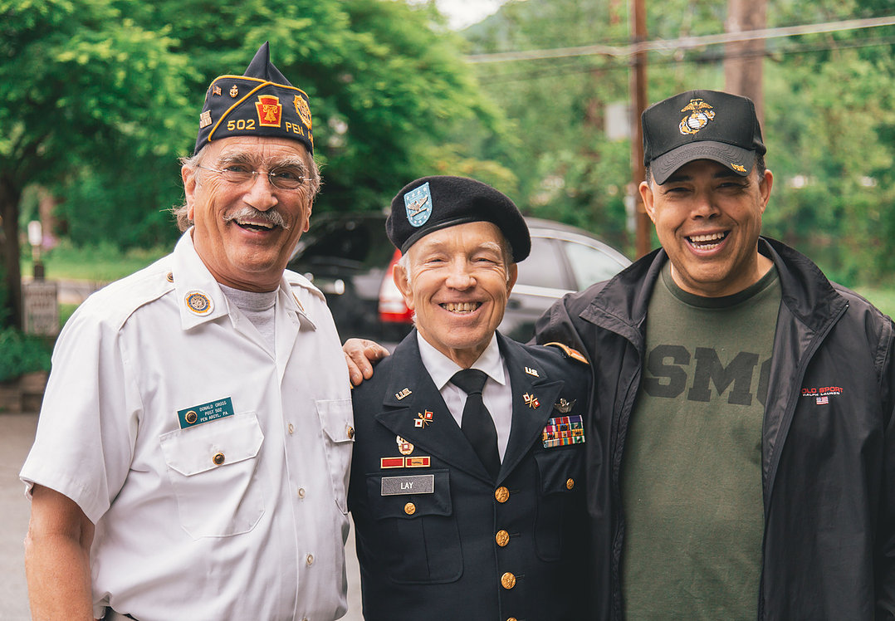
The numbers of veterans and their families in in need of help are substantial:
19 million discharged Americans warriors
are either currently suffering multiple chronic conditions
brought on by the conditions of their military service or are at risk.
54 million family members are also affected.
75 million total number of those needing some form of specialized care.
These 75 million Americans represent about 25%
of the entire U.S. population in need of some form of specialized or unique care.

