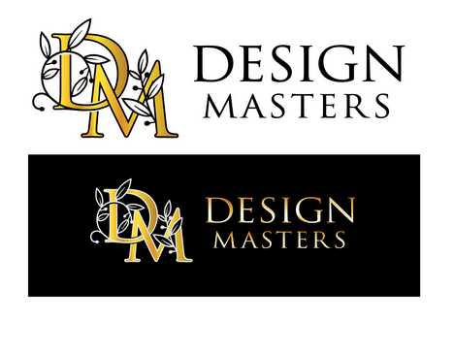
Option 1. Move S all the way to the right, under the N. Replace DM with lion and make decorative D and decorative M as the first letter in the words.

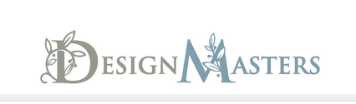
Option 2. Put lion above Design Masters with decorative D and M incorporated like this.

My lion to use….

