

Infographics Project
Project is for:
- two infographics – per below
- I’d want the completed infographics but to also have each of the single components I can use individually so I can use on slides/in proposals to identify the components using them
- I will provide RBG #s for the colors – my logo has 3 main colors and, for my new website, we’re adding in a couple of accent colors, one of which is a turquoise.

Infographic #1 - Organizational Training & Resources

Below is the mockup I created with the 6 core components of the Patient Adherence Training Program (the program for training healthcare and pharma organizations). I am not at all married to this in any way. I do like the idea of an icon in the center that shows it is for healthcare professionals – it visually differentiates it from the second program which is for patients.



Single Components Making Up Icon #1 – Titles & Notes

Live Training Intensives


Notes: Would prefer non-gender or female. Also, this component is core to the program so should appear prominently in the infographic.

Coaching Skills Development Webinars


Customized Coaching Guide

Notes: I have a mocked up Coaching Guide cover – see below – but most likely we want to keep icons in the same style?


Video Training Library

Notes: Would prefer something that indicates more than one video – there is a series of at least 5 videos included

Side Effect Management Plan


Confidential Patient Call Review



Infographic #2 - Patient Support Resources

Below is the mockup I created with the 6 core components of the Patient Support Resources – the menu of six kinds of support services I provide that can be delivered directly to the patient. I am not at all married to this in any way.



Single Components Making Up Icon #2

Texting & Email Support



Peer Mentor Support

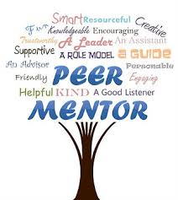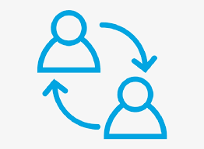
Notes: I don’t think these are particularly strong

Online Group Coaching Program
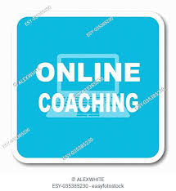
Notes: Not particularly strong.

Side Effect Management Plan
Notes: I’d like to use the same icon for both organization and patient as it will be the same plan.

Caregiver Support

Notes: I don’t think this is particularly strong

Stress Reduction Strategies

Notes: if that title is too long, just go with Stress Reduction
Maybe something like this in a vector? Don’t really thing the one I used says stress reduction
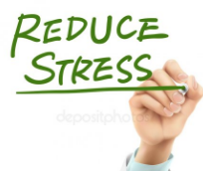

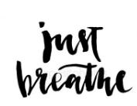

Tambre Leighn
Well Beyond Ordinary, Inc.
tambre99@gmail.com

