William and Elsie George
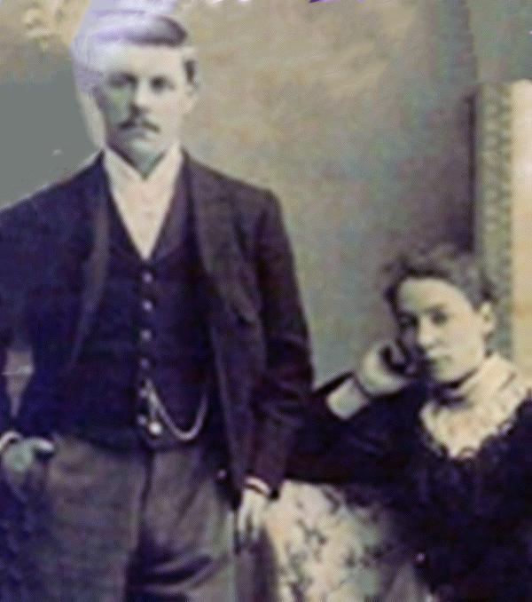

The founders of Elsa were wealthy landowners from Scotland. William and Elsie George moved to San Antonio, Texas and were introduced to land in the Valley when they purchased half of the land in what is now known as the Delta Area.
Much of this land was part of the Llano Grande land grant issued to Juan Jose Ynojosa de Balli.
Early on ranchers had settled the area before 1800. These ranchers introduced cattle and sheep ranching and various crops to the area. In the early 1900s land speculators including the Georges, began to buy up the land that was to become the Delta Area of the Lower Rio Grande Valley of Texas, and introduced truck farming. After World War 1, people from the norther part of the United States were invited to visit the area, and representative of the land companies sold property to anyone who had the money to buy.

The Elsa Townsite Company
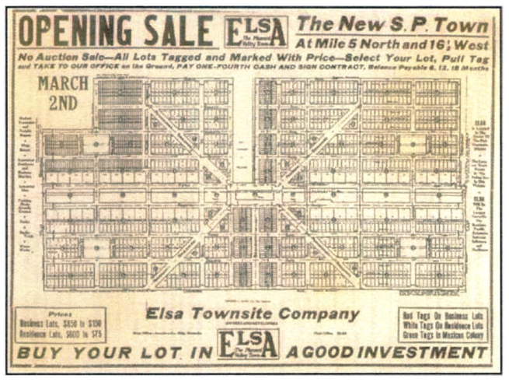
On November 12th 1926, H.B. Seay and Wm. George, both of the City of Mercedes, in Hidalgo County, Texas; and H.L. Seay of the City of Dallas in Dallas County, Texas, associated themselves and formed a private corporation under and in pursuance of the laws of Texas, and named it Elsa Townsite Company.
A City Planning Engineer, Major Edward A. Wood,
of Dallas, Texas, submitted scientific planning detail
for the future development of a new town-site in the
Rio Grande Valley of Texas. Its business, industrial
and residential districts were laid out so as to provide
for future expansion and to prevent the problems and
expense that confronted so many young towns in
endeavoring to adjust themselves to a growing
population and increasing business activity.
The carefully laid plans were indeed well thought out
and “The Planned Valley Town” went on sale at a
public auction on March 2, 1927. The Auction was
held in the center of Hidalgo County in the midst of
fertile cotton fields and typical southwest brush, and the only habitation at the time was a lone country store operated by Mrs. Elsie George, whose husband, William George, was farming adjoining acreage.

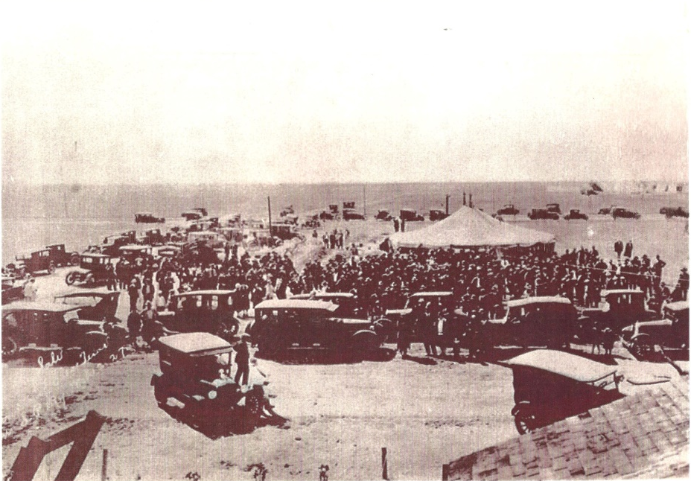

The American Rio Grande Land & Irrigation Company
JNO. C. Jones, secretary & Treasurer for
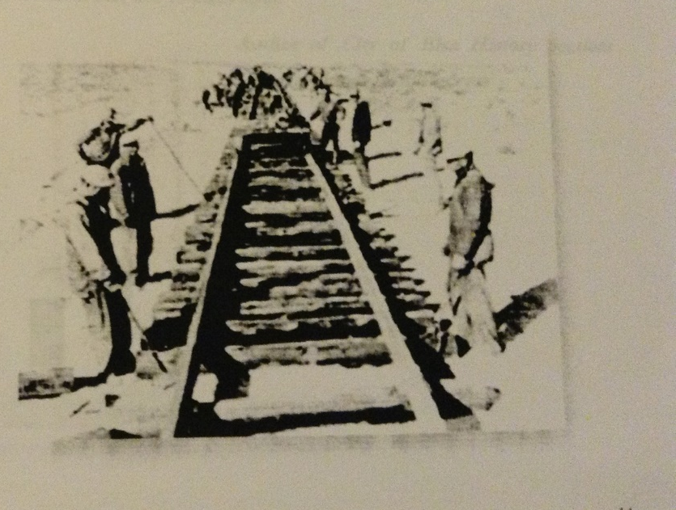
The American Rio Grande Land & Irrigation
Company in 1926, wrote to William George
the following: “It is with great pleasure that
I am able to tell you that we have decided to
name the new town “Elsa” in your honor.
The Spanish name Elsa was substituted for
the English Elsie for the reason that the
Official of the Southern Pacific Railways
had determined to use only Spanish names
for the towns on the new extension, and from
the best authorities available we learned that
“Elsa” was correct Spanish for “Elsie.”
It will interest you to know, that, before a
name was selected, we received several letter
from your friends it that community requesting
that the town be named Elsie in your honor,
and I wish to assure you that we felt a real
pleasure in adopting their suggestions.

Incorporation of Elsa, Texas
Hidalgo County Commissioners’ Court Minutes, in the matter of the Incorporation of the Town of Elsa, Texas read as followed: Be It Remembered that on January 28, 1933, pursuant to due and regular order therefor made by the undersigned, there was duly and regularly had and held an election within the town of Elsa, Hidalgo County, Texas, for the purpose of submitting to the vote of the people the question of whether or not such town shall be incorporated, and within ten days after the date of such election due return was made thereof showing that the majority of the votes so cast were for the incorporation to such town. This entry dated this the 20th day of February, 1933, shall be, and is, made upon the records of the Commissioners’ Court of Hidalgo County, Texas. E.C. Couch, Judge
Agriculture
