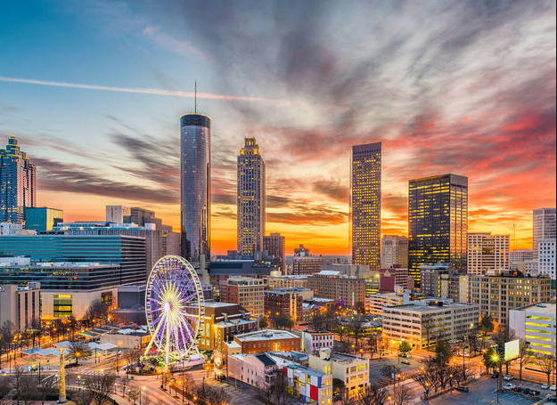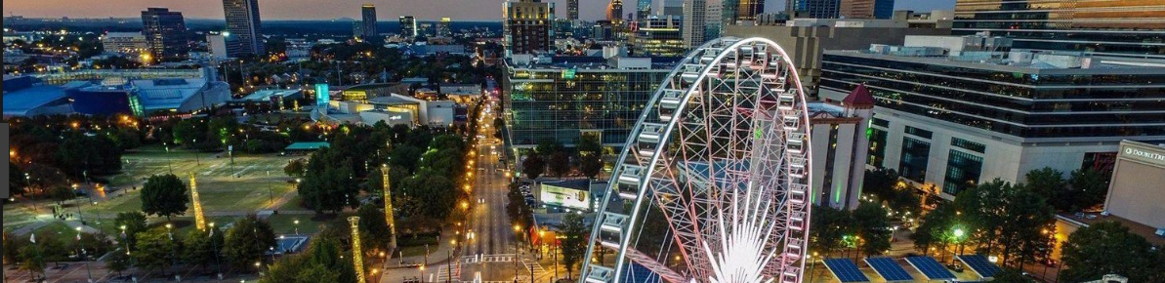
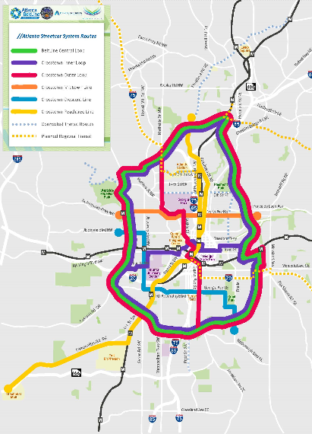

Raising the Bar on Customer Experience Store Bus Tour
Experience Unique Stores from a Shopper’s Point-of-View

Heard all the ‘Hoopla’ about the Retail Apocalypse, and how retail is dead?

Though the notion of brick and mortar retail being dead is far from fact, boring retail is dying. Increasingly, it all about a differentiated experience. In fact, physical retailers that focus on a unique and exceptional customer shopping journey are successfully growing their business, competing effectively against e-retailers, and thriving!

Join Ace Global Solutions on an exciting tour visiting several highly innovative, customer experience driven retailers near the Georgia World Congress Center (Atlanta Convention Center). Learn and be moved by how these retailer are making waves and helping to create the ‘new’ retail.

We are joined by Art Freedman, a leading expert in shopper insights and an Ace Hardware store owner for over 30 years. Art will address key trends impacting retail and how businesses are succeeding by creating unique experiences that drive loyalty in their market and beyond.

ART FREEDMAN (Keynote Speaker) 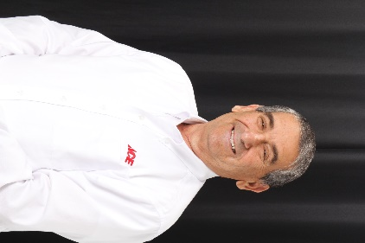
As an energetic, successful entrepreneur and business owner, Art brings 45 years of retail, on-line and business to business experience to the retail tour. He is currently leading six retailer engagements and is a sought-after speaker, having been recently interviewed during an Ace Global Solutions Academy interactive webinar. Art will share his knowledge and answer questions throughout the bus travel time and retail floor tours.

Thursday, September 5 at 1:00pm – 3:30 pm

Tour starts at: Front lobby at Westin Peachtree Plaza, 210 Peachtree Street NW, Atlanta

Pricing: Ace Global Solutions Academy Members (no charge). All others: $75 per participant

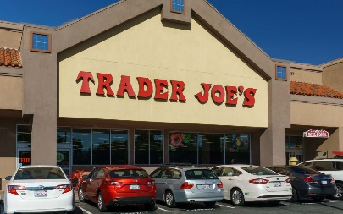
From humble beginnings as a small chain of eclectic California convenience stores, Trader Joe’s has grown to become a national chain of 490 (and counting) neighborhood grocery stores. How? By being different. Focusing on private label (products with “Trader Joe’s” name on them) simplified a lot of things, and removed a lot of costs – no more slotting fees, marketing fees, middlemen fees… They pass along those savings to their customers, because the value of Value is invaluable. And to Trader Joe’s, “Value” means offering the best quality products for the best, everyday prices. Maintaining everyday focus on Value is vital, which is why they don’t have sales, loyalty programs, membership fees or any other gimmicks. They are winning even without a digital presence. See how they execute!

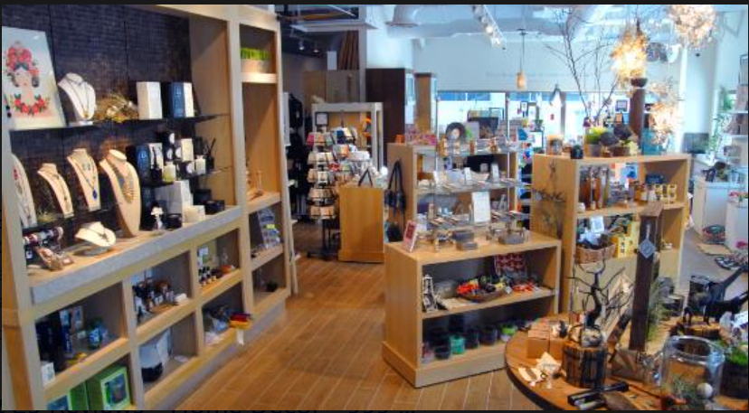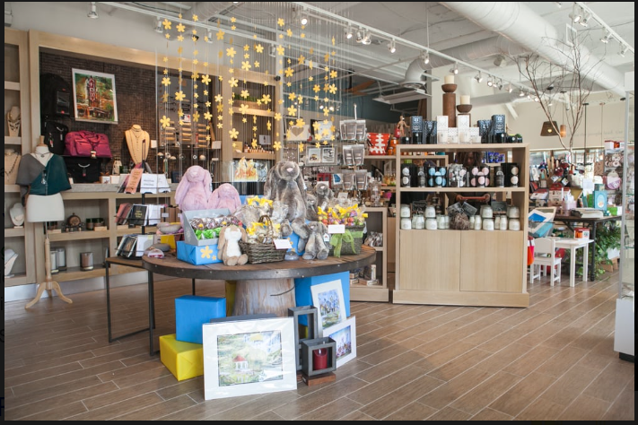
Eco Denizen puts the world at your fingertips with the wonderful selection of responsibly-sourced jewelry, accessories and more at their eco-friendly gift shop. They offer a range of great gift-giving options including handmade crafts, beautiful candles and more. Local artists craft many of the delightful items in their natural gift store. The variety in their inventory is perfect for finding a terrific last-minute gift for any occasion. From stationary, cards, and journals to art, home décor and lighting, their souvenir and gift store is a resource for beautiful, thoughtful gifts. Their helpful staff is always on hand to help the shopper choose the perfect present. Localized + differentiated products = A winning formula!

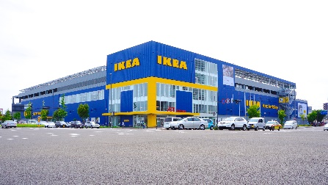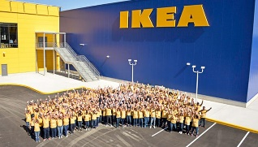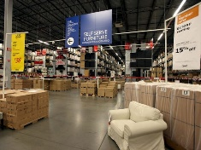

The people at IKEA, the highly successful Scandinavian value based retail furniture chain, don’t believe in perfect homes. They believe in homes that are a perfect reflection of the people who live inside. Where everything looks the way you want it to, works the way you need it to, and just generally makes you feel good – without costing a fortune. They have tons of different home ideas, from home decoration ideas to organizing tips to inspiration for making your home more green. So, you’ll have all you need for creating a space that you love calling home. Check out how their store layout design, known as the ‘IKEA maze’ inspires customers to spend and creates a unique ambiance.

