Who are we? Dog Boxes

What do we do? Dox boxes provides a convenient, premium monthly food and treat pack to the Australian pet owners market.

Who is our target market? Upper middle class Australians with at least 1 dog. Both Male and Female between the ages of 27-50. We are targeting both these dog owners and also friends of these people. Subscription boxes make a terrific gift for Christmas. These people are time poor and want to spend more quality time with their animal. Whilst they are not spending time with them, they want re-assurance that their pet is occupied.

What are our brand values. Caring, loving, premium and a little cheeky

What are the essentials of our brand (and logo). The name ‘Dog Boxes’ by-line Boxes for Dogs would be nice but not a necessary.

What is our design style: prefer a pictorial mark or a wordmark. I like to have iconography which can be used separately once the brand has been established with the customer (i.e. on the boxes, stickers and email communications). Other logos which have been done for me include the below (so you can get an idea of my style)
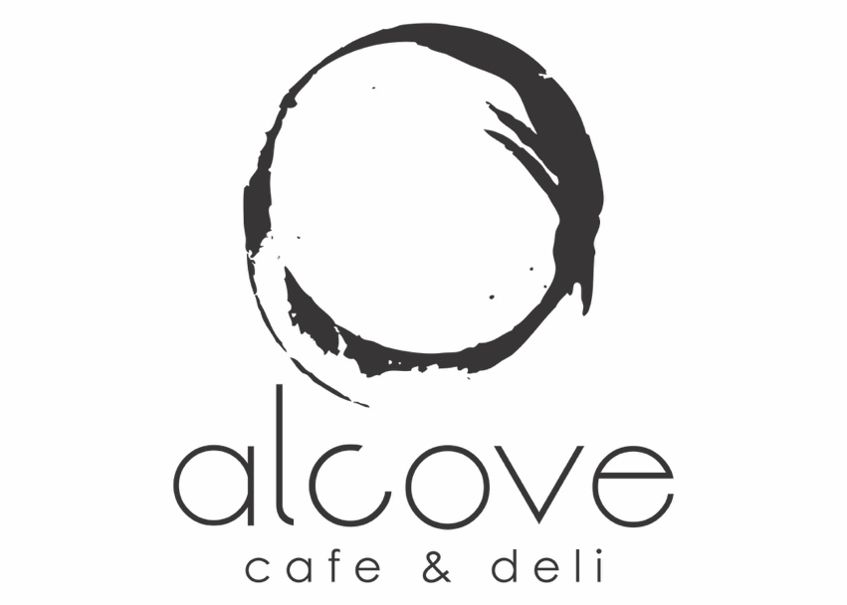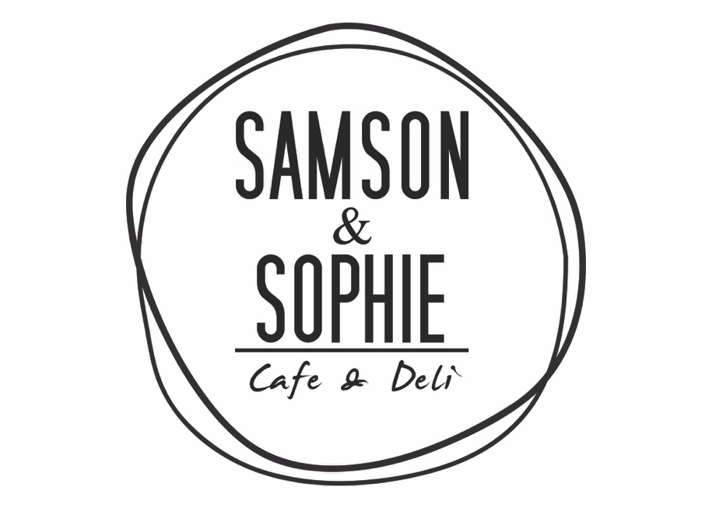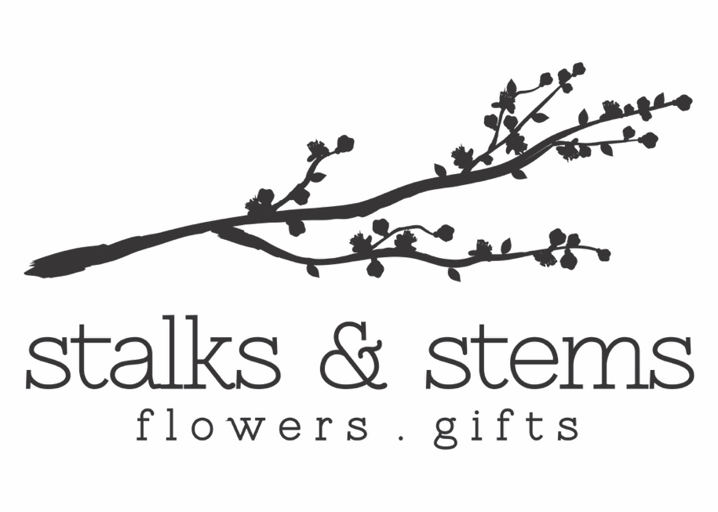

Which designs do you like? (I stole this from the 99 Designs process) I like the ones selected with the green tick.