PRODUCT LIST 2019- KENDY PHARMA
VITAMINS & MINERALS - EFFERVESCENT PRODUCTS

SV A-Z  +Lutein and Selenium  /Effervescent tablets/  4000 mg/tablet  (Citrus flavor) |  | Calcium……………….….160 mg  Magnesium……………….60 mg  Vitamin C…………………..60 mg  Vitamin B3……………..…18 mg  Ferrum……………………….10 mg  Vitamin E……………………10 mg  Pantothenic acid…….....6 mg  Zinc………………………………5 mg  Vitamin B2………………2,97 mg  Vitamin B6……………………2 mg  Vitamin B1………………1,4 mg  Vitamin A………………….800 µg  Copper………………………0,5 mg  Manganese……………….0,4 mg  Folat…………………………200 µg  Vitamin H…………………150 µg  Iodine……………………….100 µg  Lutein………………………..50 µg  Vitamin K1……………….…30 µg  Selenium……………………30 µg  Cromium…………………..25 µg  Molybdenum………………..25 µg  Vitamin D3…………………..5 µg  Vitamin B12………………...1 µg |  |  | 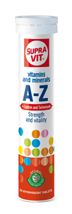  20 tablets in tube
SV MULTIVITAMINS +Biotin  /Effervescent tablets/  4000 mg/tablet  (Orange flavor) |  | Vitamin A…….……….…..900 μg  Vitamin E ……………….6,90 mg  Vitamin B1 …………….1,80 mg  Vitamin B2……………..1,45 mg  Vitamin B6…………….1,70 mg  Vitamin B12…………….…..5 μg  Vitamin C……………..…..75 mg  Folic acid……..…………..200 μg  Nicotinamide……………..20 mg  Vitamin D3…….…..……….5 μg  Vitamin B5……………..…10 mg  Beta Carotene………..0,50 mg  Biotin…………..…………….50 μg |  |  | 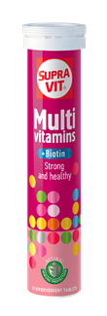  20 tablets in tube
SV ACTIVE + Q10  /Effervescent tablets/  4000 mg/tablet  (Orange flavor) |  | Vitamin E …..……...16,50 mg  Vitamin B1 …..……..2,60 mg  Vitamin B2……………..1,90 mg  Vitamin B6…………...4,00 mg  Vitamin B12…….……..4,95 μg  Vitamin C..……………..160 mg  Folic acid…….…………...200 μg  Nicotinamide…..……19,80 mg  Vitamin D3……………….….5 μg  Copper …………………..0,45 mg  Iron .………………………2,70 mg  Magnesium……………....60 mg  Zinc ………….……………2,70 mg  Manganese …………...0,90 mg  Beta Carotene……….…0,5 mg  Coenzyme Q10.………2,00 mg |  |  | 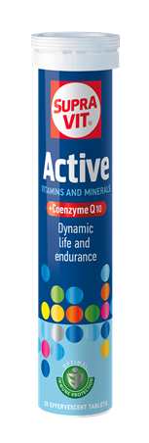  20 tablets in tube
SV FOR KIDS + CALCIUM  /Effervescent tablets/  /Natural colours/  4000 mg/tablet  (Strawberry flavor) |  | Vitamin A……..…….….270 μg  Vitamin E ……………..6,70 mg  Vitamin D3……………..2,30 μg  Vitamin B1 …………..1,25 mg  Vitamin B2…………...…2,0 mg  Vitamin B6………..… 1,20 mg  Vitamin B12…………..…0,5 μg  Vitamin C……….. ….….60 mg  Folic acid…………………200 μg  Nicotinamide…………14,5 mg  Vitamin B5……………..9,0 mg  Biotin……………………..…70 μg  Calcium ………………..200 mg |  |  | 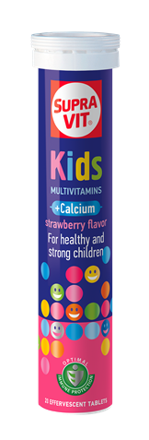  20 tablets in tube
SV VITAMIN C 550 mg  /Effervescent tablets/  4000 mg/tablet  (Lemon flavor) |  | Vitamin C………………..550 mg |  |  | 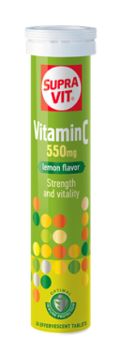  20 tablets in tube
SV VITAMIN C  1000 mg  /Effervescent tablets/  4000 mg/ tablet  (Lemon or Orange flavor) |  | Vitamin C………………..1000 mg |  |  | 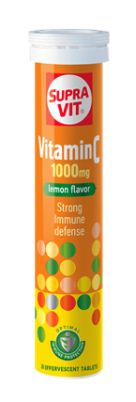  20 tablets in tube
SV VITAMIN C  1000 mg + Zn  /Effervescent tablets/  4000 mg/tablet  (Orange flavor) |  | Vitamin C……………..1000 mg  Zinc………………………....10 mg |  |  | 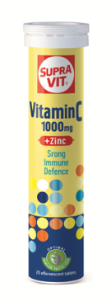  20 tablets in tube
SV ANTIOXIDANT /ACE+Zn+Se+PAPAYA/  /Effervescent tablets/  4000 mg/tablet  (Orange flavor) |  | Vitamin C………………..180 mg  Vitamin E………………...10 mg  Beta carotene………….2,0 mg  Folic acid………………...400 µg  Zinc……………………..……15 mg  Selenium………………..….30 µg  Papaya extract……..…100 mg |  |  | 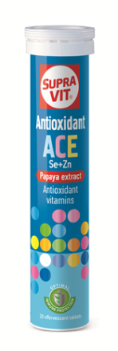  20 tablets in tube
SV CALCIUM + VITAMIN C  /Effervescent tablets/  4000 mg/tablet  (Lemon flavor) |  | Calcium …………………200 mg  Vitamin C……………….300 mg |  |  | 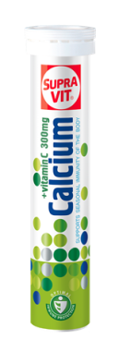  20 tablets in tube
SV CALCIUM  + Vitamin D3  /Effervescent tablets/  4000 mg/tablet  (Orange flavor) |  | Calcium …………………..500 mg  Vitamin D3 ……………..7,5 μg |  |  | 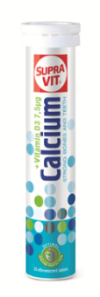  20 tablets in tube
SV CaMgZn+D3+C  /Effervescent tablets/  4000 mg/tablet  (Lemon flavor) |  | Calcium ……………..…..250 mg  Magnesium ………….…100 mg  Zinc……………………………10 mg  Vitamin D3 …..………...6,7 μg  Vitamin C ……………….100 mg |  |  | 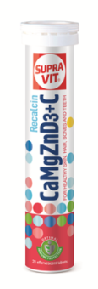  20 tablets in tube
SV CALCIUM PLUS  /Effervescent tablets/  7500 mg/ tablet  (Orange flavor) |  | Calcium………..………….500 mg  /Calcium carbonate- 355 mg  and  Calcium lactate gluconate -145mg/ |  |  | 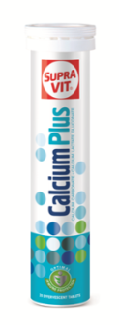  20 tablets in tube
SV MAGNESIUM  + Vit. B COMPLEX  /Effervescent tablets/  4000 mg/tablet  (Orange flavor) |  | Magnesium …………...150 mg  Vitamin B1 ……………..0,7 mg  Vitamin B2…….….….….0,8mg  Vitamin B6………………1,0 mg  Vitamin B12………….….0,5 μg |  |  | 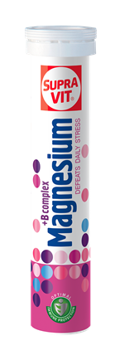  20 tablets in tube
SV FERRUM + Vitamins  /Effervescent tablets/  4000 mg/tablet  (Forest fruits flavor) |  | Iron…………………....……10 mg  Vitamin B12………..…..2.0 μg  Vitamin C …….………..100 mg  Folic acid ………………….300 μg |  |  | 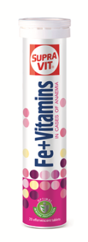  20 tablets in tube
SV ISOSPORT  /Effervescent tablets/  4000 mg/tablet  (Orange flavor) |  |  | Potassium……..…..…….210 mg  Magnesium.…..…………150 mg  Vitamin C……..….……...90 mg |  | 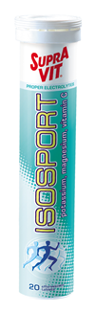  20 tablets in tube
SV Rehydration formula  /Effervescent tablets/  3000 mg/tablet  (Strawberry, Blackcurrant or Lemon flavor) |  |  | Sodium chloride…………176 mg  Citric acid…………………..492 mg  Potassium chloride.…..150 mg Dextrose……………….....1826mg  mmol/L  Glucose…………………101  Sodium…………………70  Potassium……………..20  Chloride………………..51  Citrate…………………..22 |  | 24 tablets in tube
SV L-CARNITINE  + GREEN TEA  /Effervescent tablets/  4300 mg/ tablet  (Lemon flavor) |  |  | L-Carnitine …….………1000 mg  /L-Carnitine tartrate/  Green Tea extract………30 mg |  | 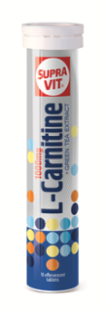  18 tablets in tube
SV L-CARNITINE  + GREEN TEA + Co Q10  /Effervescent tablets/  4000 mg/ tablet  (Lemon flavor) |  |  |  | L-Carnitine……………….500 mg  /L-Carnitine tartrate/  Green Tea Extract……….20 mg  Nicotinamide………………..5 mg  Vitamin B12……………...1,0 µg  Vitamin B6………………..0,5 mg  Coenzyme Q10………….0,9 mg | 20 tablets in tube
SV L-ARGININE  /Effervescent tablets/ |  |  |  | L-Arginine...............3000 mg | 10 tablets in tube
SV L-CARNITINE +  L-ARGININE  /Effervescent tablets/ |  |  |  | L-Arginine...............3000 mg  L-Carnitine..............500 mg  /L-Carnitine tartrate/  CoenzymeQ10 /10%/...50 mg  Lycopen-10%.............25 mg  Zinc………...............12.50 mg | 10 tablets in tube
Senna /laxative/  /Effervescent tablets/  4000 mg/tablet  (Orange flavor) |  |  |  | Senna extract…………..110 mg  Vitamin C………………...100 mg | 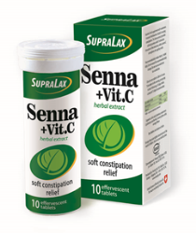  10 tablets in tube
BONE HEALTH & JOINT SUPPORT PRODUCTS

STABIFLEX  /Effervescent tablets/  4200 mg /tablet  (Orange flavor) |  |  |  | Glucosamine sulfate….750 mg  Chondroitin sulfate…. 600 mg  MSM…………………………..300 mg  Ginger extract……..…….16 mg | 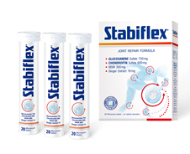  20 effervescent tablets in tube,  3 tubes in box
STABIFLEX  1400 mg/ coated tablet |  |  |  | Glucosamine HCl………500 mg  Chondroitin sulfate…..400 mg  MSM…………………………..200 mg  Ginger extract…………….16 mg  Manganese……………………1 mg | 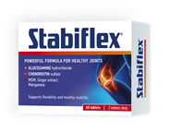  4 blisters x 15 tablets in box
OSTEOACTIVE  /Effervescent tablets/  4000 mg/tablet  (Lemon flavor) |  |  |  | Vitamin C ……………….120 mg  Vitamin D3……………..8,25 μg  Vitamin B6……………...6,0 mg  Vitamin K1….…………....60 μg  Calcium...………………..500 mg  Magnesium………….…….50 mg  Inulin………………….……100 mg | 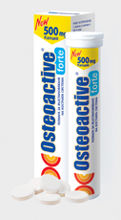  20 effervescent tablets in tube + single box
OSTEOACTIVE FORTE  /Effervescent tablets/  8200 mg/ tablet  (Orange flavor) |  |  |  | Vitamin C ………………..120 mg  Vitamin D3……………….10,0 μg  Vitamin B6……………….6,0 mg  Vitamin K1…….………..….60 μg  Calcium ………………….1000 mg  Magnesium…………….….60 mg  Inulin……..…………………100 mg | 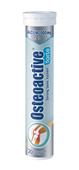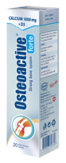  20 effervescent tablets in tube + single box
SV CaMgZn+D3  1600 mg/tablet |  |  |  | Calcium…………………….250 mg  Magnesium……………...100 mg  Zinc…………………………….10 mg  Vitamin D3……..…………...5 µg | 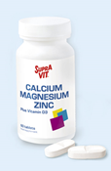  60 tablets in bottle
SV CALCIUM + Vit. D3  1700 mg/tablet |  |  |  | Calcium…………………….600 mg  Vitamin D3……………….…5 µg | 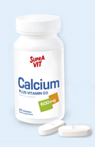  60 tablets in bottle
VITAMINS & MINERALS - PRODUCTS IN BLISTERS

SV PREGNANCY  - capsules |  |  |  | Vitamin C…… …….……...45 mg  Vitamin A…………………..400 μg  Vitamin E ……………………10 mg  Vitamin D3…………………...5 μg  Vitamin B1 ……………….1,1 mg  Vitamin B2…….………….0,8 mg  Vitamin B6……………….1,5 mg  Vitamin B12………………..1,5μg  Folic acid…………………..400 μg  Nicotinamide………..….13,5mg  Pantothenic acid………4,5 mg  Biotin……………….…………75 μg  Calcium ………………….100 mg  Magnesium………………..45 mg  Iron…………………………..14 mg  Copper………………………0,5 mg  Zinc……………………………..6 mg  Iodine………………………100 μg | 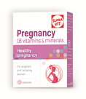  2 blisters x 15 capsules in box
SV FOLIC ACID + Potassium Iodate  100 mg/tablet |  |  |  | Folic acid………….………..400 µg  Potassium………..……....100 µg  /Potassium Iodate/ | 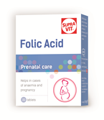  3 blisters x 30 tablets in box
SV A-Z + Ginseng  810 mg/ tablet |  |  |  | Vitamin C….……..……….60 mg  Vitamin E …………........25 mg  Nicotinamide……..……...20 mg  Zinc ……………………………15 mg  Pantothenic acid….…….10 mg  Ginseng extract (root)..10 mg  Iron….……………….…………10 mg  Manganese………..…………4 mg  Beta Carotene….………….2 mg  Vitamin B6………..………..2 mg  Vitamin B2…….…..… ...1,6 mg  Vitamin B1. …………..…1,5 mg  Copper ………….….……....1 mg  Vitamin A…………...…….750 µg  Folic acid………..………..400 μg  Iodine……………….……...150 µg  Vitamin H…….…….……...50 µg  Vitamin K1………………….30 µg  Chromium…………………..25 µg  Molybdenum…..…….……25 µg  Selenium…………..………..25 µg  Vitamin D3………………..7,5 μg  Vitamin B12……………….…3 μg  Potassium………………..…80 mg  Chlorides……………………..70 mg | 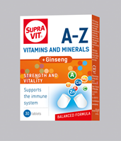  2 blisters x 15 tablets in box
SV MAGNESIUM + Vit. B6  800 mg/tablet |  |  |  | Magnesium……………....250 mg  Vitamin B6…………………1,4 mg | 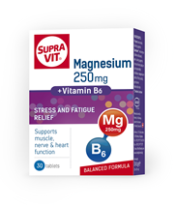  2 blisters x 15 tablets in box
SV EYE CARE  - capsules |  |  |  | Lutein…………………….…….10 mg  Zeaxanthin…………………….1 mg  Blackcurrant extract…..50 mg  Vitamin A…………………..400 µg  Vitamin E………………….….6 mg  Zinc…………………………….…5 mg  Selenium………………………30 µg | 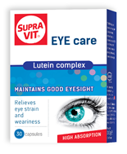  2 blisters x 15 capsules in box
SV BEAUTY –  Hair, Skin & Nails  Vitamins + amino acids + extracts  - capsules |  |  |  | Vitamin B1…………………...5 mg  Vitamin B6…………………...5 mg  Niacin ………………………….25 mg  Pantothenic acid….………25 mg  Biotin……………………………50 μg  Zinc……………………………….5 mg  Iron…………………………….2.5 mg  Medical Yeast extract….75 mg  Millet extract……………….75 mg  L-Cystein……………………..50 mg  L-Methionine …………….100 mg | 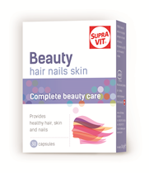  2 blisters x 15 capsules in box
SV NATURAL COLLAGEN  - capsules |  |  |  | NC II…………………….……10mg | 2 blisters x 15 capsules in box
SV SERRAPEPTASE  - Capsules |  |  |  | Serrapeptase………40 000 U.I. | 3 blisters x 10 capsules in box
NOTROCLOT  - capsules |  |  |  | Nattokinase…………..…100 mg | 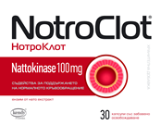  2 blisters x 15 capsules in box
PRODUCTS WITH NATURAL EXTRACTS

SV GINKGO BILOBA + Mg  - capsules |  |  |  | Ginkgo Biloba extract….40 mg  Magnesium………………….60 mg | 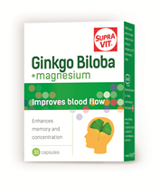  2 blisters x 15 capsules in box
SV GINKGO BILOBA FORTE  - capsules |  |  |  | Ginkgo Biloba extract-120 mg  Green tea extract…..…..30 mg  Vitamin B6….………..……1,4 mg  Magnesium……………..…150 mg  Selenium…………….…….….55 µg | 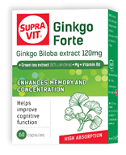  4 blisters x 15 capsules in box
SV GINSENG  + Propolis & Vitamin E  - capsules |  |  |  | Ginseng extract………..100 mg  Propolis……………………..250 mg  Vitamin E………………….…10 mg | 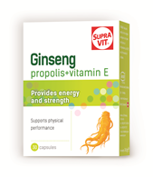  2 blisters x 15 capsules in box
SV SAMBUCUS NIGRA  /Effervescent tablets/  (Forest fruits flavor) |  |  |  | Black elderberry juice  (as extract)……………….150 mg  Vitamin C……………………60 mg  Zinc...…………………………7,5 mg | 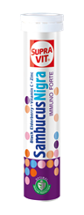  10 or 15 effervescent tablets in tube
SV SAMBUCUS NIGRA  - capsules |  |  |  | Black elderberry  extract.…………….........120 mg  Vitamin C…………..……..200 mg  Zinc...………….………………..6 mg | 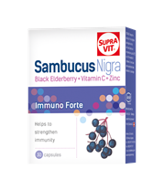  1 blister x 15 capsules in box
SV SAMBUCUS NIGRA  - Stick packs |  |  |  | Black elderberry extract 15%.......................12.2 mg  Vitamin C………….……32,50 mg  Vitamin D3.……….………….5 µg | 10 stick packs in box
PROBIOTIC PRODUCTS

ACTIFLORA  - capsules | Probiotic blend: 4.5 10⁹CFU/g  - Lactobacillus bulgaricus  - Lactobacillus acidophilus  - Bifidobacterium sp.  - Streptococcus thermophilus  + inulin (prebiotic) |  |  |  |  | 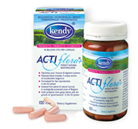  100 capsules in bottle + box
LACTOFLOR BioPlus  - capsules | Probiotic blend: 6x10⁹ CFU/ capsule:  - Lactobacillus acidophils  - Lactobacillus bulgaricus-  (LKZ-200- from geranium sanguineum)  - Lactobacillus rhamnosus  - Streptococcus thermophilus  - Bifidobacterium sp.  (B.bifidum, B.longum, B.infantis)  + Prebiotic (inulin) |  |  |  |  | 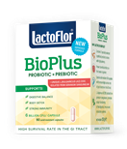  60 DR capsules in bottle + box
LACTOFLOR BioPlus  - chewable tablets | Probiotic blend: 1x10⁹ CFU/ tablet:  - Lactobacillus bulgaricus  (LKZ-200- from geranium sanguineum)  - Lactobacillus rhamnosus  - Streptococcus thermophilus  + Prebiotic (inulin) |  |  |  |  | 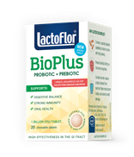  20 tablets in bottle + box
LACTOFLOR Opti 6  - capsules | Probiotic blend: 10x10⁹ CFU/ capsule:  - Lactobacillus plantarum  - Lactobacillus rhamnosus  - Lactobacillus bulgaricus  - Lactobacillus lactis  - Lactobacillus helveticus  - Bifidobacterium sp  (B. bifidum, B.infantis, B. longum)  + Prebiotic (inulin) |  |  |  |  | 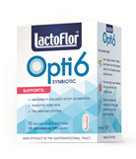  30 capsules in bottle + box
LACTOFLOR PROBIOTIC  - capsules | Probiotic blend: 2x10⁹ CFU/capsule:  - Lactobacillus bulgaricus  - Lactobacillus acidophilus  - Bifidobacterium sp  (B. bifidum, B.infantis, B. longum).  - Streptococcus thermophilus |  |  |  |  | 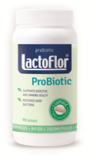  90 capsules in bottle
LACTOFLOR  ENTERIC ECOL  /against diarrea/  - stick pack | Saccharomyces boulardii  +  Probiotic blend: 1x10⁹ CFU/sachet:  - Lactobacillus acidophilus  - Lactobacillus casei  - Bifidobacterium sp.  (B. bifidum, B.infantis, B. longum) |  |  |  |  | 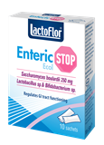  10 stick packs in box
LACTOFLOR  ENTERIC ECOL  /against diarrea/  - capsules | Saccharomyces boulardii  +  Probiotic blend: 1x10⁹CFU/ capsule:  - Lactobacillus acidophilus  - Lactobacillus casei  - Bifidobacterium sp  (B. bifidum, B.infantis, B. longum)  +  + Prebiotic (inulin) |  |  |  |  | 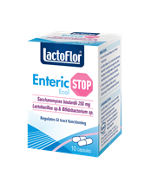  10 capsules in bottle + box
LACTOFLOR KIDS  - stick pack | Probiotic blend: 1x10⁹ CFU/sachet:  - Lactobacillus helveticus  - Bifidobacterium sp.  (B. bifidum, B.infantis, B. longum)  - Lactobacillus acidophilus  - Lactobacillus bulgaricus  - Streptococcus thermophilus  +  Prebiotic (Oligofructose) |  |  |  |  | 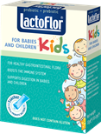  10 stick packs in box
LACTOFLOR UROBIOTIC  /urinary tract health/  (30% total acids) –  stick pack | - Cranberry extract….200 mg  (30% total acids)  - D-Mannose……………….500 mg  - Probiotic blend- 2,5x10⁹ CFU/ sachet:  (Lactobacillus rhamnosus, Lactobacillus lactis, Lactobacillus acidophilus, Streptococcus thermophilus) |  |  |  |  | 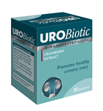  30 stick packs in box
LACTOFLOR UROBIOTIC Forte  /urinary tract health/  (40% PAC) –  stick pack | - Cranberry extract….200 mg (40% PAC)  - D-Mannose..………………500mg  - Probiotic blend- 2,5x10⁹ CFU/ sachet:  (Lactobacillus rhamnosus, Lactobacillus lactis, Lactobacillus acidophilus, Streptococcus thermophilus) |  |  |  |  | 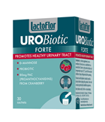  30 stick packs in box
LACTOFLOR UROBIOTIC  + garden sage extract  /urinary tract health/  (40% PAC) –  capsules | - Cranberry extract……100 mg  (40 % PAC)  - D-Mannose …………….100 mg  - Ursolia (Extract Garden sage- 15% Ursolic acid)...........50 mg  - Probiotic blend- 7,5x10⁸ CFU/ capsule:  (Lactobacillus casei, Lactobacillus acidophilus, Bifidobacterium sp.  (B. bifidum, B.infantis, B. longum) |  |  |  |  | 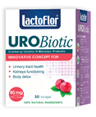  30 capsules in bottle + box
LACTOFLOR FIBERS  Prebiotic in sachets | Inulin……………..…………… 10 g  /Extract from chicory/ |  |  |  |  | 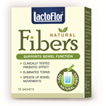  15 sachets in box
Lactoflor Helico Protect  /against  Helicobacter pylori/  - capsules | - Lactobacillus reuteri……200mg  (patented proprietary blend  Pylopass™)  - Zinc (Zinc L-Carnosine)..…10 mg |  |  |  |  | 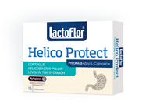  1 blister x 15 capsules in box
NEW PRODUCTS 2019

COLLAGEN  /Berries flavour/ |  | Hydrolyzed marine collagen…………………………..500 mg |  |  |  | 20 effervescent tablets in tube
Potassium product  /Lemon flavour/ |  | Potassium citrate………………...784 mg  Potassium carbonate……………780 mg |  |  |  | 20 effervescent tablets in tube
Probiotic with colostrum |  | - Probiotic blend: 4,5x10¹⁰ CFU/ capsule:  - Lactobacillus bulgaricus,  - Streptococcus thermpphilus;  - Lactobacillus acidophilus,  - Bifidobacterium sp.  (B. bifidum, B.infantis, B. longum)  - Inulin…………………..…150 mg  - Colostrum………………100 mg |  |  |  | 60 capsules in bottle + box
Probiotic with β- Glucan |  | - Probiotic blend: 4,5x10¹⁰ CFU/ capsule:  - Lactobacillus bulgaricus,  - Streptococcus thermpphilus;  - Lactobacillus acidophilus,  - Bifidobacterium sp.  (B. bifidum, B.infantis, B. longum)  - Inulin……………………..150 mg  - β-D-Glucan…………..…94 mg  - Vitamin C…………….….50 mg  - Vitamin B6………….….1,5 mg  - Zinc…………………………...2 mg |  |  |  | 60 capsules in bottle + box
Probiotic with Lactase |  | - Probiotic blend: 4,5x10¹⁰ CFU/ capsule:  - Lactobacillus bulgaricus,  - Streptococcus thermpphilus;  - Lactobacillus acidophilus,  - Bifidobacterium sp.  (B. bifidum, B.infantis, B. longum)  - Inulin……………………..150 mg  - Lactase………………….…33 mg |  |  |  | 60 capsules in bottle + box
April 2019

