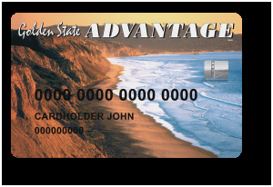

CALIFORNIA EBT CARD

CALIFORNIA MEDICAL BENEFITS CARD
