RACE CAR DESIGNS

There are over 52 USA race car series and many more abroad. Consumer would choose race car series, car and design.

- RACE CARD
This is a black t-shirt with an Ace of Spades centered on the back of tee with an Indy race car in the center of the card. Future designs the purchaser will have the option to choose a race car from any series.
The specifications of this shirt will be:
- Shirt will have a front pocket and/or just print with and Ace of Spades on front left side
- Shirt will come in several styles, vintage and modern racing
- Card borders, aces and spades will be yellow or bright colors

- QUALIFLYING
- First design should portray the power of the car. Picture of the car taking off from the starting line with surrounding track visuals. Can be used in any race series.
- Second design will be more of a character drawing you would get from a sidewalk artist. Race car driver will be in race car in a cartoonish way. Can be used in any race series.

- PIT LIFE
Pit crew fueling generic Porche. View shows on board camera angle (front)
Customer will have the option to choose race series and car. This will be a continuous project.

Note: The race designs will be a continuous evolution. Kids shirts, car graphics, race series to name a few.

ZODIAC AND SPIRITUALITY

ROCK-N-ROLL THEME

If your zodiac sign were a Rock-N-Roll (fill in music from that decade) Example 70’s would be Allman Brothers Band, “Eat a Peach”. Consumers chooses album and decade.
Album
Cassette Tape
Eight Track
CD
The t-shirt would reflect the music you listen to with correlating zodiac sign. Many variations, consumer would make selections under options. Licensing

OR
Your name on vinyl album of choice

Possible if your zodiac were a VHS, DVD ect….?

YIN/YANG ZODIAC TRAITS

T-shirt will have a glow in the dark constellation of purchaser’s zodiac sign on front pocket area. Yin Yang will be on the back of the shirt with the positive and negative traits of the zodiac. This is a project that will be a continuous creation. The consumer has the

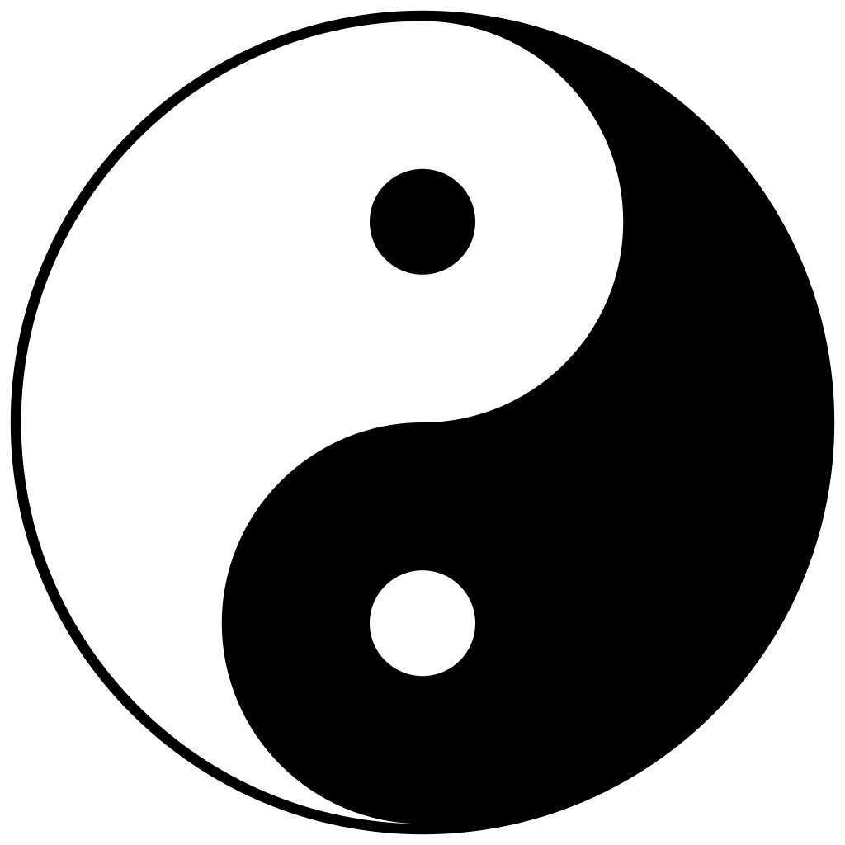
REGENERATE, CREATE & TRANSFORM (FRONT/POCKET)

POSITIVE Aspects

NEGATIVE ASPECTS

AUTISM DESIGNS

AUTISM LARGE PUZZLE PIECES
Black or white t-shirt with large puzzle pieces in neon colors over left shoulder in an airbrush look. Neon green, yellow, pink, orange, blue and purple. Consumer has option to choose glow in the dark print. Consumer’s name in airbrush look on back of shirt.

My Therapy Cat Rocks
Cat playing a puzzle pieces guitar. Cat wearing puzzle pieces wrist bands. Cat rocking out.

Autism Surfboard (1) Board has autism puzzle pieces. Palm tree and sunset on front of shirt/pocket. (2) Surfer going over a rainbow wave on the autism board. Vintage 70’s look.
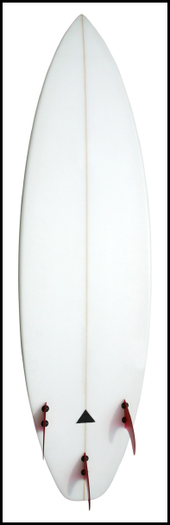
This Photo by Unknown Author is licensed under CC BY
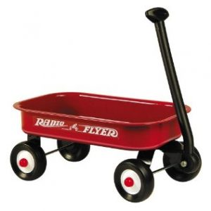
MY BEST FRIEND
This Photo by Unknown Author is licensed under CC BY-NC-ND

Small boy (4 yo) pulls his wagon with his best friend bear behind him. The bear is light brown and slouchy. The child is pulling his best friend off towards the sunset. The illustration should look classic like Winnie the Pooh. The wagon should be painted like the autism puzzle pieces.

AUTISM PEACE SIGN DESIGN -PURCHASER CHOOSES COLORS
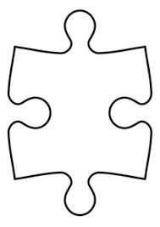

AUTISM MUSICAL GENIUS
Consumer chooses the musical note. Note will be filled with the autism puzzle pieces. Note puzzle pieces have the option to be in primary or neon colors.

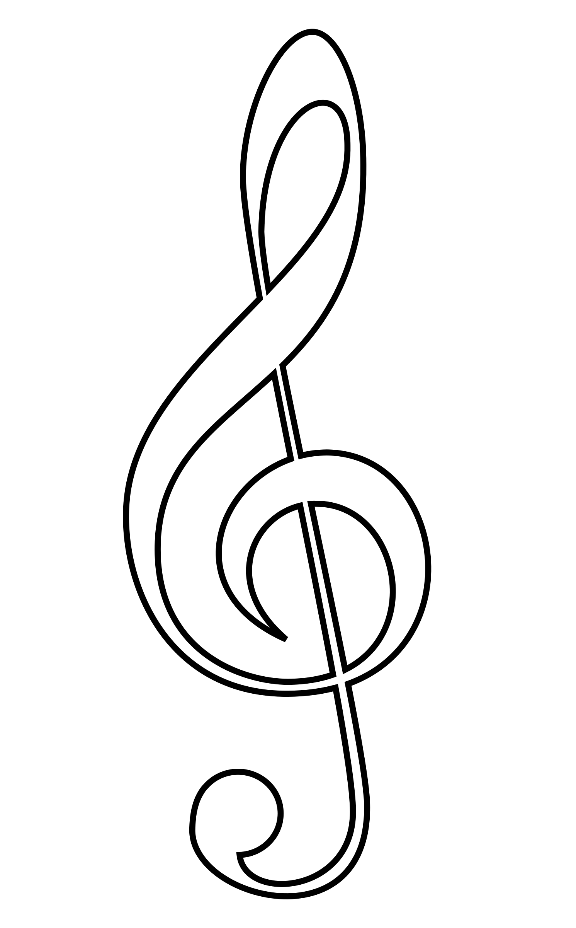

AUTISM MUSCIAL SCALE WITH AUTISM NOTES
Each note will be filled with the autism puzzle pieces. Music notes can be primary or neon colors. Consumer will choose.

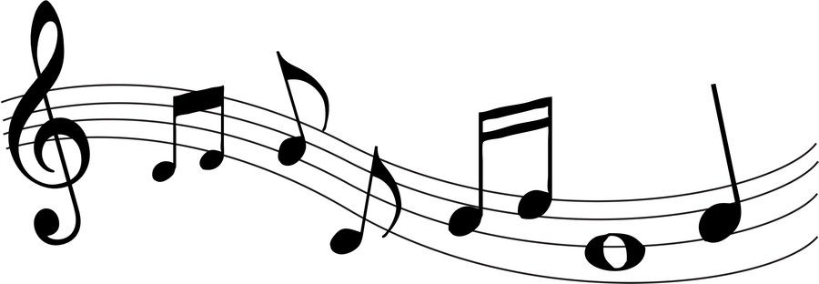
This Photo by Unknown Author is licensed under CC BY
MUSIC SCALE WITH CLASSICAL ARTIST WRITEN WITH AUTISM NOTES (Consumer chooses artist & music)

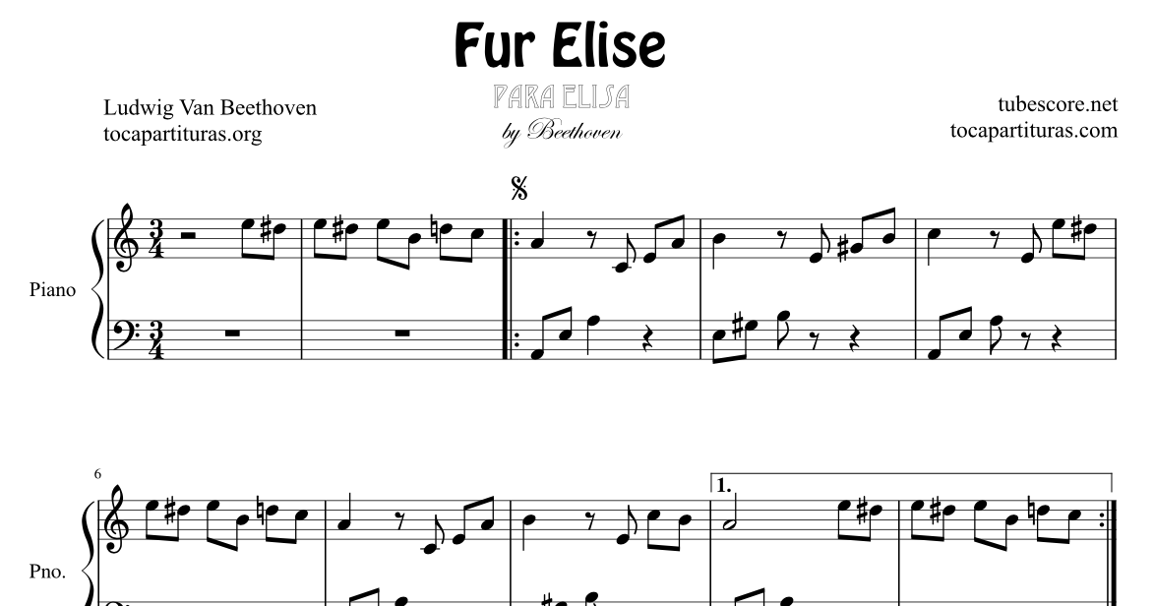
This Photo by Unknown Author is licensed under CC BY-NC-ND

NAVY BRAT- A vintage t-shirt with a tattoo type art. Navy ship on back and in the center will say, “Navy Brat”. The shirt will look like old sailor tattoos, mermaids, anchors, octopus, compass and mythological creatures art on the back of the shirt.
N E S W (front pocket)

NAVY BRAT= A vintage t-shirt style with a vintage airplane and pin up girl. Old sailor art is the theme of this shirt. Consumer can choose what color hair the pinup will be. Brunette, red, black, pink, blue ect…...

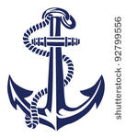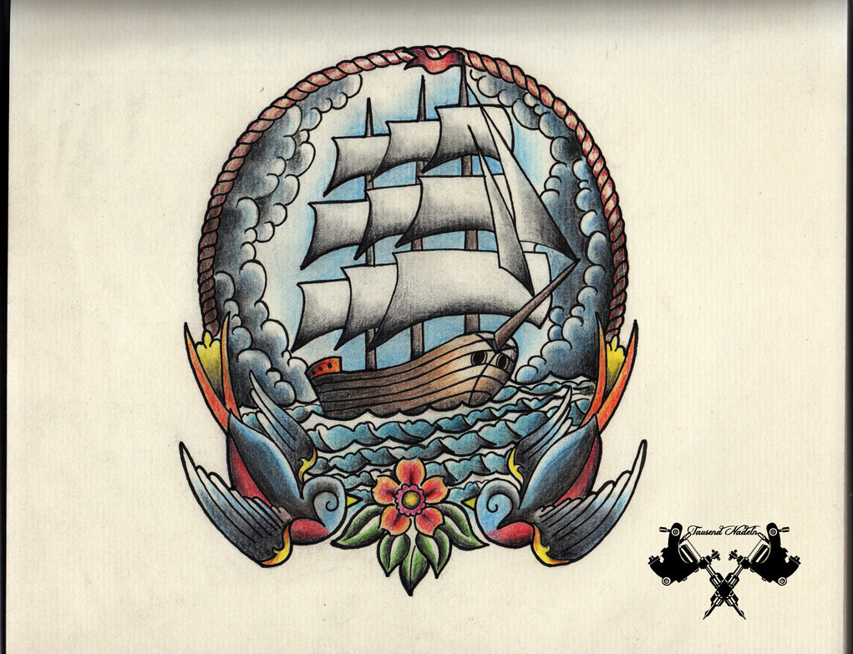
This Photo by Unknown Author is licensed under CC BY-NC-ND

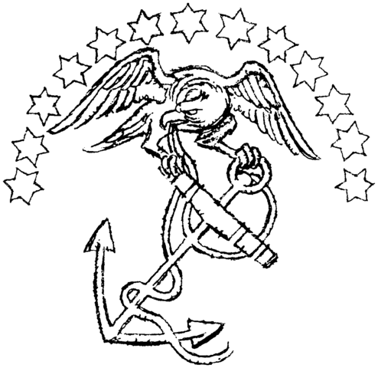
This Photo by Unknown Author is licensed under CC BY-SA
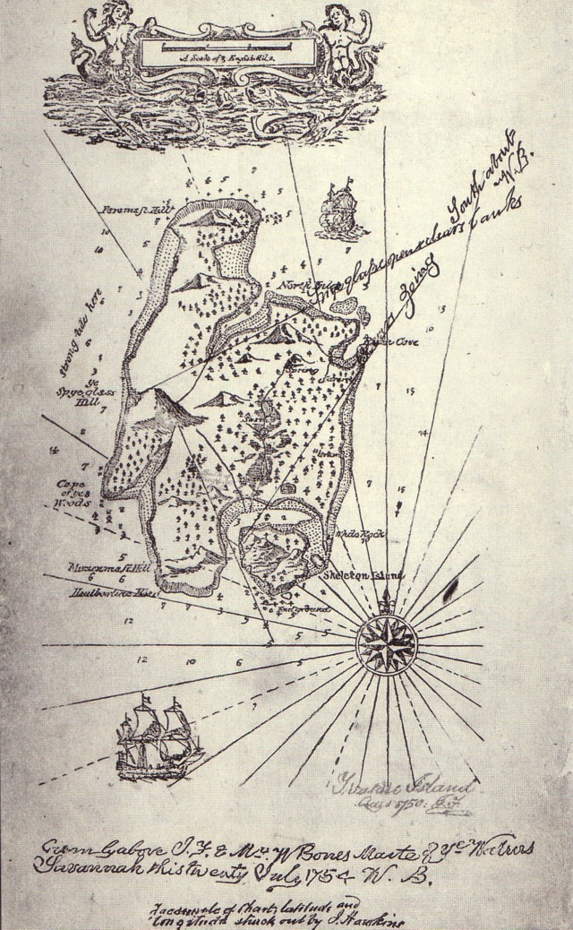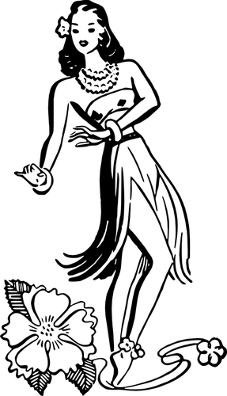
This Photo by Unknown Author is licensed under CC BY-SA
This Photo by Unknown Author is licensed under CC BY-SA-NC
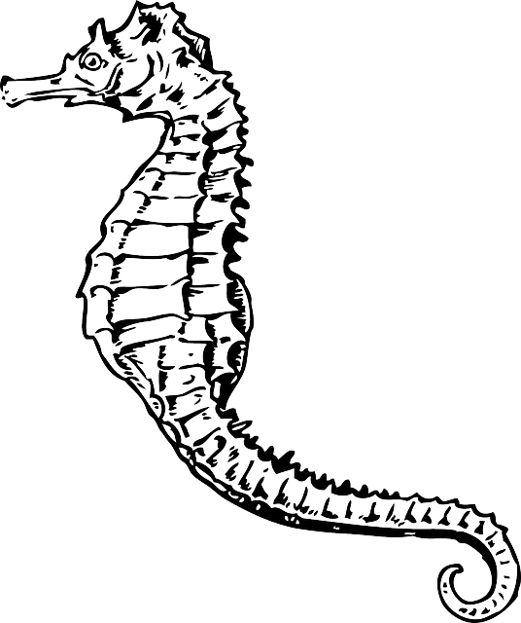

RANDOM WEIRDNESS DESIGNS

C IT B IT

SEE IT 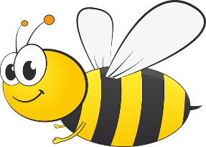 IT

Perfectly
The snuggliest
EXPECT IT

