  - Cover page
(entire page photo should be a big one split across front and back cover)
THE
ULTIMATE HIMALAYAN MOTORCYCLE ADVENTURE

www.ridenepal.co.uk

  - (please update content)
  - Page 1 Contact
  - With one foot in the UK and one foot in Nepal, we are ideally placed to organise your Himalayan adventures.
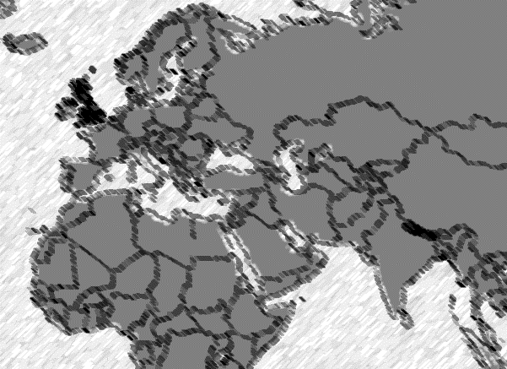
  - Got a dream of travelling to the Himalayas?
  - I’ll be your first contact right here in the UK to answer any questions regarding travelling to Nepal or Tibet. Don’t hesitate to reach me via email or directly on my mobile.
  - Already in Kathmandu?
  - Book a guided day ride if you want to experience the Himalayas by motorcycle but don’t have much time.
  - Looking forward to hearing from you!
  - Grace
  - Mobile/ WhatsApp: (+44)07493885945
  - Email: grace@ridenepal.co.uk
  - Follow, Like and Subscribe!
  - Facebook (Ride Nepal) Instagram (@ride.nepal) Youtube (Ride Nepal)
  - Find out more by visiting www.ridenepal.co.uk

  - Page 2 About Us
  - Here at Ride Nepal we are the creators and the providers of all our motorcycle tours.
  - With a life-time of experience behind us with riding the roads in the Himalayas our unique motorcycle trips will show you the world’s tallest peaks, take you over the other side of the Himalayas into Tibet, explore the tropical southern flatlands, home of the Royal Bengal Tiger and bring you to the birthplace of Buddha.
  - We have a fleet of Honda CRF250Ls , these bikes are light an agile, with a good handful of torque when you need it, perfectly suited to the mountainous terrain. And they are all fitted with ABS plus a digital dash.
  - Anyone is welcome to sign up to one of our Himalayan motorcycle adventures, no matter what gender, age, ethnicity or belief .
  - Social Work
  - Each trip we run helps provide funds for our social projects in Nepal. We currently give to the Lalit Kumari Science Scholarship Fund, which provides outstanding students from Sindhuli District with tuition and maintenance fees for university in Nepal. Sindhuli District is close to our hearts and we all would like to see this part of Nepal develop and flourish. The scholarship fund is one of the best ways to give young students a chance for further education.
  - Udaya(pic) : With many journeys both on motorbike and on foot with his friends, colleagues and clients across Nepal, travel and adventure are in his blood. Udaya’s military background makes it possible to provide personal welcomes across the country and also handle with ease any problems met with on the challenging terrain. He is a huge asset to the team and puts his heart and soul into everything he does, so you can rely on him to make your Himalayan adventure the most epic it could be.
  - Grace (pic) will travel with you to make sure your experience is unforgettable. Coming from a background in Public Health, Grace has lived in Peru, Spain, the Netherlands, and Nepal. She is from the UK and was educated at the International University of Maastricht. As well as working to make your trip to Nepal a great experience, she is your first contact in the UK for help with flight tickets, visas, vaccinations, (or simply what to pack!) via phone or email.
  - Takeshi (pic) :With 30 years of work in the tourism industry he brings a lot of experience to the team. Having a keen sense for detail his mechanical abilities often save the day and when not on a motorbike he's driving the support vehicle like a pro. Always friendly and easy-going he's great company and has a depth of technical knowledge about Nepal ranging from its architecture to its helicopters!
  - Page 4/5 Touring in the Himalayas (please spread this out over 2 pages with photo)
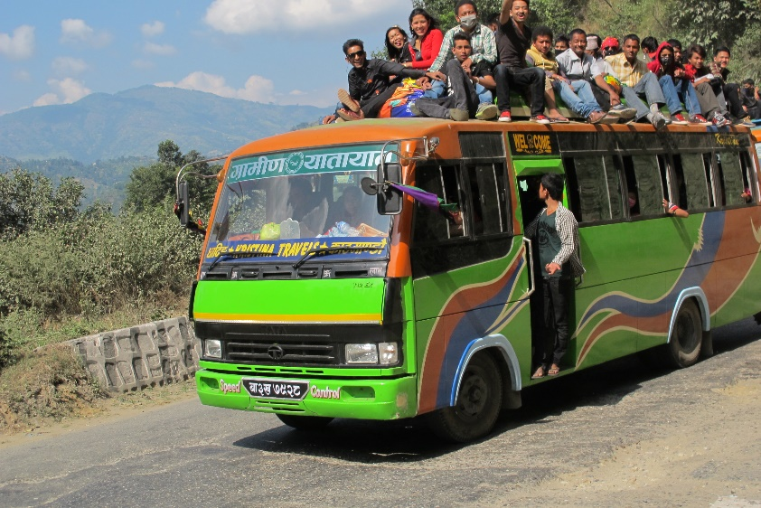
  - Nepal is a country that descends from the Rooftop of the World, Tibet, encompassing within it the 8 highest peaks of the world (including Mount Everest) that extend southwards towards the gigantic plain of India. With giant Himalayan rivers that offer unique natural beauty. It is home to countless Hindu deities, the birthplace of Buddha, the legendary Yeti, 61 ethnic tribes with different dialects and cultures. Many species of endangered and exotic animals, birds, plants and trees, including one-horned Rhinos, Musk-deer, Bengal tigers, White leopards, Dolphins, Pandas, Wild Buffalos, Wild Elephants, Himalayan Yaks, special Aardvark, Golden Eagle, migrating Siberian Goose, wild orchids and native Rhododendron Trees amongst much more.
  - It offers countless lofty and spiritual peaks, lakes, ancient Hindu shrines and temples, Buddhist monasteries and lost valleys including camps of indigenous hunting and gathering people, mobile camps of Tibetan Shepherds, and communities of Honey Hunters. The adventures are endless and amazement is around every bend.
  - Tiny villages to urban cities scattered throughout the the country are divided largely by the soaring and mystic mountains, hills, roaring and twisting serpentine rivers and streams. They offer different, unique and vibrant cultures, dialects, climates, culinary cuisines, architecture, flora and fauna providing colourful contrasts to each other. Riding and traveling around this small country brings constant changes in vista, dweller, tests, experience and atmosphere to the never ending amusement of the bewildered traveller.
  - Driving in Nepal is on the left side, as in the UK. There are many hazards to be aware of whilst riding in Nepal. The road conditions are different wherever you go. The roads can suddenly change from smooth black top to bumpy dirt without any signage or notice. There are no notice signs for hazards, obstacles or anything else so be aware and careful of, such as pot holes, mud holes, dirt patches, speed breakers, ditches, cracks, oil slicks, sand, water and streams. There are many temporary and permanent settlements on the side of the road and on the road with people, children and livestock. The road or highway is also used as a sidewalk and sometimes the front yard, so there will be people walking, sunbathing and chatting. Near the settlements you have to be aware and careful of: children playing, children going to school, adults, dogs, chickens, ducks, goats, cows, buffaloes, bicycles and people under the influence of alcohol. You will have to be aware and careful of other vehicles on the road. People, bicycles, motorcycles, scooters, tractors, rickshaws, buffalo carts, cows, elephants, cars, pickups, buses and trucks all use the road. Most of our tours travel on roads with relatively less traffic, there will always be a guide at the front and a sweeper at the back, with the support vehicle behind them for most of the way. We travel slowly as a group and always in single file, road safety is paramount in Nepal considering the risks are higher riding on mountainous roads. No racing or aggressive riding is accepted on our tours.
Accommodation in Nepal ranges from 5* resorts to small teahouses. On our tours we try to use the best available accommodation where possible as after a hard days ride, it’s great to chillout in comfort. However outside of the major cities options can be limited. Our itineraries include a wide range of accommodation including riverside resorts, hilltop hotels, jungle lodges, idyllic peninsula hideaways, teahouses and sometimes even camping. Whilst the itinerary says camping, all you need to do is show up, the rest is taken care of. Each tour’s accommodation is different as we travel to different regions of Nepal, some tours are all hotels whereas others are predominantly teahouses or a mixture of the two.
Dal Bhat: Nepalis live on a staple diet of rice, lentil soup and veggies. Outside of major cities this will be the main thing on the menu. Meat is also widely available, often either mutton, buffalo or yak meat, and sometimes chicken. In Kathmandu and Pokhara you can find all types of international cuisine.

  - Page 6: Our Services (please put every service offered with matching picture, the text can be put as an overlay)
  - Guided Motorcycle Tours around Nepal and Tibet
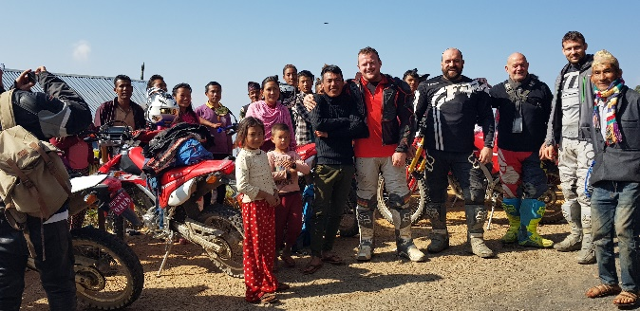
  - Day Rides around Kathmandu valley
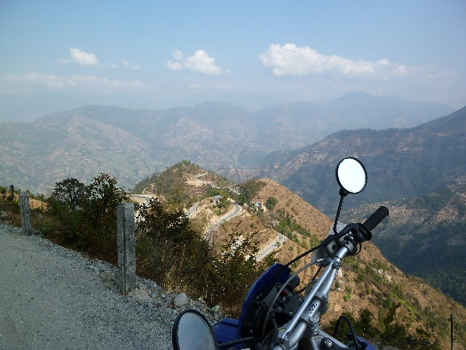
  - Bespoke Motorcycle trips: white water rafting, trekking, paragliding, bungee jump…

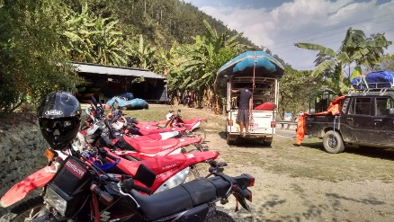
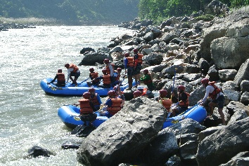
Mountain Biking
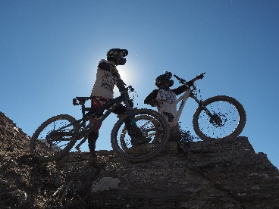
  - Heli Taxis: For those short on time, quickly access popular trekking routes or unspoilt remote destinations
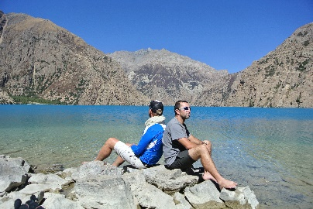
  - Yoga courses, photography, art and writing retreats…
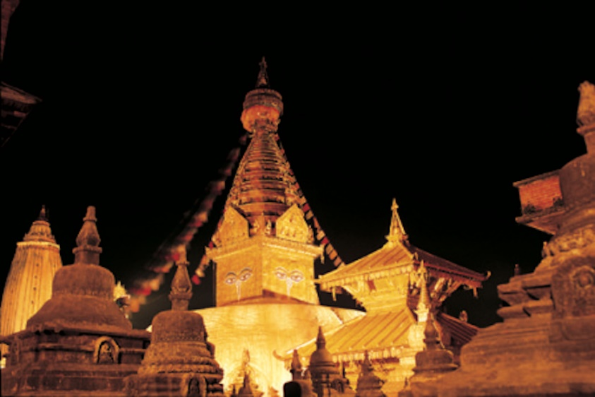
Committed to consumer financial protection:



  - Page 7/8

Please format this the best way you can.
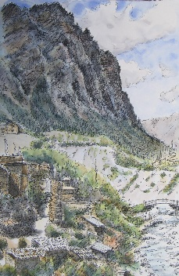
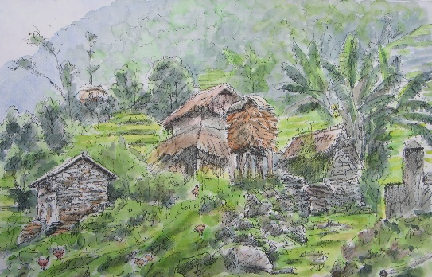
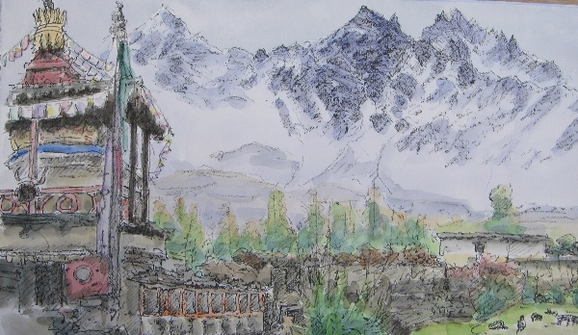
“Travelling in Nepal you will learn two very important words Namaste and Bistare. They’re equally important. One will bring a smile on everyone’s face and open all doors while the other will teach you the true meaning of this experience…patience. Thank you Nepal. See you again.” Tavi Bota

“This is not only a ride, but a complete immersive experience in the culture, foods, sights, and sounds of the wonderful people of Nepal. One may only experience this by motorcycle and travel with those who’ve lived the life of a true Nepali” Jarred Taylor

  - Page 9
  - Our tours include (please insert infographics)
- Bike rental, all fuel, all meals and soft drinks, all handpicked accommodation, friendly English speaking guides, support vehicle, permits, all transfers, mechanic/follow up rider (for groups of 4+)
Our tours exclude (please insert infographics)
- International flights, personal travel insurance, visa, tips for guide(s)/helpers, alcohol, and yetis.

Tour 1: Himalayan Highways Motorcycle Adventure

14 days
On this trip you will journey through the middle hills of Nepal, catching sight of the Himalayas and riding through tropical valleys. Riding countless switchbacks on narrow mountainous roads with mighty views. Stay within 50 miles of Mount Everest with panoramic views of 39+ Himalayan peaks from a unique hilltop in Solukhumbu. This motorcycle tour is pure adventure with a huge variety of road conditions and climates, unlocking the wild and rugged beauty of Nepal’s heritage.
After taking in the Himalayas you will travel down through the hills to lowland jungles of the Terai and safari on the back of an elephant - you may be lucky enough to spot the rare sighted Royal Bengal Tiger. Our penultimate stop before completing our circuit is the laid back lakeside town of Pokhara where you can rest and recuperate before heading back to Kathmandu.

Highlights
- Kathmandu, an ancient kingdom, the original Shangri-La, where Buddhist & Hindu temples, stupas, shrines & monasteries are written into the landscape.
- Ride through the valley of the Sun Kosi River (River of Gold)
- See Mt. Everest View and 38 other Himalayan peaks from a unique hilltop in the Solukhumbu region.
- Go on elephant back safari in Chitwan National Park
- Visit UNESCO world heritage sites
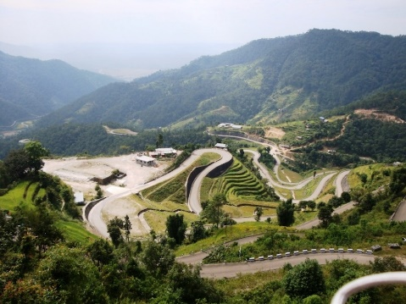
- See the Annapurna range of mountains reflected in the tranquil waters of Lake Fewa.

Page 10: Tour 2: Sky-scraping Tour through Tibet, 10 days
Time to tick this one off your bucket list! Ride Nepal takes you riding on the roof of the world on BMW F800 GS or R1200 GS.
Visiting the Palace the Dalai Lama grew up in, high altitude turquoise freshwater lakes, and of course unobstructed views of the Northern face of Mount Everest! The journey also allows two full days to explore Tibet’s old capital, the now modernised and vibrant city of Lhasa (3650m).
Accommodation will be 2-4 star hotels throughout. Riding at about 4000+m everyday on mostly well maintained tarmac roads and travelling with our own support vehicle.

Highlights
- Potala Palace, Lhasa – The Dalai Lama’s childhood home
- Ride the road to EBC, Everest Base Camp and view Mt. Everest from Rongphu at 5000m
- Yamdok Lake, one of three sacred freshwater lakes in Tibet, 72km long, this one is a brilliant turquoise
- Gyantse Fortress
- Ride by Karola Glacier
- Jokhang Temple, an ancient and important temple in Lhasa.
- Lhasa: The holy city, the centre of the Tibetan Buddhist world – Lhasa literally translates as “the place of the Gods”
- Ride over many high passes of over 5000m
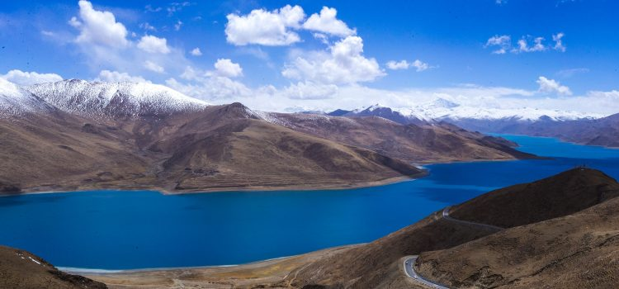

Page 10, Tour 3: Beyond the Annapurnas Adventure, 11 days
Get ready for a wild adventure into the Lower Mustang region of Nepal. This area is most likened to the Tibetan plateau as the landscape is vast and barren like a high altitude desert. Journey through a mixture of wild and rugged terrain, starting from the bustling city of Kathmandu. Visit the historic settlement of Gorkha, where the first King of Nepal started the unification of the country and home to the Gurkhas. Ride between the peaks of the Annapurna mountain range, stopping off at hot springs. Traverse through the deepest gorge in the world and onto the barren planes of the high Himalaya.
The roads are a mixture of paved and unpaved, with a lot qualifying to be some of the most dangerous in the world. This ride is not for the faint hearted!

Highlights
- 70% dirt tracks
- Gorkha palace, UNESCO world heritage site
- Pokhara, the laid back lakeside town
- Muktinath, a major Hindu, Buddhist and Jain pilgrimage site
- Ride to heights of 4000m+
- Traverse the deepest gorge in the world; The Kali Gandaki Gorge
- Hot water Springs; Tatopani
- Picturesque white washed village of Marpha
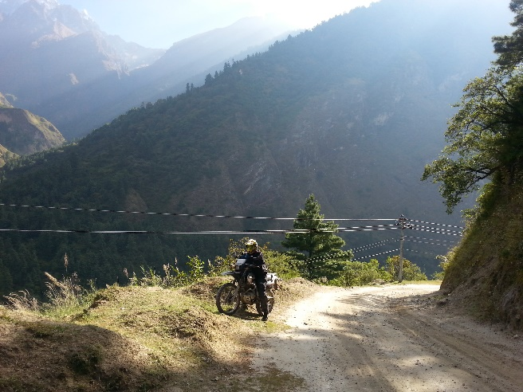

Page 11, Tour 4: Easy Everest Motorcycle Adventure, 10 days
This is a relaxed motorcycle tour with shorter riding times, designed for any level of rider. We stay on top of three Himalayan vantage points; Nagarkot, Pattale & Dulikhel to catch sight of the majestic Himalayas. Your options are kept open if you want a taste of more adventure. Explore the old kingdom of Kathmandu by motorbike before heading off to experience the amazing range of Nepal’s lustrous landscapes. You will ride through the valleys of the Sun Kosi (River of Gold) to reach a newly built road set just across from Mount Everest amongst 5 other mighty 8000+m peaks and more 6000m+ peaks of the Himalayan range of mountains. We enter the Solukhumbu region of Nepal, the most popular region for trekking in Nepal and home to Mount Everest.

Highlights
- Kathmandu, the ancient kingdom and original Shangri-La
- Ride through the valley of the Sun Kosi River, (River of Gold)
- Stay within 50 miles of Mount Everest in the Solukhumbu region.
- Views of 39+ Himalayan peaks
- Wonder the streets of Bhaktapur and admire the skilled craftsmanship and architectural prowess of the locals reflected in the palaces, temples and shrines dotted throughout the lanes of this old Kingdom neighboring Kathmandu.
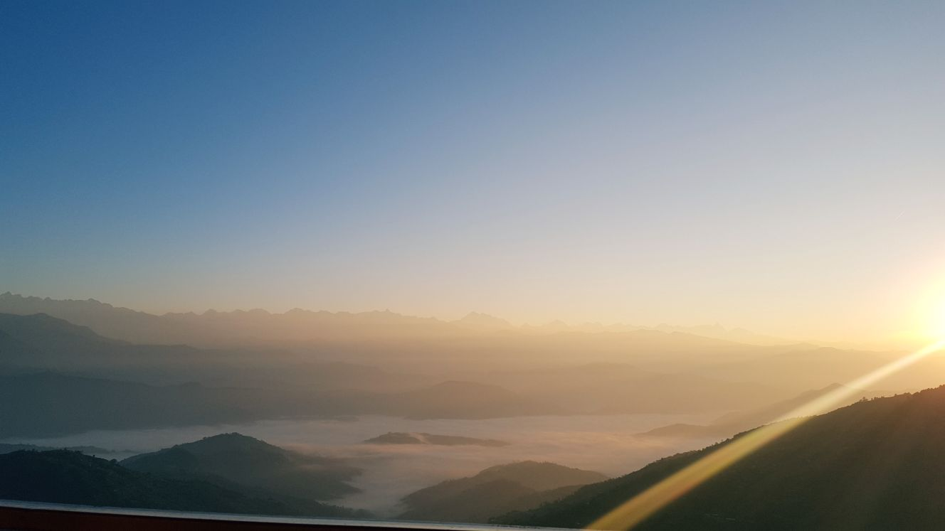

Page 11 Tour 5: Tibet Big Bike Tour: Eternal Snows of Kailash
Ride into the far corners of the roof of the world. This is the ultimate Tibetan adventure, using BMW F800S or R1200 GS to traverse the plateau, exploring the remote and barren landscapes of Tibet. Visit the most sacred mountain of earth, Mt. Kailash, watch the sunrise over the tallest mountain of earth Mt. Everest, visit the ancient kingdom of Guge, the foremost Buddhist Kingdom up til the 1600s and explore some of the highest cities on earth including Lhasa. Sightsee for two full days in Lhasa and get a guided tour around Potala Palace the childhood home of our current Dalai Lama. Accommodation will be 2-4 star hotels throughout. Riding at about 4000+m everyday on mostly well maintained tarmac roads and travelling with our own support vehicle.
Highlights
- Mt. Kailash, the sacred mountain
- Lake Manasarovar and Lake Rakchastal the freshwater and saltwater lakes that sit below Mt. Kailash
- The Ancient Guge Kingdom
- Riding the Far Western Tibetan plains
- Potala Palace, Lhasa – The Dalai Lama’s childhood home
- Ride the road to EBC, Everest Base Camp and view Mt. Everest from Rongphu at 5000m
- Yamdok Lake, one of three sacred freshwater lakes in Tibet, 72km long, this one is a brilliant turquoise
- Gyantse Fortress
- Ride by Karola Glacier
- Jokhang Temple, an ancient and important temple in Lhasa.
- Lhasa: The holy city, the centre of the Tibetan Buddhist world – Lhasa literally translates as “the place of the Gods”
- Ride over many high passes of over 5000m
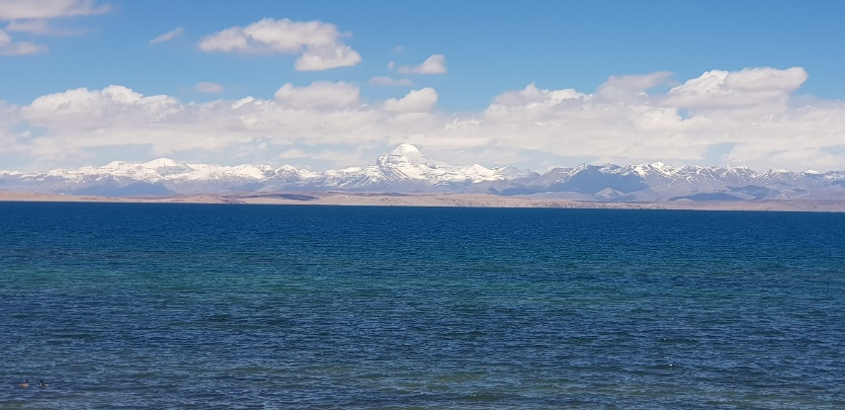

Page 12, Tour 6: The Thousand Petalled Lotus Motorcycle Adventure, 10 days
Buddha, the most famous of all Buddha’s, born in the beautiful Lumbini Gardens in South Nepal in the 6th century BC. Ride the oldest highway in Nepal, see the Annapurna range of mountains reflected in the tranquil waters of Lake Phewa, traverse the southern flatlands, home to wild jungles and the rare sighted Royal Bengal tiger. This is a relaxed motorcycle tour all on paved roads, great option for those who want adventure, comfort and culture.

Highlights
- Ride beside large Himalayan rivers
- Lumbini, Buddha’s birthplace and UNESCO world heritage site.
- Chitwan National Park
- Pokhara, the laid back lakeside town
- Kathmandu, the ancient kingdom where Buddhist stupas and Hindu temples and shrines are written into the landscape.
- Ride over a suspension bridge to reach your tropical riverside resort.
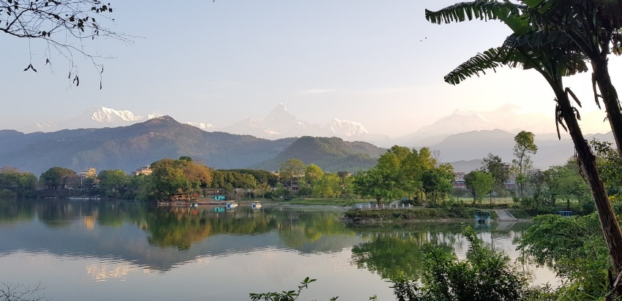

Page 12 Tour 7: Manang 9 days
Truly epic adventure biking in the Manang region of Nepal. The roads are mostly gravel or dirt tracks, some challenging sections of the road into Manang which the waterfalls used to run over the top of have now been diverted underneath. So that life threatening thrill is no longer there, which for some may be disappointing but for many a relief! There’s still loads of fun to be had riding here, the roads are spectacular; carved into the hillsides with rushing rivers in the valley below. All the unbelievable scenery, and the fact that you get taken right into the mountains, makes this one of our most appealing tours. The HondaCRF250Ls are in their prime here. Also perfect for anyone on a budget as this 9 day tour keeps the cost of pure adventure affordable.
Highlights
- Lots of dirt tracks
- Shorter Tour Length
- Breath taking views and epic mountain roads
- Kathmandu & Gorkha UNESCO world heritage sites
- Manang and Gangapurna
Page 13
Testimonials
Jarred Taylor 2019
“… True, you may take a Tata truck, horse or trek, but never can you cover as much ground as you can with an off road motorcycle. The ride is well planned, so you always have a hot meal, time for rest or coffee, a hot shower and a quality meal after a long day’s journey. The views are epic and do expect to …push yourself to new heights with confidence only given to you by experienced guides. The ride is what you make of it; do take time to enjoy and document your surroundings, meet new people, try new foods and participate in the culture of Nepal! Udaya knows just about everyone in Nepal so do expect to meet great people along your journey and learn much about the history of Nepal. Udaya and Takeshi are experienced riders both on dirt and on Tarmac. Do not fear the roads, as they are with you every step of the way and instil confidence in your riding abilities. This is one epic journey and not to be missed! Namaste :)”
-Cara Linscott 2018
“On behalf of Bikesport Gavin and gang had a fantastic adventure with great organisation and all fantastic value for money…highly recommended”
-David Gloyne 2018
“What an amazing trip, the guides couldn’t do enough for you and were happy to make changes to keep everyone pleased..! Can’t wait to book my next adventure with them..!”
–Sean Jobson 2018
“Me and 3 mates just have done this trip and we have nothing but good things to say.
From start to finish the whole team goes above and beyond what you expect to make sure the trip suits what you want. We have done everything from off-road to road riding to see the most beautiful views I have ever seen. I personally and my 3 mates are definitely booking with these guys again and I would recommend them to everyone. I would like to say thank you to the whole team for making our trip amazing and hopefully see you all again soon. Thanks, Sean”
-Teresa and Jeremy Grant 2018
“Had a holiday to remember. Nepal is a stunning country to tour and the holiday was made very special by all the hard work and knowledge of Ride Nepal guides, Udaya, Grace, Takeshi and Rajeev. Highly recommended and enjoyable.”
-Harry Squib 2018
“Great bunch of guys and a fantastic experience, highly recommended, once in a lifetime trip thanks guys for everything.”
-Simon Blakeborough 2015
“This was a trip of a lifetime which I would recommend to anyone who loves adventure. Road Motorbiking( I use the word road in the broadest sense), off road motorbiking, trekking in the most beautiful and unspoilt part of Nepal(we saw two other groups of tourists in 2 weeks!) and rafting. The trip was well organised, though flexible to allow us to include all we wanted, even when things changed (fuel crisis and weather) …and the Motorbikes were excellent, I rode a new CRF250!!... I cannot recommend this trip and this company highly enough, and I am hoping to go back next year. Many thanks to Udaya, Takeshi and the team. Brilliant”

