

TILTED TOUCH SCREEN TABLES
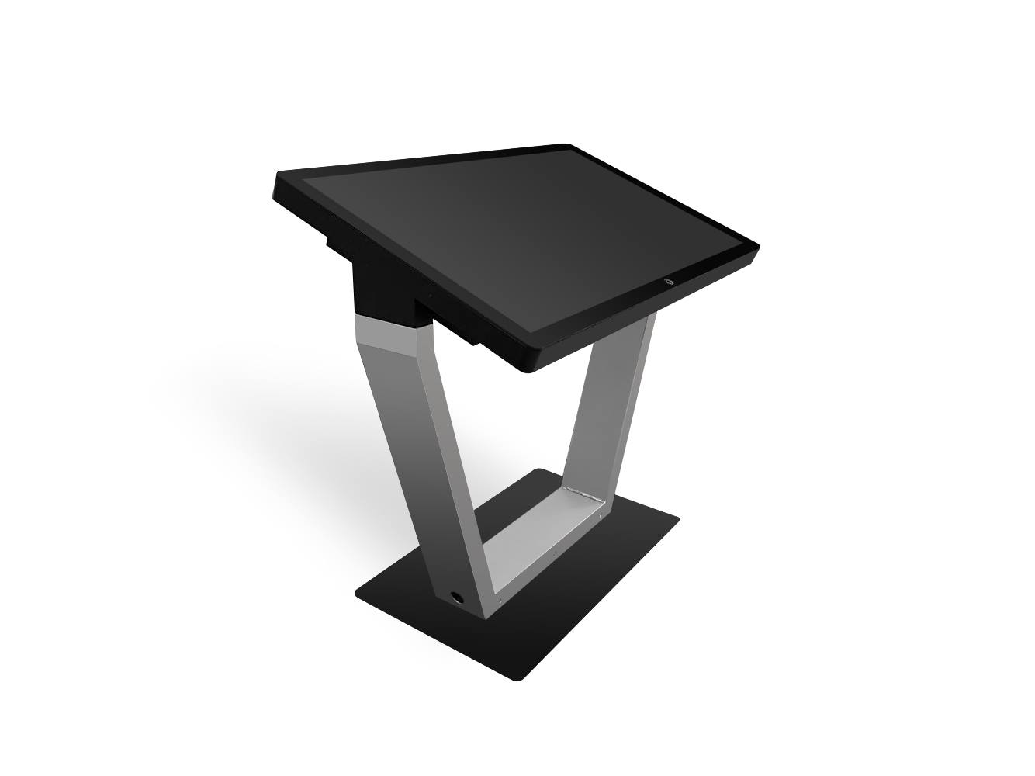


Digital Touch Systems, Inc.
7216 E US HWY 290 Austin, TX 78723
512.600.0461
digitaltouchsystems.com
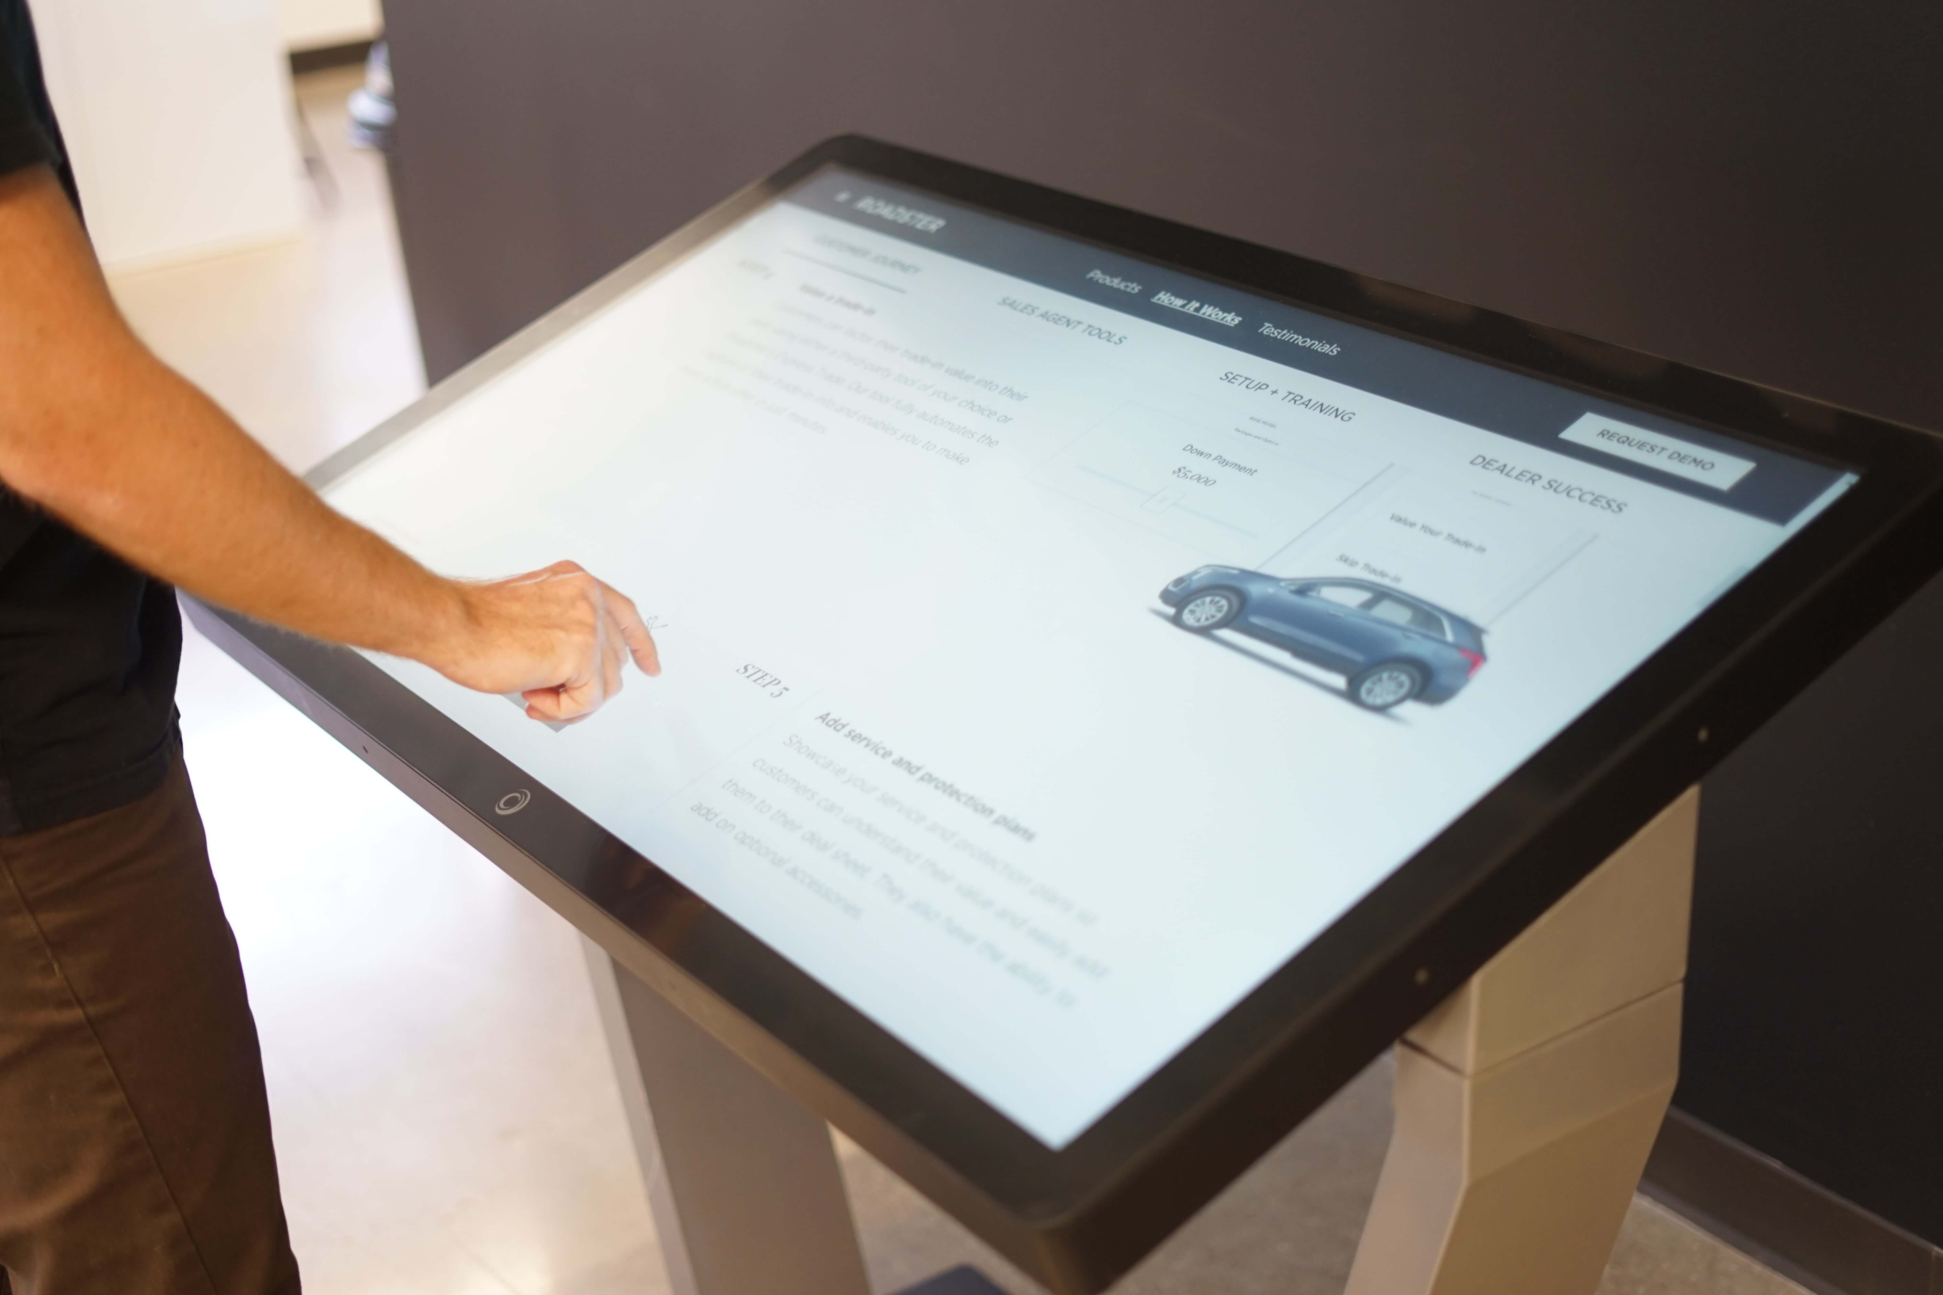

With a tilted touch screen that you can approach at any time, use for as long or as short a time as you need, and return to what you were previously doing. The 20 degree tilt is ideal for displaying content in landscape mode.

It’s also perfect as a standing desk, or for greeting visitors who need to sign up, register, or become accustomed to the layout of your building.

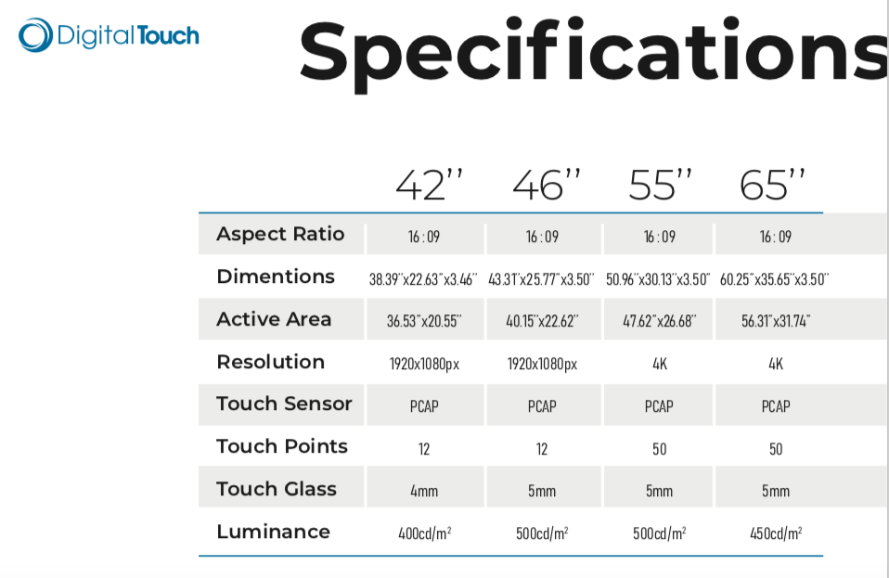

PRICING

