I want to design a calendar to have printed. I have some text and images and I need someone to apply a theme/ design to it. I have the dimensions also.. they are attached for reference. But the calendar will start in January 2020 and go thru December 2020.

But this will give you an idea of what I am looking at.

I want the upper part where it says "January image" ETC to laid out with a theme for each month. It’s for Digital Marketing. So each month will be a different theme. Like Social Media, PPC, Website Design, Reputation Management, Etc. I want the upper image and design to flow thru the calendar below. There are a few things I want to display in the dates on certain months. Like USA Holidays and also some Digital marketing conference dates/ Also I wanted to have the calendar a little smaller on the right side and have a Task List with items in it to do for that month.
Sample of text in the calendar blocks.

This is the list type I want o the side of the calendar. Layout is what I like in this image.
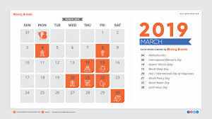

I Like the realness and adding the color to the style.

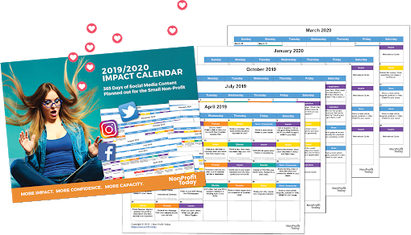
I like that this has some text in the date blocks. I would not have this much but this is what I like about this image.
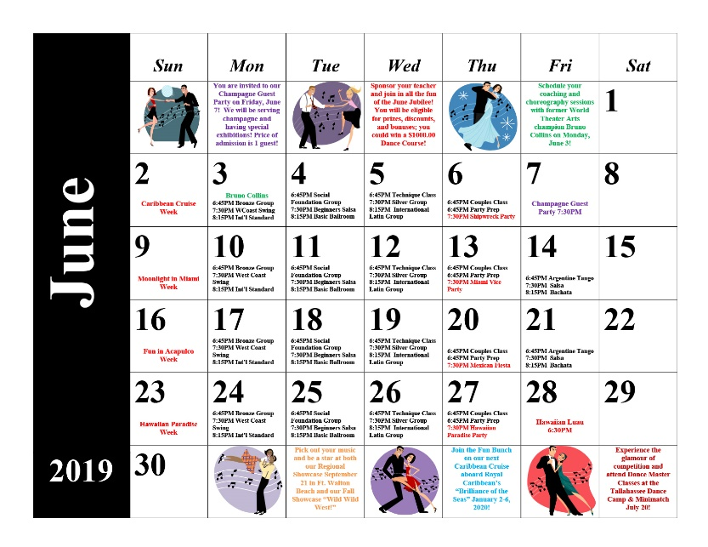

I like that this has a design thru the image. I no not necessary love this design- but this is the tyoe of feel I want with it flowing to the top page also. Disregard the image layout. Just looking at the design aspect. 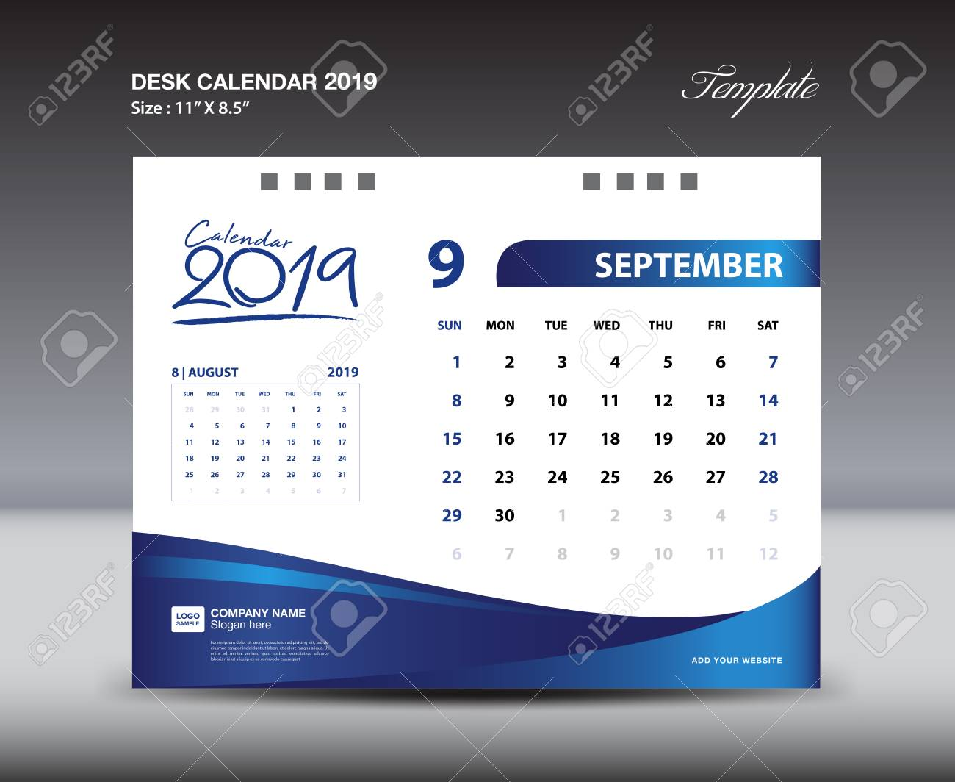

Also like the design
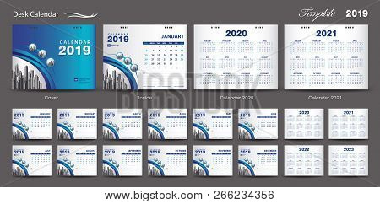

Love the colors on this one. 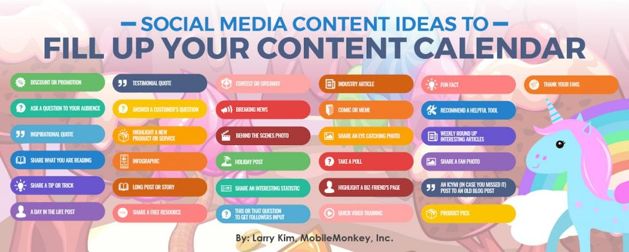

Colors and icons

I like the designs of the below for themes ideas. 

