


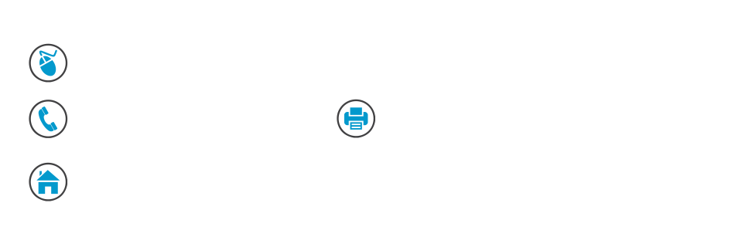


residentialreports.com.au

6288 0402 6288 9516

35 Poynton Street Hughes ACT 2605
155 Bettington Circuit
Charnwood

Report Prepared:

12 June 2019

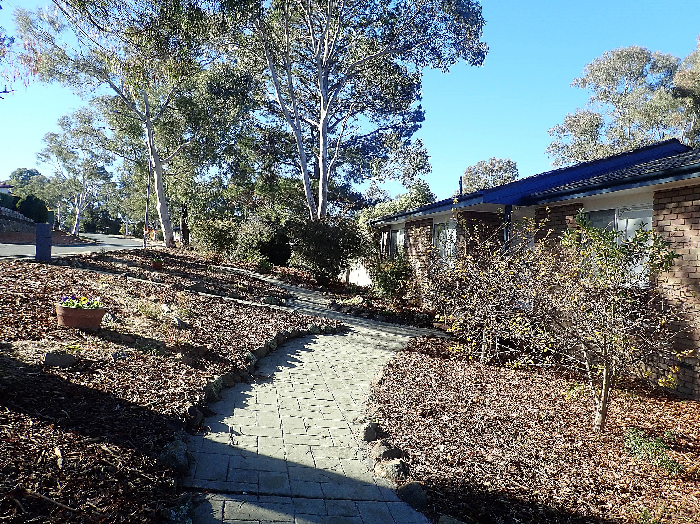

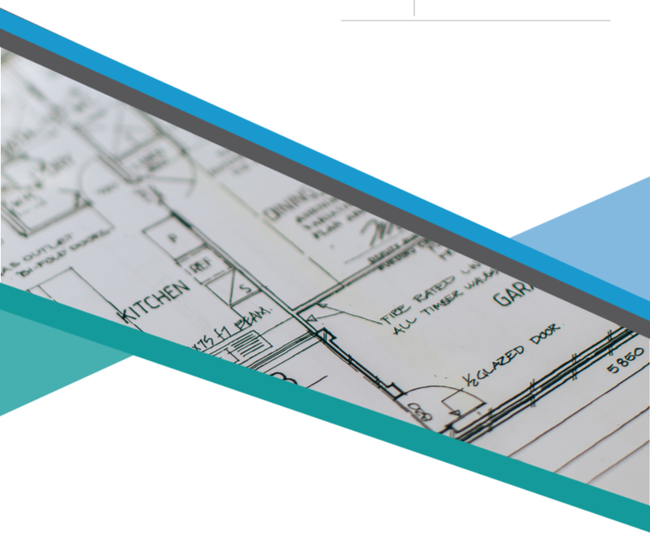
IMPORTANT INFORMATION
RELATING TO THIS REPORT
This report is written with reference to Australian Standard AS 4349.0-2007 Inspection of Buildings (General requirements) and AS 4349.1-2007 Inspection of Buildings (Pre-purchase inspections - Residential Buildings) and is the result of a VISUAL INSPECTION ONLY. It is intended to be read in its entirety. If there are any discrepancies between the “Report Summary” and the Detailed Report, the detailed report information should be relied upon. It is important that you carefully read the complete report including the Warranty & Use, Scope of Inspection and the Scope & Limitations sections prior to making any critical decisions that may be influenced by this report.

Significant structural defects or maintenance items that have a substantial cost associated with repairs, or where in our opinion may have an influence on the decision to purchase the property are documented in this report.

Where reference has been made to termites, maintenance items or defects of significance we recommend that prior to making a decision to purchase the property the advice of a suitably qualified tradesman who is able to quantify the extent and cost of appropriate remedial action is obtained.

Where reference has been made in this report to cracking, settlement, movement or an opinion has been provided on structural integrity, it is important to note that we are not experts in this area and our advice is limited accordingly. If considered necessary, further advice should be obtained from a Structural Engineer before critical decisions are made. Any cracking reported should be monitored for further movement. Superficial or hairline cracks that are considered to have no immediate structural implications will not be identified. Please refer to the Compliance Report to ensure that you identify any unapproved or non-compliant structures.

Extracts from the Australian Standard
incorporated into this report have been
reproduced with the permission of SAI
Global under Residential Reports
Copyright Licence 1104-c092

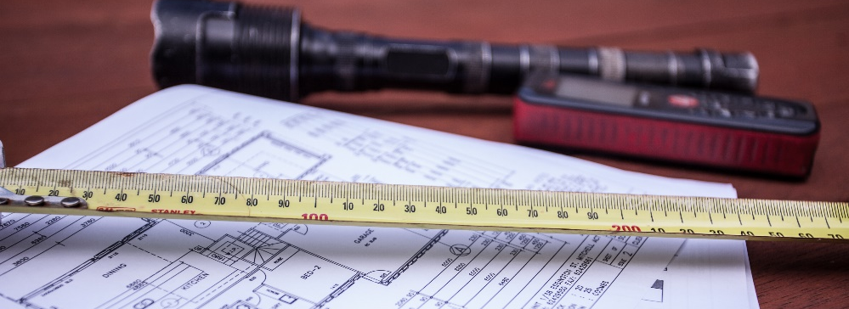

REPORT
SUMMARY

ADDRESS 67 Bettington Circuit Charnwood
BLOCK NUMBER 2
SECTION NUMBER 87
Inspection Date 11 June 2019
Inspector Terry Bennett
Client Sample Client
Our Reference 26091
Weather Conditions Fine

Living Area (approx. sqm) | 139
Occupancy Status | occupied - the dwelling was furnished at the time of inspection
Wall Construction | brick veneer construction
Roof Construction | timber truss construction concrete tile roof covering
Floor Construction | timber bearers and joists with tongue and groove flooring
Energy Rating | 0.5 stars
Construction | the dwelling is of adequate construction and structural workmanship for this type of residential development and its condition is commensurate with the era of construction, design, age and use
Maintenance | there are maintenance items detailed in this report, please read the entire report carefully
Timber Pest Report | no evidence of active subterranean termites (live species) was found at the time of our inspection
This report is intended to be read in its entirety. Please read the full document including detailed inspection information and the Scope & Limitations of Report before reaching any conclusions regarding the condition of the property. If there are any discrepancies between the “Report Summary” and the Detailed Report, the detailed report information should be relied upon.

Property Access
The following extracts from the Australian Standard AS 4349.1-2007 should assist the reader to understand how we have approached the inspection and define the general focus of the report:
2.3.1 GENERAL - The inspection shall comprise visual assessment of the property to identify major defects and to form an opinion regarding the general condition of the property at the time of inspection.
4.1 GENERAL - It is necessary to inspect each of the areas and items set out in Section 3; however, it is not necessary to report on each one. An inspector may choose to report only on an ‘exceptions basis’, i.e., listing only defects, rather than also reporting items that are in acceptable condition.

Restricted access caused by stored goods, furnishings, window treatments, floor coverings, security devices, vegetation, duct work, confined spaces, insulation and other impediments will limit the scope of this inspection. Whilst every effort has been made to conduct a comprehensive roof cavity inspection there are limitations relative to safe access requirements which include low clearances, the availability of safe walk-ways and work-safe roof temperatures, conditions which when applicable will limit the scope of the inspection. The roof exterior is inspected when accessible from a 3.6 metre ladder, or from ground level where there are height restrictions.

- interior - our inspection of the interior was restricted by;
- furniture and stored goods in cupboards and under sink units
- window treatments and floor coverings
- stored goods within the dwelling
- subfloor - access was significantly restricted by;
- low clearances
- duct work
- insulation
- stored goods
- work health and safety requirements restricted the scope of the inspection
- roof cavity - access was significantly restricted by;
- low clearances
- insulation covering the ceiling framing
- roof exterior - access was restricted by;
- safe access considerations required a top of ladder inspection for some areas and ground level inspection for the height restricted areas
- safe access limitations did not allow for all areas of the roof to be inspected
- external structures - our inspection of external structures is restricted by;
- garden foliage or overgrowth restricted access to some structures
- stored goods restricted access to some areas

Where accessible, roof covering, roof cavity and subfloor images are featured below.
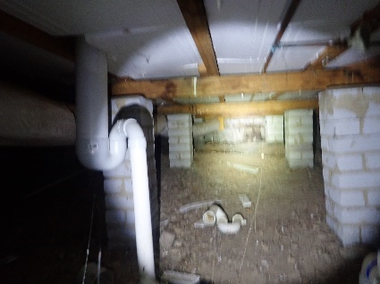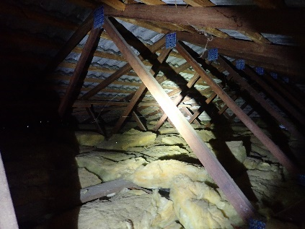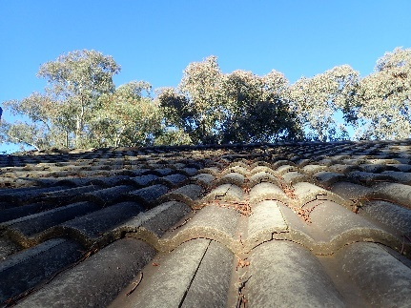

The following extracts from the Australian Standard AS 4349.1-2007 should assist the reader to understand how we have approached the inspection and define the general focus of the report:
2.3.1 GENERAL - The inspection shall comprise visual assessment of the property to identify major defects and to form an opinion regarding the general condition of the property at the time of inspection.
4.1 GENERAL - It is necessary to inspect each of the areas and items set out in Section 3; however, it is not necessary to report on each one. An inspector may choose to report only on an ‘exceptions basis’, i.e., listing only defects, rather than also reporting items that are in acceptable condition.

PROPERTY
REPORT

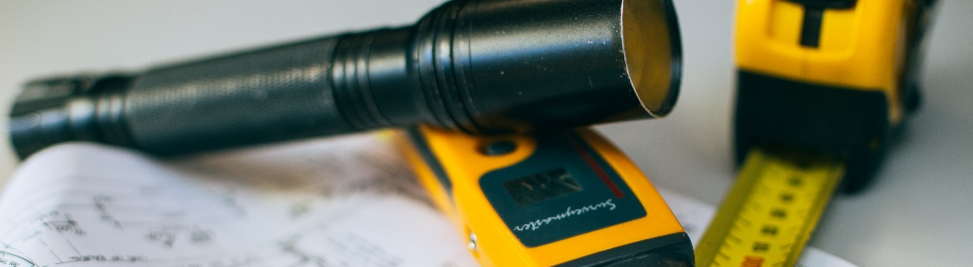

The following extracts from the Australian Standard AS 4349.1-2007 should assist the reader to understand how we have approached the inspection and define the general focus of the report:
2.3.1 GENERAL - The inspection shall comprise visual assessment of the property to identify major defects and to form an opinion regarding the general condition of the property at the time of inspection.
4.1 GENERAL - It is necessary to inspect each of the areas and items set out in Section 3; however, it is not necessary to report on each one. An inspector may choose to report only on an ‘exceptions basis’, i.e., listing only defects, rather than also reporting items that are in acceptable condition.

SCOPE OF INSPECTION
It is our role to conduct a thorough visual inspection of the property and report only on areas of concern, identifying critical defects for an intending purchaser, insofar as an inspector can reasonably identify those defects. When reading this report, the age of the building must be taken into consideration. Some items may not have been detailed as they are considered a normal occurrence or general wear and tear for a building of this age. Electrical appliances and utilities such as water reticulation, electrical wiring or gas installations, swimming pool and spa equipment were not inspected. Qualified technicians should be consulted in regard to these items. The report is not designed to quantify features of the property, generally, ongoing maintenance items, upgrading, cosmetic works and minor defects or faults will not be detailed.

The Property Inspector uses the following terms when describing the standard of a building or a particular item being evaluated:
No significant defects have been identified
This overall condition is applied where the inspector has not identified any defects that are considered to be significant from a structural or functional perspective. The subject area may present with minor defects. Remedial action, if required, is discretionary. Good, Fair or Poor may be used when an area has been given this condition.
Defects have been identified
This overall condition is applied where the inspector has identified defects that require remedial action or investigation. Remedial action is considered to be necessary rather than discretionary. Good, Fair or Poor may be used when an area has been given this condition.
Good: The feature subject to comment is, in the inspector’s opinion, of sufficient standard to not require any significant remedial action. There may be imperfections in the finish or the structure.
Fair: The feature subject to comment is, in the inspector’s opinion, usable but has deteriorated and would benefit from cosmetic or remedial repair work. For instance, painting may be required, render may require patching, and door fittings may require adjustment or repair.
Poor: The feature subject to comment in the inspector’s opinion, requires remedial action. Repairs or replacement are considered necessary rather than discretionary.

STANDARD INDICATORS



All of the above terms are used having regard for the age, quality of workmanship, style and type of construction of the building being inspected. For example, the features and finishes considered “good” in a 50 year old building are not necessarily going to be so in a modern dwelling. Our inspectors do not quantify the cost of repairs to any defects as this will be highly variable based on your service provider and the remedial action chosen.

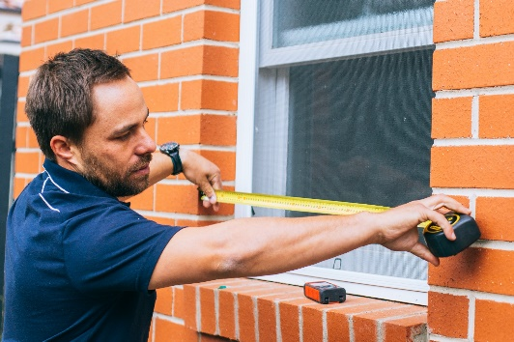
WHAT OUR INSPECTOR
EXAMINES


We are aware that many comments made throughout this report are repetitive. However, this is designed to inform the reader that the elements commented on have been inspected.
To provide relevance and value for the reader, at the end of this report we have included a summary showing aspects that are considered during our inspection. We recommend that you read this information carefully to gain perspective about the detail of our examination. Comment on many items will only be provided in the event of an adverse finding that may have an influence on any decisions relating to the value of the property.
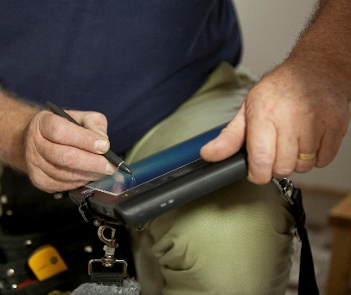

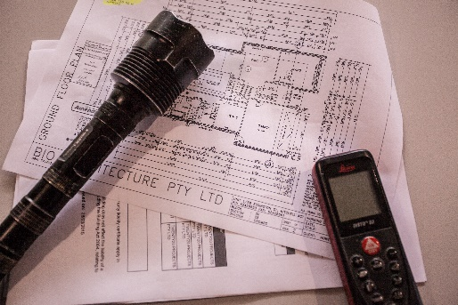

Interior

Entrance
- ceilings and cornices - good
- walls - good
- architraves and skirting boards - good
- doors and windows internal - good

Bedroom One
- ceilings and cornices - good
- architraves and skirting boards - good
- walls - good
- doors and windows internal - good

Bedroom Two
- ceilings and cornices - good
- architraves and skirting boards - good
- walls - good
- doors and windows internal - good

Bedroom Three
- ceilings and cornices - good
- architraves and skirting boards - good
- walls - good
- doors and windows internal - good

Ensuite
- ceilings and cornices - good
- walls - good
- architraves and skirting boards - good
- doors and windows internal - good
- vanity and basin - good
- shower screen - good
- toilet suite - good
- ventilation -
- ceiling fan unit (with heat lamps)
- water leakage -
- no water leakage was detected
- wall tiles - good
- floor tiles - good
- fit-out - good
- hardware, fixtures and fittings - good

Bathroom and Toilet
- ceilings and cornices - good
- architraves and skirting boards - good
- walls - good
- doors and windows internal - good
- vanity/hand basin - good
- shower screen - good
- bath - good
- ventilation -
- ventilation is provided by a ceiling mounted exhaust fan
- toilet suite - good
- water leakage -
- no water leakage detected
- wall tiles - good
- floor tiles - good
- fit-out - good
- hardware, fixtures and fittings - good

Laundry
- ceilings and cornices - good
- architraves and skirting boards - good
- walls - good
- doors and windows internal - good
- laundry tub - good
- water leakage -
- no water leakage was detected
- wall tiles - good
- floor tiles - good
- hardware, fixtures and fittings - good

Kitchen, Dining and Family Area
- ceilings and cornices - good
- there is some sagging or undulations to the ceiling lining - however, this was not considered structurally significant at the time of our inspection
- architraves and skirting boards - good
- walls - good
- splashback - good
- doors and windows internal - good
- ventilation -
- ventilation is provided by a recirculating range hood
- kitchen fit-out - good
- the kitchen fit-out is in functional condition with normal wear and tear evident
- hardware, fixtures and fittings - good
- sink - fair to good
- the sink is showing signs of deterioration, no leakage was detected

Living Room
- ceilings and cornices - good
- architraves and skirting boards - good
- walls - good
- doors and windows internal - good

Hallway
- ceilings and cornices - good
- architraves and skirting boards - good
- walls - good
- doors and windows internal - good

Roof Cavity
- insulation -
- the roof cavity is insulated with fibreglass batts
- sarking -
- no sarking has been installed in the roof cavity
- FOR MORE INFORMATION Go to the index page at the end of this report and read resource 16 - Sarking
- roof construction -
- timber truss construction

Exterior

PLEASE NOTE
- Roof waterproof integrity and roof drainage is not tested during our inspection therefore it is not possible to determine the effectiveness of the roof cover and drainage system under all conditions. Please refer to the Scope and Limitations section of this report for more information.

- Where structures are obscured by foliage, or other concealments, evidence of timber pest activity, damage or other defects may be concealed.

Roof Exterior
Overall condition: no significant defects

- concrete tile roof covering
- the condition of the tiled roof covering is commensurate with the age of construction, on older roofs over time, tiles and pointing can crack and there may be corner breakages, sometimes flashings may need to be repositioned. No leakage was detected at the time of inspection

Gutters and Downpipes
Overall condition: no significant defects

- some areas of the guttering are rusting and should be monitored to ensure drainage system continues to function effectively
- gutters need to be cleared of leaf litter, silt and debris to ensure that maximum roof drainage occurs in all weather conditions. Additionally, the leaf litter may be concealing rust or damage to gutter system

Eaves, Fascia and Barge Ends
Overall condition: no significant defects

Wall Construction Exterior
Overall condition: no significant defects

- brick veneer construction
- FOR MORE INFORMATION: Go to the index page at the end of this report and read Resource 5 - Brick Veneer Wall Construction
- there is movement cracking in the exterior masonry beneath the bedroom 3 window, while the cracks were not considered to be structurally significant at the time of our inspection they should be monitored over time to ensure that there is no ongoing movement. In the event that significant movement is detected, consideration should be given to obtaining the opinion of a Structural Engineer to determine the most appropriate remedial action

Doors and Windows External
Overall condition: no significant defects

Sub Floor
Overall condition: no significant defects

Floor Construction
Overall condition: no significant defects

- timber bearers and joists with tongue and groove flooring
- undulations were noted to the flooring between the kitchen and family area. There is no evidence that this is caused by structural deficiency and appears to have been this way since the construction of the extension. Remedial action was not considered necessary at the time of inspection
- there are some squeaky floorboards. Squeaky floorboards are not generally structurally significant and in this instance we have no concerns regarding structural integrity

Driveway
Overall condition: no significant defects

- there is some movement cracking in the driveway

Paths and Paving
Overall condition: no significant defects

- there is some minor cracking to the paths

Steps and Stairs External
Overall condition: defects have been identified

- the sleeper stairs are deteriorating, replacement will be required in the near future

Retaining Walls
Overall condition: no significant defects

Balustrades and Handrails
Overall condition: defects have been identified

- the deck balustrades are not built to regulation height of 1.0m above the floor level. In the interests of safety, rectification is recommended

Fences and Gates
Overall condition: no significant defects

- previous termite damage was sighted to some fencing timbers. No live termites were sighted, remedial action is not required - refer to detailed pest report for further information

Garage Area
Overall condition: no significant defects

- description -
- the single parking space is on the lower level
- wall construction exterior - good
- brick construction
- floor construction - good
- concrete slab construction
- there is no evidence that the floor has any significant defects, stored goods prohibit a visual inspection of some areas so it is possible that defects may be concealed
- doors - good
- one tilt door has been fitted

Rear Storage Shed
Overall condition: defects have been identified

- description -
- detached metal shed
- roof exterior - good
- metal deck roof covering
- the condition of the metal roof covering is commensurate with the age of construction, typically over time some fixings will ease and the sheeting will deflect and there can be oxidation of the metal surface At this inspection we found no evidence of roof leakages
- gutters and downpipes - fair
- some areas of the guttering are rusting and should be monitored to ensure drainage system continues to function effectively
- gutters need to be cleared of leaf litter, silt and debris to ensure that maximum roof drainage occurs in all weather conditions. Additionally, the leaf litter may be concealing rust or damage to gutter system
- wall construction exterior - fair to good
- metal cladding
- surface rust is evident to the cladding in some areas, preventative maintenance is recommended to prevent further deterioration
- impact damage was evident to some areas of the cladding
- floor construction - good
- concrete slab construction
- there is no evidence that the floor has any significant defects, floor coverings prohibit a visual inspection so it is possible that some minor defects may be concealed
- ceilings and cornices - good
- doors and windows internal - good
- eaves, fascia and barge ends - fair to poor
- there is timber decay in the fascia boards. Repair or replacement is likely to be required in the near future

Deck
Overall condition: no significant defects

- decking timbers - good
- structural integrity - good
- deck support posts - good

Deck - Entry
Overall condition: no significant defects

- decking timbers - good
- structural integrity - good
- deck support posts - good

Pergola
Overall condition: no significant defects

- pergola roof - good
- metal deck and polycarbonate roof
- pergola timbers - good
- structural integrity - good



COMPLIANCE REPORT

IMPORTANT NOTE: This report relates to Building and Development approvals only. If you are considering obtaining approval for unapproved structures or alterations prior to or following the sale of this property, please contact our office on 6288 0402 and our expert Certification team will make your project a priority.

Plan No.  (if applicable) | Description | Date of COU  Approvals  (Certificate of Occupancy) |  | Comments
52100 & 52100/A | brick veneer residence | 15/05/1979 |  | the front deck differs from plans
52100/B | metal storage shed | 2/06/1981
52100/C & 52100/D | timber carport | 7/02/1983 |  | the structure no longer exists (did not proceed or has been removed)
52100/F | additions to residence | 12/10/1984
52100/E | fireplace and hearth |  | no certificate of occupancy issued for 52100/E, permit only  the structure no longer exists (did not proceed or has been removed)
 | deck and pergola |  | approval is required - the structure exceeds allowable dimensions for exemption
 | installation of timber doors to family area |  | approval is required - doors exceed 2.0m in width
 | dining area window installation |  | approval is not required - window is less than 2.0m wide
 | bathroom upgrade |  | approval is not required
 | stone retaining walls and timber steps |  | approval is not required  the stone retaining walls are located outside of the boundary in some areas
 | timber retaining walls |  | approval is not required

Survey Reports | Date | Comments
Allan J Mail & Associates | 6/02/1979 | the surveyor's report indicates that there are no encroachments onto this property nor by this property onto adjoining properties

NOTE For more information regarding current dimensions and approvals regulations please visit: www.planning.act.gov.au/topics/design_build/da_assessment/exempt_work

A Building File from Access Canberra has been obtained to complete this Compliance Report. Documentation in this file may include: floor plans, site elevations, Certificates of Occupancy & Use, file index, survey reports and drainage plans. This report is based on an examination of the building file documents and a visual inspection by our Company of this property. The report deals with matters of compliance from the plans and documentation provided. Please note that where the detail on plans has been compromised or is illegible, Residential Reports will not accept any liability for omissions or errors in our report. Please read the Compliance Notation in our Scope & Limitations Section.

Easements: An easement is a section of land registered on your property which gives another party the right to access it for a specific purpose. An example is a section of the property that contains municipal services such as electricity, water or drainage infrastructure. If a structure has been identified as requiring approval and is located on an easement the appropriate utility provider is consulted during the certification process and it is they who determine if an application for approval will be supported. TCCS, PLUMBING & ELECTRICAL APPROVAL: If this report reveals structures or alterations that require Transport Canberra & City Services (TCCS), Plumbing or Electrical Approval or cites plumbing and electrical additions and or alterations, please note that approval may have been granted, however, documentation is not provided in the building file. The Environment & Planning Directorate or the owner may have further information. Development Approval: If this report identifies structures that require Development Approval, information relating to the status of Development Approvals relative to those structures will be shown on the Lease Conveyancing Enquiry provided by the solicitor. This will be included in the Conveyancing Contract for Sale. Development Approval information is not contained within the building file and is not available to the Building Inspector.

TIMBER PEST REPORT

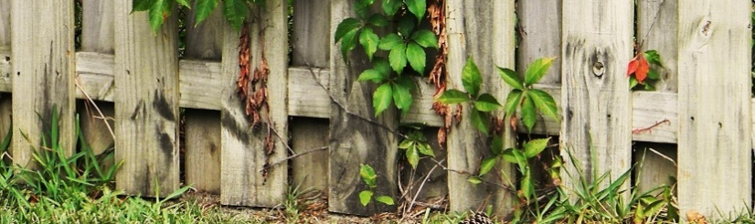

Our visual inspection is undertaken to identify the following timber pests:
- Subterranean termites
- Borers
- Timber decay (rot) fungi

Where applicable and where there is reasonable access, the following areas are examined during our Timber Pest inspection:
- Interior and exterior of structures, roof cavity, subfloor, garage or carport, garden and storage sheds/outbuildings, retaining walls and garden borders, pergolas and decks
- Structures, fences and trees within 30m of the building within the boundaries of the property

Inspection Results

Occupancy Status
- occupied - the dwelling was furnished at the time of inspection

Live Species
- no evidence of active subterranean termites (live species) was found at the time of our inspection

Timber Pest Evidence
- evidence of previous termite activity was sighted in;
- evidence of old termite activity was sighted to some fencing timbers. No live termites were sighted
- there is evidence of timber decay;
- timber decay is present to the sleeper steps and the rear metal shed fascia boards

Subfloor Drainage & Ventilation
- our inspection indicates that the subfloor drainage and ventilation is generally acceptable

Recent Termite Treatments & Recommendations
- we found no evidence of any recent termite treatment

- previous termite activity was sighted to some areas of the property
our visual inspection revealed evidence of previous termite activity however, we did not find any evidence of current termite activity and no live species were found. It may be prudent to conduct a more invasive inspection to determine if there is any termite activity in areas that could not be inspected visually. Physical probing of surfaces or the deployment of an infra-red scanning camera may prove useful

Overall Susceptibility of the Building to Timber Pest Infestation
- considering all of the relevant factors, it is our opinion that the overall degree of risk of timber pest infestation to the property is MODERATE to HIGH - we strongly recommend that regular inspections are undertaken

IMPORTANT INFORMATION:
- Where a property is furnished at the time of inspection, you will appreciate that the furnishings, floor coverings and stored goods may be concealing any evidence of Timber Pest Activity.

- Where fences are obscured by foliage, overgrowth or structures, evidence of timber pest activity or damage may be concealed.

- Poor subfloor drainage increases the likelihood of termite attack. If drainage is considered inadequate, a plumber or other building expert should be consulted. Ventilation of the sub-floor region is important in minimising the opportunity for subterranean termites to establish themselves. If the ventilation is found to be inadequate, remedial measures should be taken. Consideration should be given to installing high air flow vents and/or improve the cross flow of air within the subfloor to produce ventilation equivalent to 8400 sq mm net ventilation area per lineal metre on external and internal walls.

- It should be noted that if the risk factor is considered to be high, this is not meant to deter an intending purchaser; it is simply encouraging awareness that increased vigilance is warranted and any recommendations regarding reducing conducive conditions or frequency of inspections should be observed. It is recommended that a full pest inspection be under-taken every 6-12 months. Regular inspections DO NOT prevent timber pest attack; they are designed to limit the amount of damage that may occur through early detection. The overall degree of risk of Timber Pest Infestation cited in this report is a subjective assessment by the inspector at the time of the inspection, taking into account many factors which include, but are not limited to, location and proximity to bushland and trees and/or other timber structures, evidence of timber pest damage or activity close to the inspected structure or within the inspected structure, conducive conditions that raise the potential of timber pest attack, such as timbers in contact with soil, inaccessible areas, slab on ground construction, or other factors that, in the inspector’s opinion, raise the risk of future timber pest attack.

WARRANTY & USE OF OUR REPORTS

This report is written solely for the use and benefit of:

- The Client named in this report
- The Purchaser of this property

NO LIABILITY or responsibility in contract or tort or statute is accepted to any Other Party who may rely on the report wholly or in part. Any Other Party acting or relying on this report, wholly or in part, does so at their own risk.

NO LIABILITY or responsibility will be accepted if the invoice for this report is not paid on or before settlement of the sale contract or within one hundred and eighty (180) days from the date of inspection.

NO LIABILITY shall be accepted on account of failure of the report to notify any termite activity and/ or damage present at or prior to the date of the report in any areas of the subject property physically inaccessible, or to which access for Inspection is denied by or to the Inspector including but not limited to any areas so specified by the Report.

NO LIABILITY shall be accepted where documents supplied by external agencies, the client or their representative, have any omissions, errors or are incomplete, inaccurate or illegible.

The report is only an opinion of Residential Reports and is valid for one hundred and eighty (180) days from the date of inspection as per the Civil Law (Sale of Residential Property) Act. No liability will be accepted or claims considered
after the expiration of this period of liability.

If it is claimed that a defect has not been documented or it is claimed that there is any other omission relating to this report, Residential Reports must be notified in writing before ANY action is taken. NO LIABILITY shall be accepted where any costs (including for remedial action or professional advice) are incurred by the claimant prior to Residential Reports receiving written notification of the defect or omission along with evidence of the defect or omission, being given a reasonable opportunity to re-inspect the property, identify the defect or omission, obtain professional advice and propose a resolution or arrange for rectification work to be undertaken. Unless costs are specified and agreed to in writing, no liability will be accepted. NO LIABILITY shall be accepted for any costs incurred in excess of the reasonable costs required to rectify the defect or omission claimed only.

Copyright remains with Residential Reports, the report content, style and presentation is not to be copied or reproduced without the written authority of the Company.

This report supersedes any other report, verbal or written, given to you by this company in respect of this property. Please feel free to contact our inspector at any time if you have questions or require clarification prior to acting on this report.

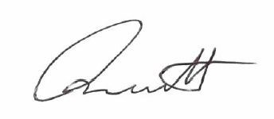
Signed on behalf of:
Residential Reports Pty Limited
ABN 38 609 880 122
Terry Bennett

What the Inspector Examines to Prepare a Property Report
To provide relevance and value for our readers, the following pages show (but do not limit) aspects of the property that may be examined, where visual inspection is possible. These items have been extracted from the Australian Standard AS4349.1—2007 Inspection of buildings (Pre-purchase inspections - Residential buildings) and are considered as the inspector reviews each room or area. In most circumstances comment on a particular area or item may only be provided in the event of an adverse finding considered to be worthy of mention. The inspector did not move or remove any wall coverings, floor coverings, furnishings, equipment, appliances, pictures or other household goods. In an occupied property, these items may be concealing defects.

WALL CONSTRUCTION
Distortion (significant), nail popping, defective lining, dampness/water damage, cracking, defective or damaged plaster/render
Settlement cracks, if present, need to be monitored over a period of time to determine if an ongoing structural problem exists. If any reference has been made in this report to cracking, settlement and/or movement, it should be noted that we are not experts in this area and further advice should be obtained from a Structural Engineer.

FLOORS
TIMBER: Springy or squeaky boards/sheeting, timber decay (rot), out of level – significant, undulations - significant, dampness/water damage
CONCRETE: cracking, out of level – significant,
HARD FLOORING: cracking, loose or drummy units, dampness/water damage

INTERNAL & EXTERNAL DOORS & DOOR FRAMES
Binding doors, defective hardware – significant, rotting/corroded frames, loose/badly fitting doors, damage

TIMBER & METAL WINDOWS
Putty/glazing sealant, broken glass, rotting frames (timber), rotting frames, corrosion (metal), sills, fittings/hardware, damage
In most cases access to windows is restricted by window treatments, furniture or security locks. Older style timber windows can sometimes bind with the frame generally due to paint build up. This is viewed as a general maintenance issue. Sash windows sometimes require maintenance to the window balance mechanism or sash cords. We are not able to guarantee that windows will operate smoothly. Sometimes window runners, sashes and balance mechanisms will require maintenance or replacement.

PAINTWORK
The condition of painted surfaces is often a subjective matter. Areas that appear to be acceptable when furnished may not always be considered so when devoid of obstructions. Paint work is normally not considered in Property Inspections. To prevent wood decay of timber surfaces and deterioration of metal components, the condition of these surfaces should be monitored and repainting carried out regularly. Corrosion of any metal roof sheeting should be repaired, treated and painted to avoid water leakages. Painted surfaces can mask areas where timber has deteriorated. Our visual inspection may not detect instances where this has occurred.
The opinions provided here are of a general nature only, given that there can be significant differences in the condition of painted surfaces in each area of the property. The reader of this report is urged to conduct their own detailed inspection before reaching a conclusion regarding the acceptability of painted surfaces

WET AREAS
Fixtures and fittings, ventilation, cistern/pan, taps, basins, tubs, leakage, sealants, drummy/cracked/missing tiles, grout defects, vanity, shower leakage, broken/cracked glass
If a wet area was not in service prior to and or at the time of inspection and no elevated moisture readings were recorded, or there was no visible evidence of current water leakage, then it is possible that an existing water leak will remain undetected.
WATERPROOFING
A VISUAL INSPECTION OF THE AREA CANNOT PROVIDE CONCLUSIVE EVIDENCE THAT THE AREA IS WATERPROOF. Compliance with Australian Standard AS 370-2004 Waterproofing of Wet Areas is critical to meeting waterproofing requirements.

Should conclusive evidence be required regarding the integrity of waterproofing of wet areas, in particular shower areas, we recommend that a qualified technician be engaged to complete a comprehensive test to include:
- Capping the shower rose and leaving the water reticulation system under pressure and then checking for evidence of water leakage around tap spindles etc. (the sound of escaping air when the shower rose cap is removed indicates a water tight system). The technician may be engaged to complete a comprehensive pressure test of the entire water reticulation system.

- Plugging the floor drain of the shower cubicle and filling the base with water to the maximum level. Allowing the water to remain in the base for an extended period and checking that the level has not dropped. If the water has diminished it is most likely that the waterproofing system has failed. In this event, extensive repairs to correct the problem are often the outcome.

KITCHEN
Fitout, sealants, ventilation, taps, leakage, sink, drummy/cracked/missing tiles, grout defects
This report does not cover any matters relating to the operation of electrical or gas appliances. Any comments made in this regard are from a general observation only.

INTERNAL & EXTERNAL STAIRCASES
Stringers, handrails, balustrades, newel posts, treads (goings), risers

INTERNAL ROOF SPACE
Framing, insulation, sarking, party walls (if applicable)
Sarking is a foil insulation/vapour barrier. Used in conjunction with bulk insulation, sarking provides an ideal insulation system for the control of heat and condensation. Sarking can only be installed during construction.

EXTERNAL ROOF COVERING, FASCIAS, GUTTERS & DOWNPIPES
Tiles/slates, sheet roofing, flashing, skylights, vents, downpipes, valleys, guttering, eaves, fascia boards, barge ends
It is important to note that a visual inspection of the roof covering may not identify roof leakages. We do not guarantee that the roof will not leak in all weather conditions. Roof design can have a significant impact on roof drainage. Low pitched construction can, in adverse weather conditions lead to flooding of the roof cover. Effective roof drainage is absolutely critical for a flat framed or low pitch roof. Flooding of the roof cover can result in water ingress within the building envelope. Roof drainage and the stormwater system are not tested at the inspection. Inadequate, blocked or non-existent stormwater drains are often accountable for problems relating to roof drainage. Repainting of timber can mask the existence of timber rot. We cannot guarantee that all timbers are sound. A visual inspection may not, in some circumstances, detect roofing timbers affected by rot.

EXTERNAL WALLS & NON STRUCTURAL RETAINING WALLS
Bricks, mortar, render, cracking/movement, dampness, visible flashing, weep holes, joint sealants, perpends, decay
Settlement cracks, if present, need to be monitored over a period of time to determine if an ongoing structural problem exists. If any reference has been made in this report to cracking, settlement and or movement, it should be noted that we are not experts in this area and further advice, if considered necessary, should be obtained from a Structural Engineer.

PATHS, PAVING & DRIVEWAY
Cracking, movement, uplifting, sinking, alignment, roof penetration

FENCES & GATES
Palings/panels, rails, posts, sagging, timber decay (rot)

SUB FLOOR
Dampness, debris, drainage, ventilation, cracked or leaking pipes
TIMBER CONSTRUCTION: bearers & joists, framing, piers/stumps
SUSPENDED CONCRETE FLOOR CONSTRUCTION: concrete condition, cracking
If moisture is noted, it is recommended that the sub-floor area be monitored to ensure that surface and sub-surface moisture ingress is not an ongoing issue. If the area remains damp, consideration should be given to upgrading subterranean and surface drainage systems to ensure that moisture is directed away from the building foundations and the sub-floor area is kept dry. A qualified drainage expert should be consulted with regard to drainage issues.

Many serious foundation problems are caused by reactive soil types and trees and gardens being planted too close to the building. Generally, clay soils which are common in the ACT, are reactive soils. Large trees use vast amounts of water and can quickly draw moisture out of the ground during dry periods, this results in destabilised moisture content of the soils around the building and ultimately may cause a foundation problem. Over watering gardens close to the building may have the opposite effect, especially with clay soil. Over watering increases the moisture content of the soil which can result in “heaving” of the foundations adjacent to the garden. When watering close to the building you should avoid ‘pooling’ of water in a particular area, as this also affects the moisture content of the soil which in turn can cause damage to footings and foundations. Too much or too little water near the perimeter of the building may cause serious problems with foundations and footings and damage can cause major structural problems, resulting in costly repairs.

HINTS FOR AVOIDING PROBLEMS AND COSTLY REPAIRS:
    - Water evenly close to the building and do not over water
    - Ensure the ground is graded away from the walls of the building and that the property has adequate drainage
    - Promptly repair broken downpipes, leaking taps, sewerage pipes and other water services
    - Hot water system overflows should be directed away from the area immediately adjacent to the foundations and the services maintained to ensure excessive leakage does not occur
    - Garden beds should not be located against the house

SPECIAL PURPOSE REPORTS
Improvements such as swimming pools and spas are subject to a Special Purpose Report and are not included in our inspection and reports. We recommend that a qualified technician be engaged to report on these items and to advise on current regulations relating to safety fencing and equipment.



This report is intended to be read in its entirety.
Please read the detailed inspection information and the Scope & Limitations of Report sections before reaching any conclusions regarding the condition of the property. Any person who relies upon the contents of this report does so acknowledging that the following clauses, which define the Scope and Limitations of the inspection, form an integral part of the report.

SCOPE &
LIMITATIONS OF
OUR INSPECTION

This report has been prepared as a result of a VISUAL INSPECTION with reference to the requirements of Australian Standard AS 4349.0-2007 Inspection of Buildings (General requirements), AS 4349.1-2007 Inspection of Buildings (Pre-purchase inspections - Residential Buildings) and AS 4349.3 - 2010 Inspection of Buildings Part 3: Timber Pest Inspections. It is limited to the condition of those areas of the property that were fully accessible (see Safety and Reasonable Access) and visible to the inspector at the time of inspection. In the case of a Strata type property, our inspector only undertakes an examination of the interior of the unit.

AS 4349.1 – 2007 Inspection of buildings excludes reporting of the following items: footings, concealed damp-proof course, electrical installations, smoke detectors and residual current devices; plumbing, drainage, gas fitting, air conditioning and heating; garage door opening mechanisms; swimming pools, spas, saunas and associated equipment; the operation of fireplaces and chimneys; alarm systems and intercom systems; soft floor coverings including carpet and vinyl, floating floors; window treatments; appliances including dishwashers, garbage disposal units, ovens, ducted vacuum systems; paint coatings; landscaping.

Limitation of Liability

This report is valid on the date of inspection. No responsibility is accepted for any matter not existing or evident or for any deterioration occurring after the inspection date.
The inspection is completely visual. Concealed areas where access is unavailable are unable to be inspected and are not reported on; such defects could include, but are not limited to:
• Breakage, blockage or interference with any concealed pipes, broken window mechanisms (sash cords) etc.
• Any part of the structure which is underground or concealed e.g. footings, wall framing, under floor coverings. Areas concealed by furnishings or stored goods or low clearances
No responsibility can be accepted for defects which are latent or otherwise not reasonably detected on a visual inspection without interference with or removal of any of the structure including fixtures, fittings, furniture, insulation or stored items within and around the building.

Safety & Reasonable Access

Australian Standard 4349.1 – 2007 3.2.2 The extent of accessible areas shall be determined by the inspector at the time of inspection, based on the conditions encountered at the time of inspection. The inspector shall also determine whether sufficient space is available to allow safe access. The inspection shall include only accessible areas and areas that are within the inspector’s line of sight and close enough to enable reasonable appraisal. The Australian Standard 4349.3 defines reasonable access as “areas where safe, unobstructed access is provided and the minimum clearances are available; or, where these clearances are not available, areas within the consultant’s unobstructed line of sight and within arm’s length. NOTE: Reasonable access does not include removing screws and bolts to access covers.”

Reasonable access is determined in accordance with the provisions of the following WHS requirements
Area | Access Manhole MM | Crawl Space MM | Height
Subfloor | 500 x 400 | Vertical clearance -  Timber Floor: 400*  Concrete Floor: 500
Roof Interior | 400 x 500 | 600 x 600 | Accessible from a 3.6 m ladder
Roof Exterior |  |  | Accessible from a 3.6 m ladder
* To underside of bearer, joist or other obstruction to access.

Roof Cover Inspection
Work Health and Safety requirements determine that an inspector accessing a roof cover must be protected by harnessed safety lines and or edge protection. These safety measures are not practical during a presale inspection, therefore, this report is restricted to a “top-of-ladder” inspection. This report is not a guarantee that defects and/or damage do not exist in any part of the property not specifically seen and described by the inspector. This report is not a warranty against problems that may develop in the future.

Work Health and Safety Act 2011
A non-residential building and the common property of some group residential buildings will fall within the definition of a workplace for the purposes of the Work Health and Safety Act 2011,

The owners of workplaces must ensure that:
- premises are safe and without risk
- plant and substances are used without risk
- workers are trained in WHS, are aware of their obligations and do, in fact, act in a safe manner

A pre-purchase building inspection may identify some safety issues in the common area but it is not an audit conducted for that specific purpose. It is essential that every Owners’ Corporation or Company consult an appropriately qualified specialist to ensure it meets its legislative obligations.

Safe Working Temperatures for the Inspector
When the temperature of a workspace (for example a ceiling cavity) exceeds the level considered to be safe according to WHS guidelines, the inspector will complete a risk assessment and the inspection will be limited accordingly. In the event that the inspector determines that the temperature exceeds safe working limits, generally, the inspection will be limited to the area immediately adjacent to the access for inspection.

Property Report

This report does not and cannot make comment upon: defects which may have been concealed; the assessment or detection of defects (including rising damp or leaks) which may be subject to the prevailing weather conditions; whether or not services have been used for some time prior to the inspection and whether this will affect the detection of leaks or other defects; the presence or absence of timber pests; gas fittings; environmental concerns; the proximity of the property to flight paths, railways, or busy traffic; noise levels; health and safety issues; heritage concerns; security concerns, fire protection; site drainage (apart from surface water drainage); the operation of swimming pools and spas; detection and identification of unapproved building work; detection and identification of illegal or inadequate plumbing or electrical work: durability of exposed finishes; neighbourhood problems; document analysis; any matters solely regulated by statute; any area or item that could not be inspected by the inspector. Unless otherwise specified, no examination has been made of any documentation of any type. We have not referred to statutory authority records nor have we examined any survey or water and sewerage service diagram or any other document prepared by any statutory authority or other party.

Purpose of This Report
The purpose of this report is to identify major defects in the building, decks, pergolas, garages and other similar significant improvements insofar as a property inspector can reasonably identify those defects. Structures, not limited to but including, garden sheds, play equipment, garden trellis’, swimming pools and spas are not inspected or included in this report. A Special Purpose Report may be commissioned for these types of improvements.

This report contains numerous observations but is not intended to list every defect. Defects are common to all structures and generally are commensurate with the age of the construction and use. Ongoing maintenance, upgrading or replacement requirements, cosmetic works and minor defects or faults are subjective and have not been included.

Concealed Surfaces
The inspection did not include breaking apart, dismantling, removing or moving objects, including but not limited to foliage, mouldings, roof insulation or sisalation, floor or wall coverings, sidings, ceilings, floors, furnishings, equipment, appliances, or personal possessions. The inspector cannot see inside walls, between floors, inside skillion roofing, behind stored goods or any other areas that are concealed or obstructed. The inspector did not dig, gouge, force or perform any other invasive procedures. Visible timbers have not been destructively probed or hit. In an occupied property, furnishings or household items may be concealing defects. Some defects may only be visible once furniture and other items have been removed from a property or when alterations are carried out. Built-in cupboards are usually filled with personal items and clothing. Some exterior surfaces may be obscured due to overgrown vegetation. Therefore, we cannot comment on the condition of the surfaces obscured or concealed by these or other items.

Roof Drainage and Water Penetration
Some water penetration problems and/or dampness do not become apparent and sometimes cannot be detected unless there has been recent heavy rain or prolonged periods of rain. Roof drainage is not tested. Therefore, no guarantee is given or implied that the roof will remain weatherproof in all weather conditions. If there is reference in the report to water stains within the interior of the property this is evidence that the roof and or drainage system has previously leaked. If moisture has been identified by the inspector using electronic testing equipment then it will be noted in the report. We recommend that you contact the inspector to discuss the probability of ongoing roof leakage. Particularly with respect to older properties and where the roof has a low pitch, engaging the services of qualified roof plumber to provide an expert opinion should be considered. The very best roof drainage systems can fail in extreme weather conditions sometimes impacted by conditions not related to the property under review. (Blocked or impaired stormwater drains for example).

Fire Protection Equipment & Ordinance Requirements
These are not covered by this report and these matters should be checked with the statutory authority. Any fire protection equipment has not been tested, e.g. smoke detectors etc.

Hazardous Materials & Contamination
Our inspection and report does not cover any hazardous materials or prior use of the land and building or any chemicals applied to land and buildings, which may have caused contamination.

Retaining Walls & Structural Columns
We are not engineers. Comment in respect of large and/or structural retaining walls and columns are beyond the scope of this report. It is not possible to determine from a visual inspection whether a retaining wall or column has been built in accordance with sound engineering principles and, even if it has, whether it is or will remain sound. An engineer should be consulted in any case where there are large, or structural, retaining walls, columns or similar building elements.

Cracking/Settlement/Movement & Structural Integrity
Where reference has been made in this report to cracking, settlement, movement or an opinion has been provided on structural integrity, it is important to note that we are not experts in this area and our advice is limited accordingly. If considered necessary, further advice should be obtained from a Structural Engineer before critical decisions are made. Any cracking reported should be monitored for further movement. If further movement is noted, a Structural Engineer should be consulted at the earliest opportunity. Cracking of masonry walls is very common in the ACT, particularly where there are volatile clay soils. There may be some superficial or hairline cracks that we consider have no structural implications which have not been identified.

Electrical, Gas & Other Service Installations
We are not licensed electricians, gas fitters or mechanical engineers. This report does not cover any matters relating to electrical and gas installations or any apparatus operated by electronic, mechanical or hydraulic means. This report does not cover any matters relating to the operation of electrical or gas appliances. Any comments made in this regard are from a general observation only. You should satisfy yourself as to the operation and condition of any appliances or other installations. Any comments made in this regard are from general observation only. There has been no electrical, data, security or fire detection system testing or investigation.

Plumbing & Drainage
We are not licensed plumbers and a specialist inspection of the water service, plumbing and drainage system including roof drainage is excluded from this report. We recommend an inspection by a licensed plumber and drainer to identify any plumbing faults or drainage problems.

Timber Pests
If this report does not include one, we strongly recommend that an independent inspection and report be obtained from an accredited Pest Inspector to determine whether the property is free from infestation (whether active or dormant).

Boundaries
Unless otherwise stated, the inspector has not gained access to any neighbouring properties and is therefore unable to comment upon the external state of any boundary fences and walls. The common areas of unit developments are not inspected. Any comments made in relation to common areas are strictly observational.

Rural Property Inspection

This inspection and report relates to the residential structure; rural improvements on the property are not inspected or reported on, any comments contained in this report relative to rural improvements are strictly observational.

Areas and Dimensions

Whilst every care has been taken to accurately quantify dimensions referenced in this report, we accept no responsibility for inaccuracies as supplying this information exceeds the requirements of a standard building inspection as per Australian Standard 4349.1-2007. In many instances scale plans are not available and therefore the reader should not rely on this report when making critical decisions relating to dimensions.

Elevated Structures

Where reference has been made in this report to an elevated structure such as a deck balcony or verandah, it is important to note that we are not Structural Engineers and accordingly our advice is limited. Any opinion relating to structural integrity is relative to weight loadings typical of a normal household event. Prior to loading the structure beyond normal which may occur at a larger gathering, we recommend that professional advice be obtained to determine that the structure will safely cope with the weight loading. Additionally, the structure should be regularly inspected to ensure that structural integrity is maintained.

Special Purpose Reports
This Property Report does not contain any assessment or opinion in relation to any item which is the subject of a Special Purpose Property Report, or any matter where the inspection or assessment of which is solely regulated by Statute. Special Purpose Property Reports include comment on the following: common property areas, environmental concerns such as sunlight, privacy, streetscape and views, proximity of property to flight paths, railways and busy traffic or other neighbourhood issues; noise levels; WHS issues including, but not limited to the presence of asbestos, lead or other hazardous materials; heritage concerns; security or fire protection systems; climate control or water heating systems; analysis of site drainage apart from surface water drainage; swimming pools and spas; detection and identification of illegal and unauthorised plumbing work; durability of exposed finishes.

Compliance Report

The information within this report relies on the plans, survey reports, certificates of occupancy and other relevant documents supplied by the Environment & Planning Directorate (EPD), the appropriate local council or Directorate, the client or their agent. Our company or its employees are not responsible for any omissions or errors where incomplete, inaccurate or illegible information is supplied. It is the responsibility of the property owner to resolve any file discrepancies with the relevant authority. Documentation of any plumbing or electrical alterations is not included in the building file. If required, this documentation can be obtained by the title holder from the relevant utilities provider. If the subject property features a second driveway or verge crossing, Transport Canberra & City Services approval may be required. This information is not supplied in the building conveyancing file. If this report confirms that certification is ‘pending’ for an unapproved structure, it is important that you are aware that this process can take weeks and involve more than one agency including but not limited to the Environment & Planning Directorate, Icon & Transport Canberra & City Services. Whilst it is rare, in some instances throughout the approvals process an application may be rejected.

The Compliance Report relies on documentation provided in the Building File. Residential Reports Inspectors are not Building Surveyors. Certifications included in the file are not cross referenced with the Building Code of Australia (BCA) applicable at the time of construction to confirm that the improvements are compliant with the BCA. This is the responsibility of the Building Surveyor prior to issuing a Certificate of Occupancy. No attempt is made in this inspection and reporting process to confirm that the existing improvements on the subject property are in strict accordance with approved plans. There may be variations in design, features and dimensions that conflict with each other. Additionally, there is no guarantee given that improvements are in accordance with the current Building Code of Australia. In most circumstances, there is no requirement to upgrade specifications to the current Building Code

Timber Pest Report

This report is the result of a VISUAL INSPECTION ONLY. Inspection of the property and this report has been completed with reference to AUSTRALIAN STANDARD AS 4349.3 - 2010 Inspection of buildings Part 3: Timber Pest Inspections. In all instances throughout this report the inspector is referring to accessible areas only. Areas that were not accessible at the time of inspection or were concealed from view are not covered by this report. The inspector does not imply that inaccessible or partly inaccessible areas of the property were not, or have not been, infested by Timber Pests. This Report is not a guarantee that an infestation or future infestation and/or damage does not exist in any inaccessible or partly inaccessible areas of the property.

This inspection DID NOT include breaking, removing or moving objects, floor and wall coverings, roof insulation, foliage, furniture, appliances stored goods and personal possessions - these may all limit the scope of inspection. The inspector does not have access to the inside of walls, between flooring, inside eaves and skillion roofing. At NO TIME did the inspector use invasive

procedures or bang/tap surfaces to reach conclusions. Where the property is occupied, please note that furnishings and household items may be concealing evidence of Timber Pests which may only be revealed when the items are moved.

This Report is confined to reporting infestation and/or damage caused by white ants (subterranean and damp wood termites), borers of seasoned timber and Timber Pests (wood decay fungi), present on the date of the Inspection. The Inspection did not cover any other pests and this Report does not comment on them. Dry wood termites and European House Borer (Hylotrupes bujulus Linnaeus) are excluded from the Inspection due to the extreme difficulty in locating the small colonies. Some species of termite and house borers, if discovered, will be reported (by law) to Government Authorities.

Determining Extent of Damage
This Report is NOT a structural damage report. You agree that we are not responsible or liable for the repair of any damage, whether disclosed by our report or not. Our inspectors are not necessarily specialised builders and any inexpert opinion provided with respect to timber damage CANNOT be relied upon. The Report will not state the full extent of any timber pest damage; rather, we may provide comment on the damage for your information. If evidence of Timber Pest activity and/or damage is reported in the structure(s) or the grounds of the property, then you must assume that there may be further concealed structural damage within the building(s). This concealed damage may only be found when invasive procedures are applied to reveal previously concealed timbers. In the case of Timber Pest activity and/or damage WE STRONGLY RECOMMEND an invasive Timber Pest Inspection is undertaken and a qualified person such as a Builder, Structural Engineer, or Architect be engaged to carry out a structural inspection to determine the full extent of the damage and repairs that may be required.

Mould
Mould (also referred to as Mildew and non wood decay fungi) is not considered a Timber Pest. This report does not cover the inspection of Mould. If evidence of mould was observed during the inspection, it may be noted for your information. If you are concerned as to the possible health risk resulting from the presence of mould then you should seek advice from your local State or Commonwealth Government Health Department expert.

IMPORTANT INFORMATION:
This Report reflects the condition of the property existing at the time of the inspection date and may not reflect the current state. Timber Pests, particularly termites, may have gained entry to the property since the inspection date. Termites can, in a relatively short period, cause significant damage to both structural and non-structural timbers within and around the buildings of the property. Termites are difficult to detect and much of the damage caused may not be readily visible, if damage exists, it may be costly to repair. It is, therefore, strongly recommended that you promptly arrange for an inspection in accordance with Australian Standard AS4349.3 if this report is being read after one hundred and eighty (180) days from the date of inspection.

If the Report indicated the presence of termites, termite damage, previous activity or treatments, or recommends a treatment, you should obtain copies of the treatment proposal, any certificates of treatments carried out, details of all repairs including copies of quotations, invoices and any other reports. It is strongly recommended that you arrange for an inspection in accordance with AS 4349.3 to verify that the treatment has been successful and carried out in accordance with AS 3660.2 and arrange for a further building inspection in accordance with AS 4349.1. The person carrying out the inspection and this company will have no liability to you for any damage or loss you may suffer as a result of your entering the contract to purchase the property or in connection with completing the purchase of the property as a result of your failure to heed the advice given in this report, and may use such failure in defence of any claim that you may later make against any of them.


Energy Efficiency
Rating FACT Sheet

QUICK FACTS
- Sellers of residential properties are required to provide an Energy Efficiency Rating (EER) to potential buyers. (This is known as mandatory energy efficiency disclosure.)
- The EER forms part of the Sale Contract and must be published in all advertising material
- The EER rating system uses computer simulations to assess the potential thermal comfort of your home. The more stars, the less likely the occupants need cooling or heating to stay comfortable.
- The ACT Government has two systems in place for Energy Ratings:
  - one is for new homes - (2nd Generation Software) and
  - one is for established homes – (1st Generation Software)
Residential Reports (and all other companies preparing reports for the sale of a property) uses 1st Generation Software.
- The consumption of energy in the home for heating, cooling, hot water or lighting and other appliances IS NOT considered when calculating the EER rating.
- Many aspects of solar passive designs are also not able to be accounted for in 1st Generation Software.
WHAT IS RATED?
The rating is dependent on:
- Layout of the home
- Construction of its roof, walls, windows and floor
- Wall, floor and ceiling insulations
- Orientation of windows and shading of the sun's path and local breezes
- Influence of the local climate

WHY IS THERE A DISCREPANCY BETWEEN MY OLD EER AND MY NEW EER?
- Increasingly, in a number of circumstances particularly where new homes have been rated using 2nd generation software and are being offered for sale where the rating must be conducted using 1st generation software, there can be a significant variation between the two ratings:
  - 1st generation software rates to 6 stars
  - 2nd generation software may rate up to 10 stars


- ACT Legislation currently PROHIBITS Inspectors from assuming insulation values which may have been the case previously. Documented proof or access for a visual sighting is now required to verify the existence and rating of insulation.
When you engage Residential Reports to complete your EER you have the peace of mind of knowing the Inspector undertaking your assessment is licensed in the ACT as a Class A Energy Assessor and your Energy Rating is calculated using software approved by the ACT Government.

Further information is available via the Environment, Planning and Sustainable Development Directorate
http://www.planning.act.gov.au/topics/design_build/design-and-siting/energy_ratings

Resource Library Index
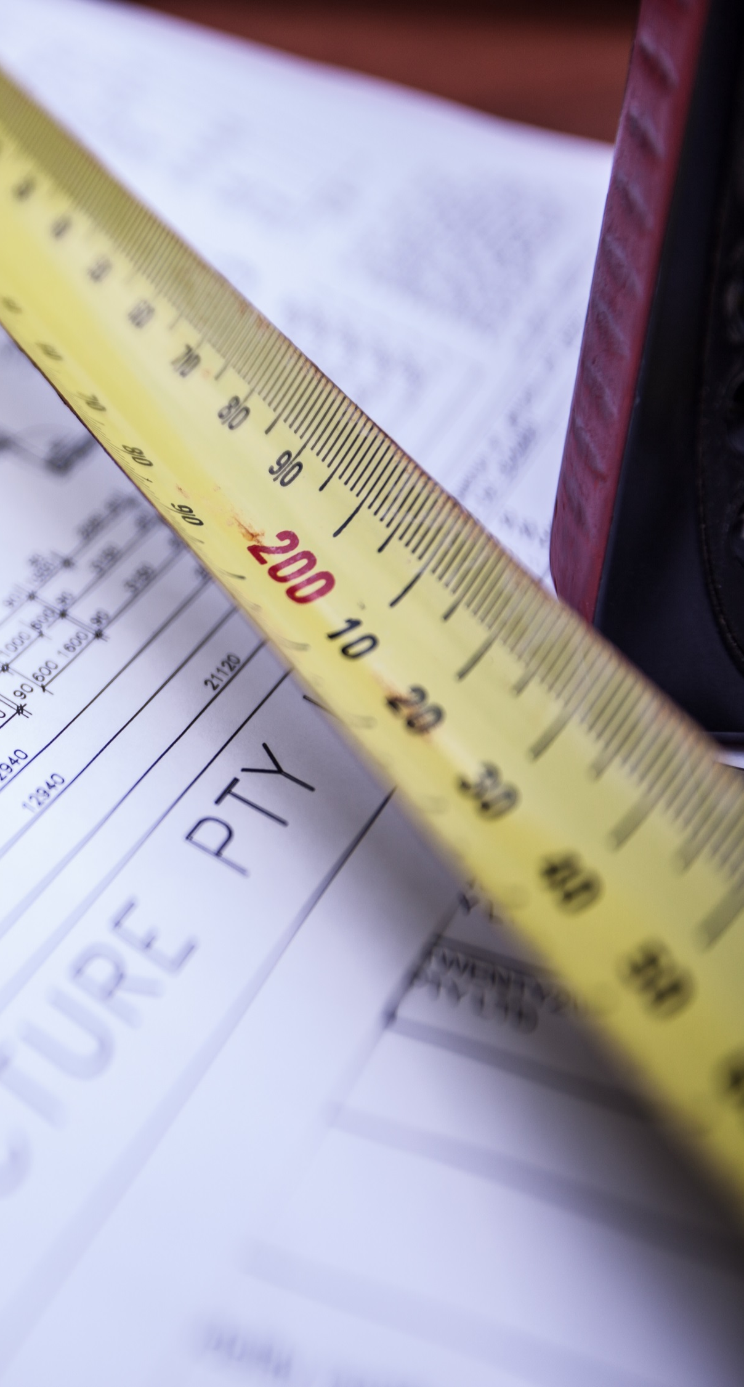
Please click on the resource name to open…
ACT Building Regulation Index
ACT Government Building Certifiers Website Link
ACT Govt. Asbestos Awareness Fact Sheets
Advanced Structural Designs Website Link
Amosite Friable Asbestos
Asbestos Information
Brick Cavity Wall Construction
Brick Veneer Wall Construction
Building Near Trees
Carports and Shade Structures
Concrete Efflorescence
Condensation in Houses
Cracking in Brickwork
CSIRO Information Sheet For Concrete Roof Tiles
Earth Leakage Protection
EER Fact Sheet an Important Read for Vendors
Efflorescence in Masonry Walls
Expansive Clay Soil
Exterra Termite Management System
Fences and Freestanding Walls
Floor Construction
Floor Joists Explained
Fungal Decay or Dry Rot
Glancing Light on Plasterboard
Glossary of Building Construction Terminology
Glossary of Roof Construction Terminology
Identifying Asbestos in your Home
Monier Maintenance Guide
NSW Smoke Alarm Regulations
Powder Post Beetle Information
Residential Reports Safe Access Resource
Roof Structures
Sarking
Slab Edge Dampness
Swimming Pool and Spa Information Sheet
Tree Root Damage to Buildings and Foundations
Useful Timber Pest Information
Weep Holes

