Landing Page



Solutions Page

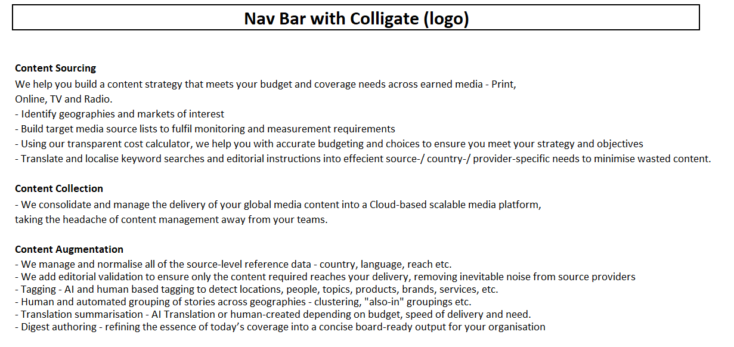

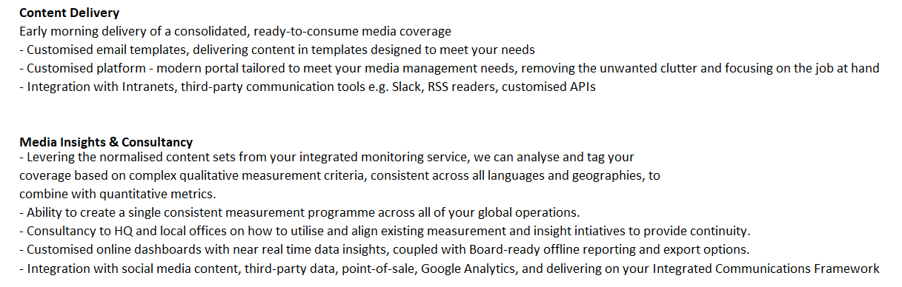

How We Do It Page



Our People Page


Our Technology Page


