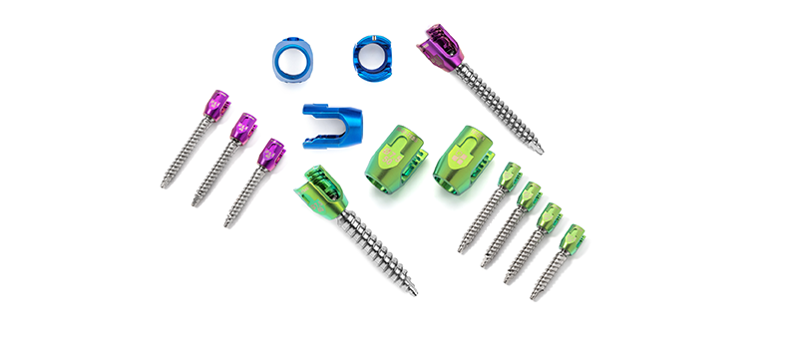
www.cbenterprisescnc.com
(661) 250-3346
26818 Oak Avenue, Unit A, Canyon Country, CA 91351

Medical, Implants, Aerospace, Aviation & Military applications
ISO 13485, 9100, 9001 certified

> 5 AXIS CNC MILLING
>TURNING
> CNC SWISS-TYPE
> DEBURRING
> LASER MARKING
> OGP SMARTSCOPE 302
> Coordinate measuring machines, comparators, surface plated micrometers
> Dedicated temperature controlled room
> Ultrasonic cleaning & reverse osmosis water
Our Education, Training, and 25 years of Medical and Aerospace machining experience helps us determine the best possible methods of manufacture that will be most cost effective for your parts.

