Brief

Client: VIDAS Company

Brand: “1 Thing to Drink”

Products: Carbonated Soft Drink and Ice Tea

- Project context and general information:

Our new all natural drink needs a product design (logo and front-pack).

We developed an innovative alternative, all natural and great tasting soft drinks and ice tea, beyond the conventional big commercial brands. Our ambition is to set a new high standard for soft drinks and ice tea, produced in a simple honest manner.

In sum, it is the HONEST LOCAL DRINK.

There will be 5 natural flavours - a combination of a fruit and typical Bulgarian local herbs:

1. Forest Fruits with Roses (Bulgarian Rose Damascena)

2. Green Fig & leaves from Green Fig

3. Peach with St. John's Wort

4. Lemon with Ironwort

5. Pomegranate & Black Cumin

Pack formats: plastic bottles of 0,5 L and 1,5 L in minimalistic clear shape.

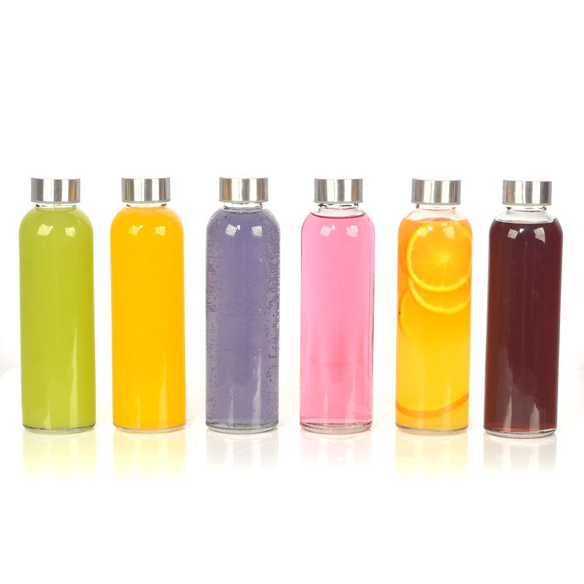

*not actual bottle – just for visualization purposes

- Project objectives

Create product design that clearly communicates

- The brand name: “1 honest drink”

- Product benefits: 100% natural product with local ingredients that will give you an invigorating taste experience and will keep you refreshed throughout the day

- Brand Character: Simple, clean and honest product that is good for your well-being

- Product information: brand history & strategy

In today’s world, our fast paced lives make it seem as if healthy food and drink appear to be the more difficult alternative over a quick bag of chips and soda.

Consumers don’t want to have to choose between a refreshing drink and a healthy drink - they want to have a truly tasty product that will make them feel good about the choice they made.

That is why our purpose is to offer an “honest” product - an indulging and naturally refreshing treat for good times with family, friends, at home or on-the-go – with or without food.

That is why our purpose is to offer an “honest” product - an indulging and naturally refreshing treat for the good times with family, friends, at home or on-the-go – with or without food.

We will do this by providing an honest local drink.

- Honest: 100% natural products from sustainable sources and consumer-inspired quality. No white sugar, aromas, colors, additives, artificial substances, citric acids or ascorbic acids allowed. We focus on the highest quality possible and superior natural taste experiences. In general, no compromises!

- Local Drink: herbs in our drink have been sourced locally and in many cases those herbs are unique to their country of origin. The herbs have healing properties which give you not only a refreshing and tasty drinking experience, but also a healthy one. The goal of our drink is to set a new high standard for soft drinks and ice tea; beyond the conventional big commercial brands.

- Target group, consumer insights

Health conscious consumers, age group – 25-50, that know the benefits of a good healthy product and will spend a bit more to get them. People that buy organic and bio products, but also people who are willing to switch from conventional to healthy products for small price difference (or for the same price).

Young mothers (parents) who want to buy healthy juices (products) for their kids/family.

Young adults who exercise regularly and are conscious with their food diet and do care about their look.

Working people who are willing to replace the afternoon coffee and unhealthy snack/drinks.

- Design Objectives

We want “clean” minimalistic design with focus on the number “1”, but also to present the ingredients we have inside the different flavour variants.

We also want to be visible and easy recognizable on the shelves in-store

- Deliverables

Create product design with strong recognisable logo and front-pack communication

Where will the logo be used?

- On the product packaging

- In POSMs (Printed materials, wobblers, posters, neck hangers, displays etc.)

- Digital use - website

- Social Media Profile Image

- Printed Stationery

- Printed Corporate Literature

- Various Marketing Merchandise

- Event & Conference Stands

