My Companies name is Tempus our product is a beverage which is a tropical Caribbean drink made from coconut water and gin called Sky Juice. I'm looking for a shrink sleeve that covers the whole bottle, with a nice tropical scene for the label. Will allow your team full design.
- 16 oz. OSD Round PET Beverage Bottle with 38mm DBJ Neck Dimensions:
- 2.553" Diameter x 7.661" H Diameter_of_container:
- Material: PET-G Application_process:
- Manual Sleeve_type:
- White Perforations:
- Vertical Plain_or_printed: Custom Printed Number_colors: Four Print_style: Flexographic Printing
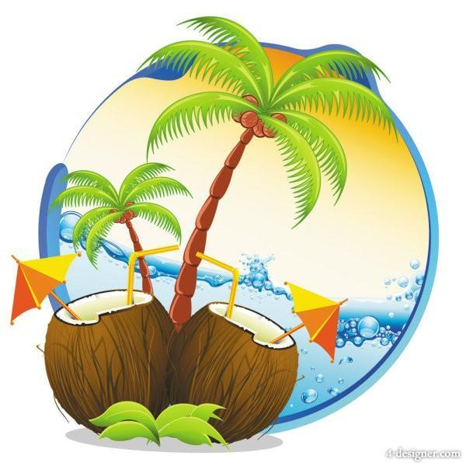Basic Art work ideas for labels

Would like the label to read,
Front Information
Tempus
Sky Juice
Premium Gin & Coconut Water Beverage
18% Alcohol (ALC) By Volume (Vol)

Side Information
PRODUCED BY
TEMPUS Co.
Nassau, N.P Bahamas
Tel: (242) 525 – 8484
Keep Refrigerated (Shake Well Before Opening)
Drink Up
It's Time Reach for the Sky

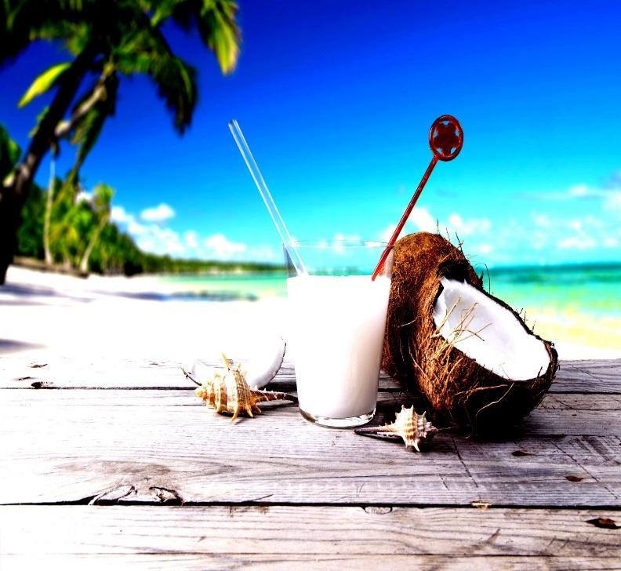

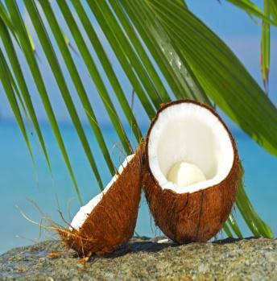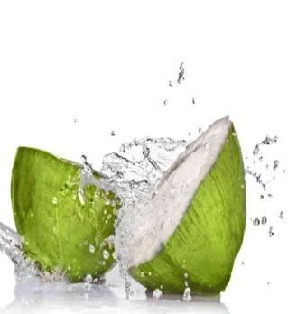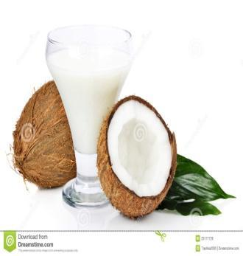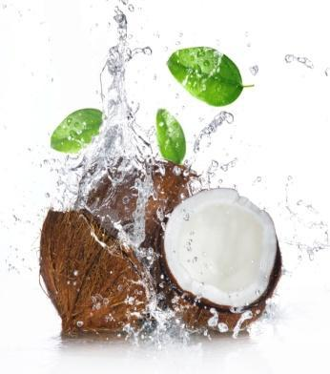
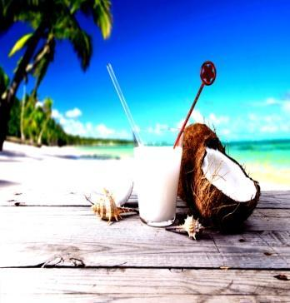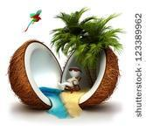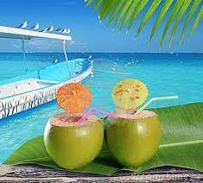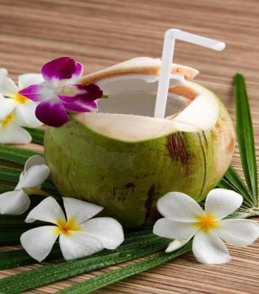
Original artwork and basic ideas for the label.
Suggested changes
- Would like to change the fonts on the words (Premium & Coconut water & Gin Beverage) to something more enhanced. Design team can modify
- Label sizes 8.25” x 2” (Wraparound Water bottle)
- If possible design team has the freedom to be creative make suggestions and changes to the entire layout, back ground, and fonts for the original basic label. The labels will be used for a Tropical Drink
- Add Nutrition Facts to Label
- Bar Codes Needed on Labels
- Company Name: Tempus
- Beverage Name: Sky Juice - (Premium Gin & Coconut Water Beverage)
- Alcohol Content: 18% Alcohol (ALC) By Volume (Vol)

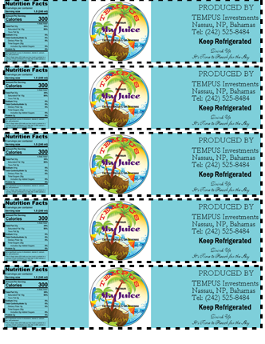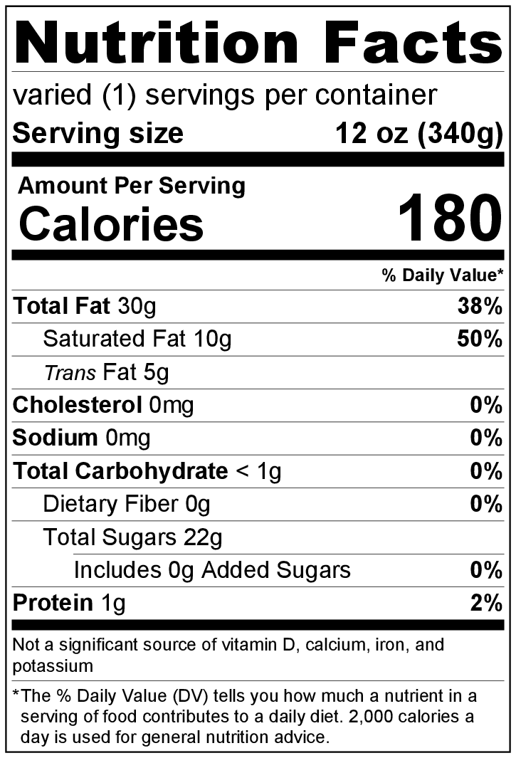
Bottle for Label:
- 16 oz. OSD Round PET Beverage Bottle with 38mm DBJ Neck PET bottle
- BPA free
- 38 DBJ neck
- Dimensions: 2.553" Dia. x 7.661" Hgt.
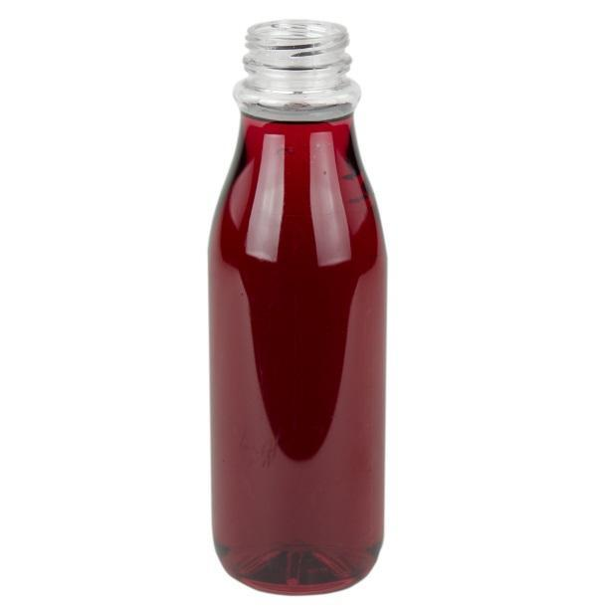
- Suggested Label panel: (Would prefer label to cover entire dimensions of bottle)
