COACHING WORKBOOK
- I’m looking for a more creative version in PowerPoint than what I made in Canva.
- Please look at my uploaded Canva version to incorporate the quotes I used.
- I would like to see all 3 of my branding colors used: HEX #: 2994ae, fa8070, 10dfd3
- I am including stock images to use on each page.
- Please use my logo and titles on the cover.
- I don’t like a modern or corporate presentation look. Want a warm personal style. Most clients are middle aged females, but I do work with some males. So not too feminine, please.
- There should be 14 pages in the workbook.

Table of Contents
Welcome Message
Coaching Model
Benefits of Journaling
Life Satisfaction
Understand Your Why
Values & Beliefs
Personal Mission Statement
SMART Goals
Mindfulness & Meditation
What Are You Tolerating?
You Are Enough!
Reflection

Welcome Message (DO NOT USE THIS TITLE)

Congratulations on taking the first step to a healthier emotional life! (MAKE THIS STATEMENT A HEADER)

This workbook gives an overview of the transformational exercises I incorporate during our coaching sessions. Skim through these pages to get an idea of what it's like working with me.
As your coach, I’ll be your support and guide as you find the focus and strength to make changes to your life. It’ll be hard work, but I’ll be there with you every step of the way.
My goal is to empower you to confront the “sticky stuff.” That is, those unpleasant memories, unwanted negative emotions, or secret insecurities. The areas most of us are uncomfortable talking about. The areas that most often keep us stuck.
My life and health coaching packages are available to improve your life in several areas, like mindfulness, healthy habits, relationships, and goal setting.
Client Corner becomes your online library, filled with years of personal and professional development resources to apply to your own life.
One new thought can change the direction of your life! Schedule a complimentary discovery coaching session and let’s get you living your best life.

Ronda Bonfanti – Life & Health Coach, Grief Recovery Specialist

Include A SMALL PHOTO of me at the bottom with my titles.
Ronda Bonfanti – Life & Health Coach, Grief Recovery Specialist


Coaching Model

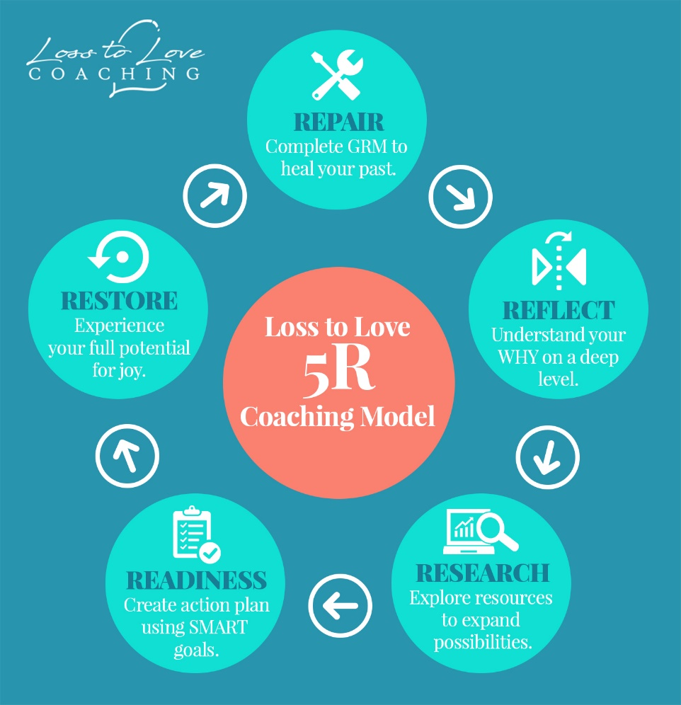

Look at the Canva version. I don’t have any text for this page. Can use a HEADER:
Reach your full potential in the shortest amount of time!

Benefits of Journaling



Have you made journaling a part of your daily well-being routine yet? If not, you might be thinking, “No – I’m not a great writer.” Or even, “I really don’t like writing. Why would I journal?”
Journaling is not about writing. It’s about providing you with a deeper understanding of your life.
Trust me, I’m not a gifted writer. English was my most difficult subject in school. It wasn’t until I was in my thirties that I discovered the benefits of journaling. In my journal, my writing didn’t have to be perfect. It wasn’t about receiving a passing grade. Journaling helped me sort out my past, let go of what was no longer serving me, and start living more in the present. It provided a great outlet for my monkey mind before bedtime, so that I could sleep more easily.
Often, journaling was, for me, just a brain dump on paper. Yet, it has led to so many gifts. Most importantly, it gave me a profound insight into my mind and desires.
Spending time in this quiet self-reflection helped me shed the blanket of shame I had been living under for so long. Replacing unhealthy and damaging thoughts became easier. And with a clearer mind, my creativity began to flow. I tapped into more courage. And a desire to connect with others on a similar path fueled my passion for coaching.
Want to experience the benefits of journaling? Check out a free, password protected online digital journal at Penzu.com.

Life Satisfaction

A big part of transforming your life involves assessing where you are right now. It’s asking yourself, “How satisfied am I with my life?”
The wheel of life exercise is a great starting point for evaluating your life. It’s a self-reflection exercise that helps you build in more balance, happiness, and success to your daily life. It also brings your attention to all the different areas of your life and helps you prioritize your goals.
Complete the wheel of life below, labeling the eight most important areas of your life in each blank around the circle. Then, rate your level of satisfaction from 0 (the least satisfied) to 10 (the most satisfied).

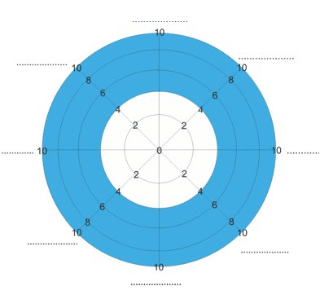

Understand Your Why



Cognitive clarity is an integral component of getting the most out of life coaching!
Cognitive clarity means understanding your why. Learning what motivates you and influences your decisions and actions is not only key to making successful life changes, it’s also what gives you an idea of what makes you tick and why.
Our brains are gifted with the ability to make new and improved neural pathways throughout our life. My goal as your coach is to help you connect with your why on a deeper level and foster healthier connections as you continue working on your goals.
Read more about understanding your why.

Values & Beliefs



What are your deepest held values and beliefs?
Our values and beliefs are what drive the direction of your life. Yet, most people never stop to seriously consider what their values and beliefs are.
That’s why so many of us find ourselves wondering, “How did I get here?”
Upon reflection, you may that you’ve modeled your values and beliefs after those of the important people in your life, like your parents. Or, you may find that as you move through life, your values and beliefs changed.
Unfortunately, it’s possible you’ll also discover you’ve been holding onto negative beliefs about yourself for years. Life coaching shines a bright light on where and how some of our negative belief patterns were adopted. Reversing any negative core beliefs affecting your life will be instrumental in our work together.
Once you know clearly your values and beliefs, it’ll be easier to be the person you want to be in all circumstances. And as you work to achieve your goals, you’ll make decisions that are closely aligned with your core values. Ultimately, you’ll feel like you’re completely living a life of integrity.

Personal Mission Statement



Corporations have mission statements to inform the direction of their business decisions. Similarly, personal mission statements help us manage the direction of our lives.
When we don’t know where we want to go, how will we know how to get there? Your personal mission statement will help you live the life you most desire. It will become your compass, directing every decision. You’ll be able to stay on course easier knowing what you are working towards.
Every decision, relationship, promotion, and expenditure can be weighed against your personal mission statement. Before acting, you can ask, “Will this next step bring me closer to or further away from my mission?” And have a crystal-clear answer.
Read How To Write A Personal Mission Statement In 8 Steps

SMART Goals

Please look at my Canva sample to make SMART and the Acronym words in color.
Please use all 3 of these images!

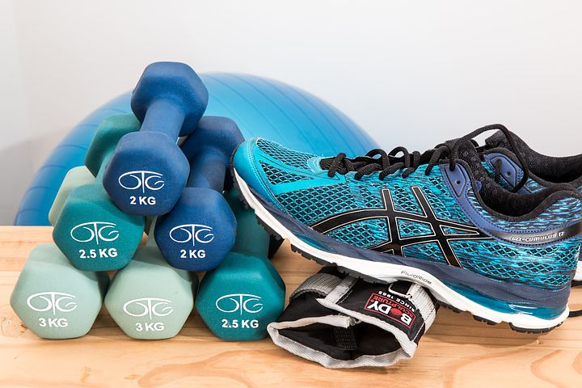


SMART goal setting is a coaching methodology that provides structure to the process of formulating, planning, and achieving your goals. The acronym stands for:
Specific - What exactly do you want to accomplish?
Measurable - How will you track your progress to stay motivated?
Achievable - How will you accomplish this goal?
Relevant - Is this goal realistic given everything else on your plate?
Timely - What is the target date for completion?

This SMART Goal worksheet can help you make changes to any area of your life.
Mindfulness & Meditation

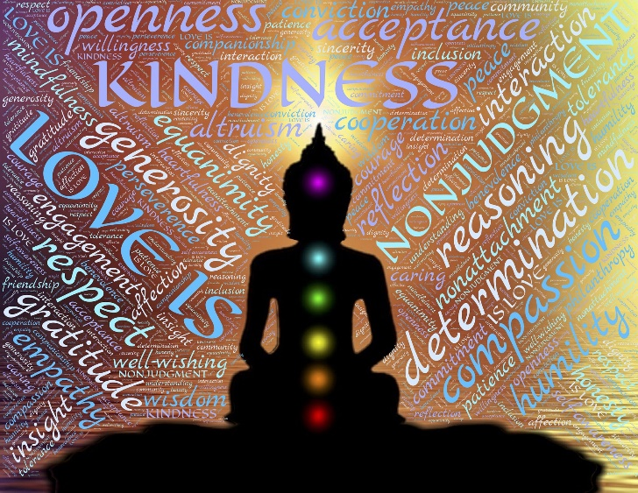
Have you ever wondered if there’s more to life? More than what you’ve experienced thus far?
Do you ever feel like you’re not in control of your life and it’s just passing you by? Too quickly.
Mindfulness and meditation are tools that can help us experience life on a different level. We can learn how to not react so personally to the actions of others. We can feel less stressed and at peace more often. We can harness an inner source of fulfillment that others are incapable of giving us. Mindfulness and meditation provide a deeper awareness and presence to life and helps unleash our true potential to experience more creativity, love, passion, and joy.
Learning something new can feel intimidating. Even more so if your inner circle isn’t raving about it.
The health benefits of mindfulness and meditation are well documented. On both a personal level and as a Health Coach, I incorporate these life-enhancing resources into our coaching sessions.
It takes a little time and patience when embracing the unknown. But I’m here to support your journey to living a healthier and happier life. Together, we’ll map out your best plan to incorporate mindfulness and meditation into your self-care practices.

To get started, sign up for a free 40-day mindfulness meditation online training.

Learn how mindfulness and meditation help you connect with your most authentic self.

What Are You Tolerating?
Tolerations are all the little things that annoy us yet aren’t quite painful enough for us to do anything about. We learn to tolerate a lot, and it probably doesn’t seem like a big deal. But if you add them all together, they can cause major friction in our lives and drain us emotionally, physically, and spiritually.
Every day, we put up with, take on, accept, and are dragged down by other people’s behavior, situations, unmet needs, crossed boundaries, incompletions, frustrations, and even our own actions.
Think of your brain like a computer running many utility programs. Each uses only a small amount of memory, but if you open enough of them all at the same time, your computer will slow down – or worse, freeze up.
The first step to eliminating tolerations is to determine what they are.
Look for tolerations related to these areas:
AT WORK:
Boss or Manager
Working Conditions and Environment
Procedures and Job Tasks
Company Culture
Co-workers
Commute or Travel Requirements
WITH OTHERS:
Criticism or Unrealistic Expectations of Others
Friends
Family
Significant Other
Children
WITH YOURSELF:
Criticism of Myself
Health
Money
Car
Home Projects and Repairs
Clutter
Procrastination
Unrealistic Expectation of Myself

Once you’ve identified the tolerations in your life, determine which are within your control to do something about?

You Are Enough!

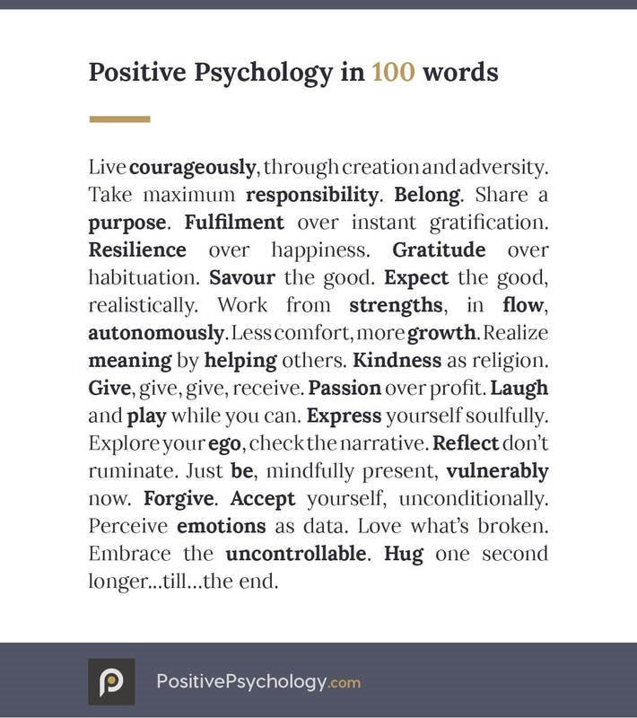
From an early age, we are conditioned to compete and compare ourselves to others. For example, in elementary school, we can be split up based on our reading level. While this separation may be needed to maximize education, it starts our young brains on the journey of comparison. Am I smart enough?
As older kids, we were continually trying out for a spot on a team. Am I talented enough?
And as young adults, with all the social media surrounding us, being skinny equates being beautiful and desirable. Am I good looking enough?
Or, relationships we thought were going well can end in a moment’s notice, leaving us emotionally paralyzed. Was I not good enough for that person?
There’s no wonder we can spend a lifetime trapped in this rat race of comparison.
If you’ve worked through The Grief Recovery Method, you’ve already begun to identify where some early messages of not being good enough came from.
Life coaching will continue working in this area to replace unhealthy thoughts of worthiness with more positive, empowering beliefs. You will learn to release the limiting life story that is holding you back. I incorporate Brené Brown’s work to support growth in this area.
When we harness moments of clarity and hope, our minds begin to tap into the power of possibilities. Instead of believing we’re not good enough, we start asking, “What if we already are good enough? What would I be empowered to do if I believed that?”
This is where the magic in life begins. In the WHAT IF’S. What if you are enough, just the way you are? What if you don’t have to change to earn unconditional love and acceptance? What if your life could reside comfortably in a place of serenity and self-acceptance?

Recommended Self-Esteem Worksheets
Learn more about Positive Psychology

Reflection
I’ve had three knee surgeries because I love tennis too much to ever stop playing (and I definitely wasn’t going to let a little thing like a damaged knee stop me!). After each surgery, I followed the recommended physical therapy to maximize my healing. The therapy was painful. What if I had let the fear of the pain of physical therapy win? What if I had tried to push thoughts to the back of my mind, pretending I wasn’t injured at all?
I would have avoided the short-term intense pain and hard work, alright. But I also would have been saddled with a lifetime of low-level knee pain, restricted motion, and no more tennis. If I hadn’t done physical therapy, my quality of life would have diminished, forever.
Just as it is with physical injuries, so it is with emotional injuries. If you experience a loss, trauma, or any kind of emotional stress (as we all have!) and you ignore or avoid your feelings, the rest of your life will be subconsciously affected by that pain.
However, unlike with physical injuries, where the pain is validated by the world, emotional injuries are easily unnoticed or dismissed by you and others. That makes it harder to address in the moment.
Fortunately, rehab for your heart can begin at any time. That’s where the Grief Recovery Method comes in, with me as your coach to guide you through the process of dealing with unresolved pains and losses.
After you complete the Grief Recovery Method Program, my life and health coaching packages continue building on your incredible progress to improve your life in other areas, like mindfulness, healthy habits, relationships, and goal setting.
Today, the scars from my knee surgeries are still visible, reminding me of my limitations and my need for continued self-reflection and healing. Right now, you may have emotional scars invisible to the outside world. But that doesn’t mean they’re not there, limiting your full potential for joy.
Schedule a complimentary discovery coaching session with me to discuss your next best steps in living your best life.

In Wellness,
Ronda Bonfanti – Life & Health Coach, Grief Recovery Specialist

Can this picture be used as the background to this page with a light filter on top? Similar to the Mindfulness Meditation page in the Canva version I created.


