DESIGN PROJECT -- Eating from the Garden: Getting the Most from the Season

FRONT OF POSTCARD:
This should include the title of the event as well as the when/where. I am thinking a photo of a summer garden with someone picking vegetables or just a shot of the garden and hands holding a basket of veggies. Or you could have two photos well integrated one of a garden another of a summer outdoor garden meal. Below are some EXAMPLES of photos I pulled from a stock photo site (without paying so please just use as reference). Please include the sponsorship details.

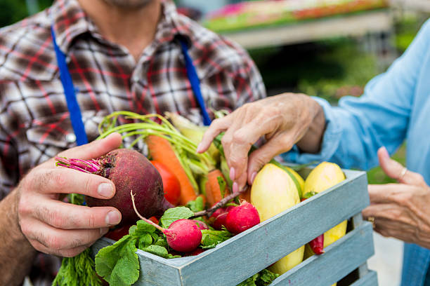

Eating from the Garden: Getting the Most from the Season
When: Tuesday, July 23rd at 12:30 p.m.
Where: Bradford Hall

Sponsored by Cameron Financial


BACK OF POSTCARD:
This should include the photos and bios of the organizers. Side by side as a header or footer. Please include the title of the event, event description, and raffle information as the “meat” of the postcard. Also, include one of the following photos.

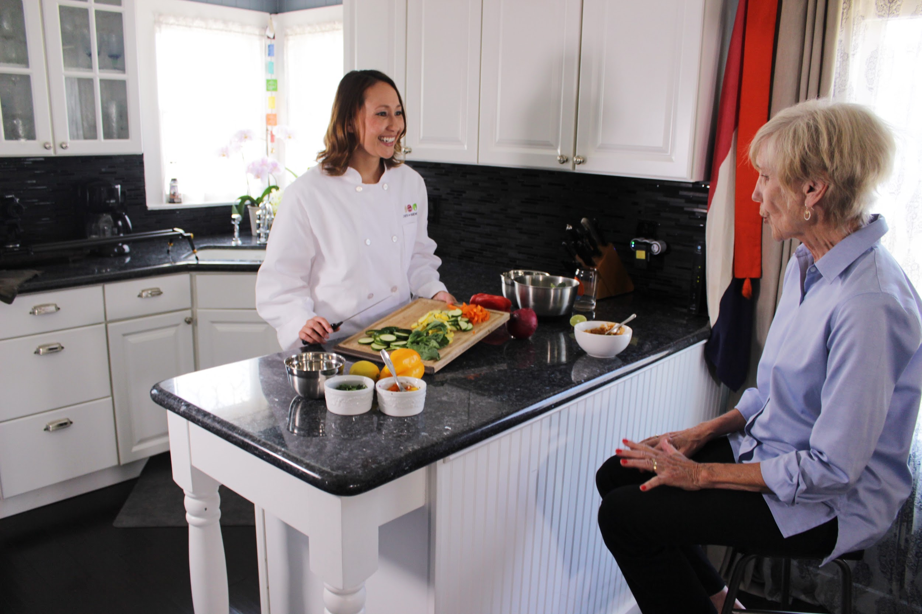

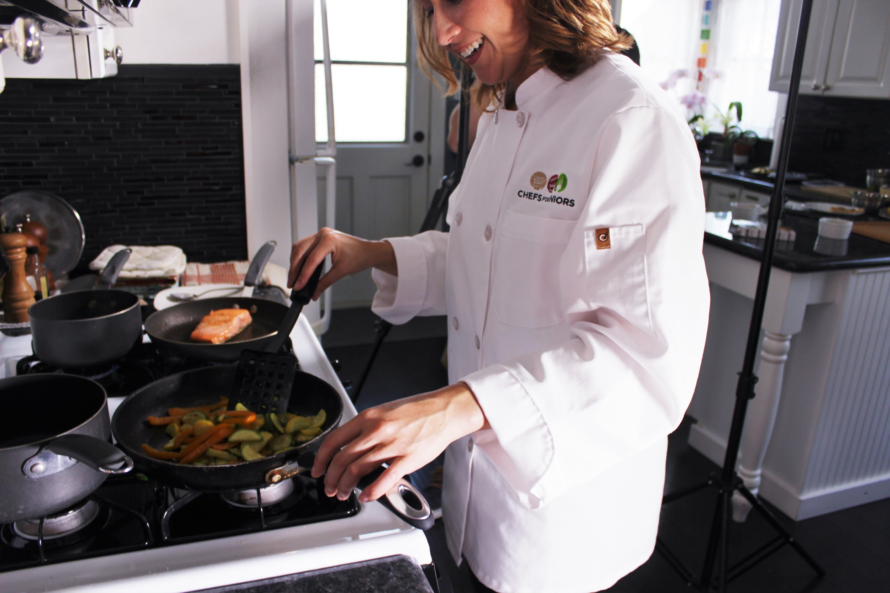


A Certified Financial Planner you can trust.
Tom Cameron is a Certified Financial Planner, specializing in asset management of IRA, retirement, investment, and trust accounts. Cameron Advisors, LLC is an independent Registered Investment Advisor with low cost, commission free business model. Concierge level service is provided to Carolina Preserve residents.

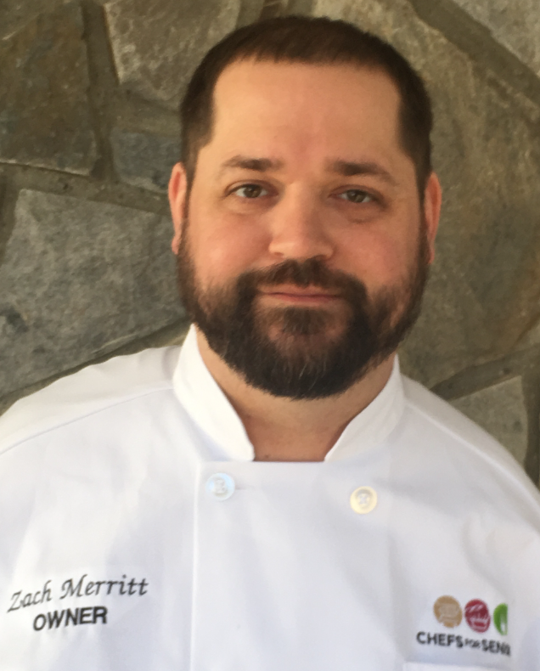
Chef Zach Merritt
Chef Zach Merritt is a formally trained chef with over 15 years of experience. He started Chef with Seniors Raleigh, a meal service that connects seniors with licensed, professional chefs who prepare high-quality, affordable, and nutritious meals in the home. Zach is so pleased to have found an opportunity to share his passion for food and connect with local Seniors.

Eating from the Garden: Getting the Most from the Season

Learn from Chef Zach Merritt how to build a menu full of flavor, nutrition, and seasonal ingredients with ease. Followed by a financial workshop where Tom Cameron, Certified Financial Planner, will have some fresh investment ideas to go along with your farm-to-table meal. Tom encourages any questions you may have


Enter a raffle to win the services of Chef Zach who will work with you to design a meal plan of 10-12 servings that addresses your dietary needs.

Please keep in mind that any design “instructions” are mostly a guide. I am not a graphic designer (that’s why we’re coming to you!), therefore you likely have a much more creative idea. I merely wanted to provide you with a jumping off point.

