RISC Vision

Logo and Font Design Brief

About RISC Vision

RISC Vision monitors complex business ecosystems alerting clients to emerging threats. RISC Vision uses sophisticated machine learning algorithms to identify third-party risks at company, group and sector levels across your portfolios of vendors, clients, borrowers or insured parties.

RISC Vision monitors your business ecosystems alerting you to risk and emerging threats.

Image from our website:


RISC Vision's alerts help you:
​​​
- Maximise profitable business with risk-adjusted pricing

- Reduce costs and stem losses with early risk identification

- Manage reputational risk arising from counterparties

- Minimise operational risk capital requirements

Here is the link to our website: https://www.riscvision.com
Introduction video (OLD BRAND but gives good idea about what we do)

Business Identity:

We are looking for easy recognition through a clean, sophisticated design. Minimalism is key, as well as meaning behind the logo, colour and font.

No slogan – Just sophisticated font for RISC Vision that should look professional, clean and not be overlooked when placed next to Logo.

  - Vision
  - Transparency
  - Truth, Trust and Confidence
  - Intuitive
  - Deep understanding
  - Horizon scanning
  - Sustainability
  - Intelligence
  - Efficiency
  - Loyalty

Logo Format

Combination Mark – Combining Wordmark and Pictorial mark (or abstract mark). Picture and ‘RISC Vision’ company name side-by-side or stacked on top of one another.

Design Style

  - Modern
  - Flat
  - Minimal
  - Serious
  - Possible Tech related design in the logo if appropriate

Colours

We like primary colours with white background! Keeping it clean and simple like Google, Doorda and DueDil.

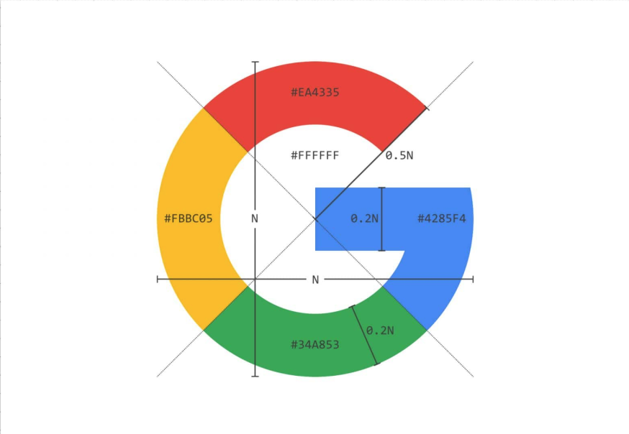

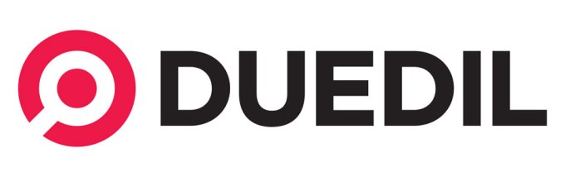

Company name and logo styles we also like include:

Below shows creativity with the ‘O’ in vision

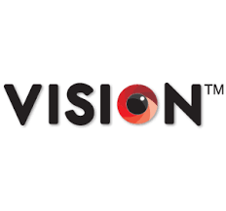
Below shows creativity with use of the ‘V’



Ideal Colours – Blues, greens and slate greys

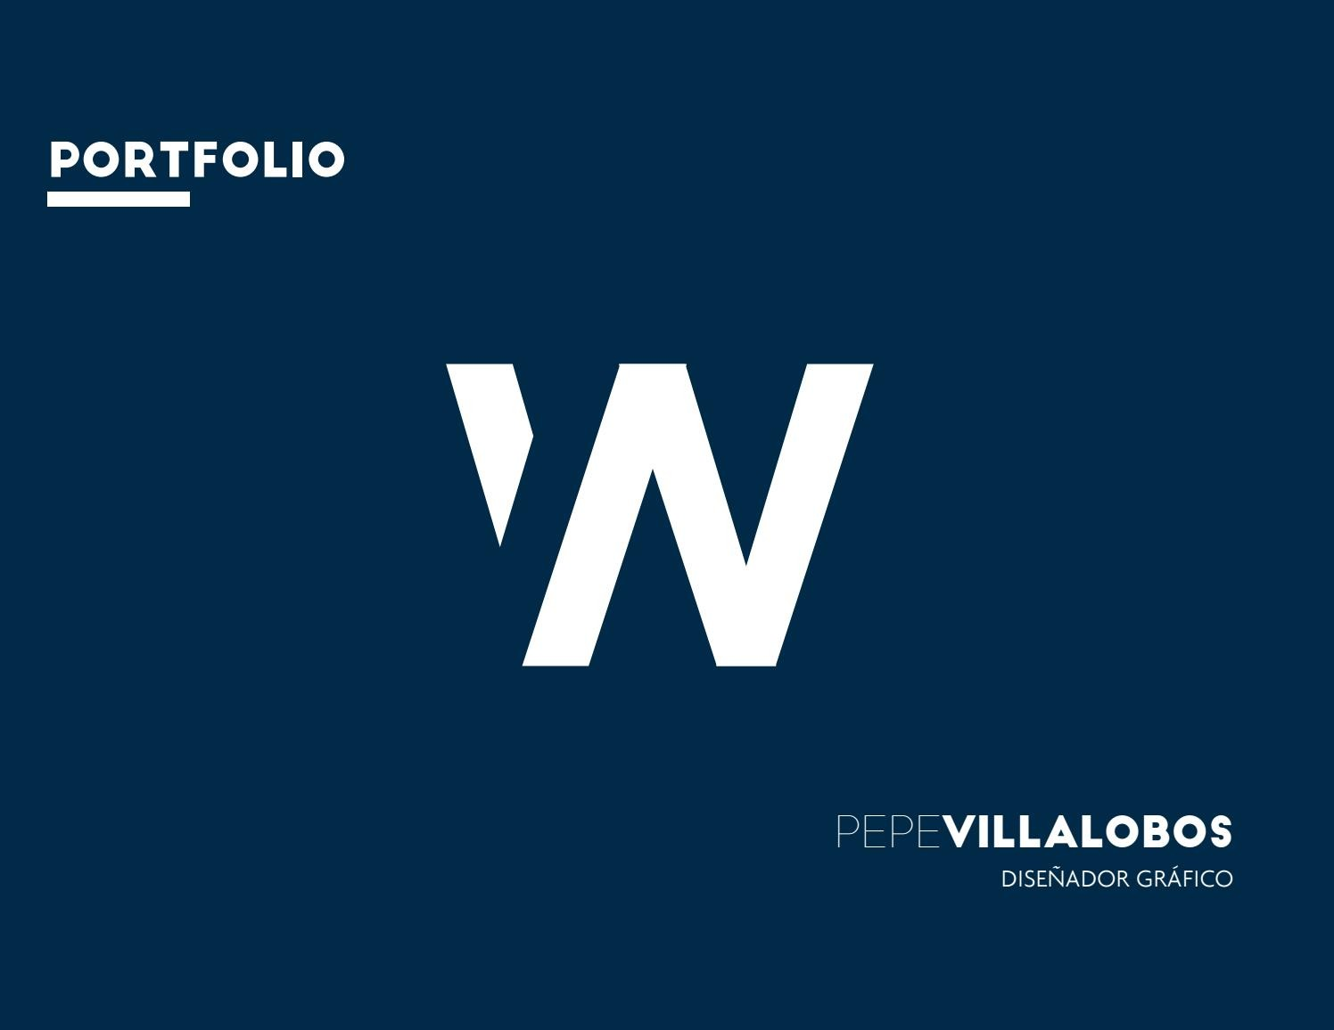

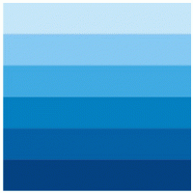



Blues we DO NOT like:

Below blues are too ‘electric’ and dark.

However, we also do not like powder and sky blues (unless playing a minor part of a blue colour palette).

BAD: Twitter and Skype are too powdery.



Colours we must exclude entirely – purple, orange, yellow, brown, pink and any pastel, fluorescent or bright colours. We are looking for subtlety and professionalism.

Logo Ideas

We are interested in eyes and bulls-eyes / circles

Eye logos we like include:

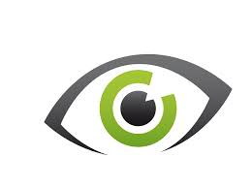

BAD eye logos include:

BAD = any 3D logo (i.e. shadows, depth of perspective, etc.)
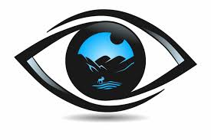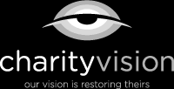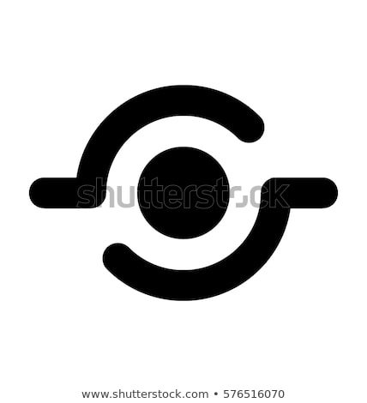

Font Ideas

We are interested in clean fonts. Nothing too obscure! We like Arial, Helvetica and the like.

Very much like the font in the below images:

BAD fonts include:
Times New Roman
Calibri
Courier
…and any others which are curvey or attempts at cursive or artistic flair.

