

Dunes Manor Hotel & Suites
2800 Baltimore Ave.
Ocean City, Maryland 21842

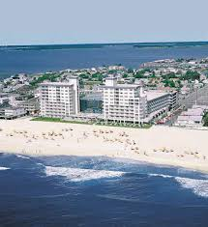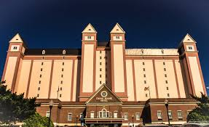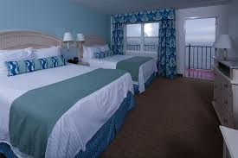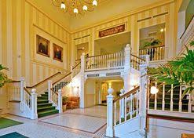

Included:
- All Retreat Sessions
- 2 Nights Hotel Accommodations
- 1 Hot Lunch Buffet
- 1 Full Hot American Breakfast

Cost: $295 *Based on double occupancy

**ALL deposits/registrations are NON-refundable and NON-transferable. Your entire registration is due by October 1, 2018. Please submit your desired roommate's name at the time of registration. If you do not choose a roommate one will be assigned to you unless you have registered for a private room. Please contact Anjel via email anjel@varlerollinsministries.com or phone 240-432-6610 for more information.

Website: joyspring2019.eventbrite.com

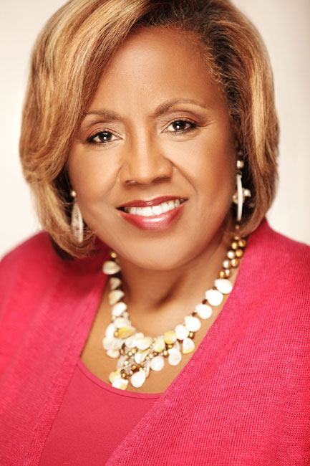
Retreat Host: Apostle Varle Rollins

Retreat Speakers:

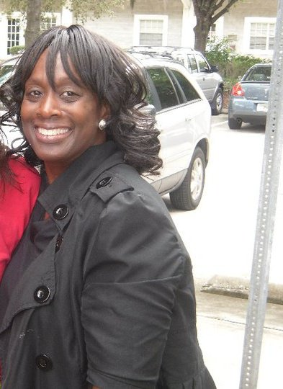

Pastor Zaretta Lee - Orlando, Florida

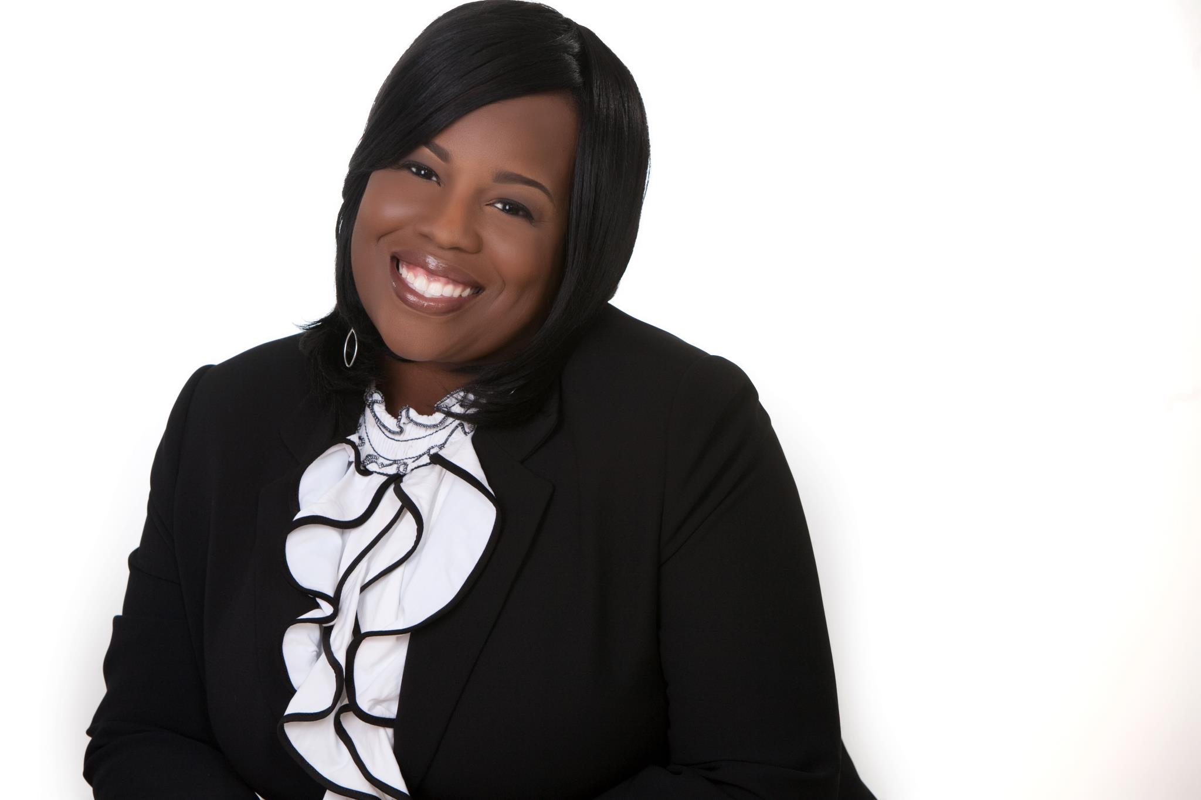

Pastor Portia Taylor - VCMI - Waldorf, Md.

