We need a logo design for our venture capital investment firm called "YUJ VENTURES".

"YUJ" is a Sanskrit root word which means to unite, to join, to add, or to bind. “YUJ VENTURES” is a an early stage venture capital firm that aims to add value through (1) strategic investments into start-ups developing disruptive and innovative solutions across various sectors globally, (2) forming joint venture partnerships in with businesses in emerging markets and (3) managing an in-house incubation platform.
Some guidelines on the logo design:
- The words in the logo should be capitalized
- There should be an icon that resembles the definition of “YUJ” (family, unity, growth, synergy etc.)
- The word YUJ itself can be somehow merged with a logo as well (just an idea)

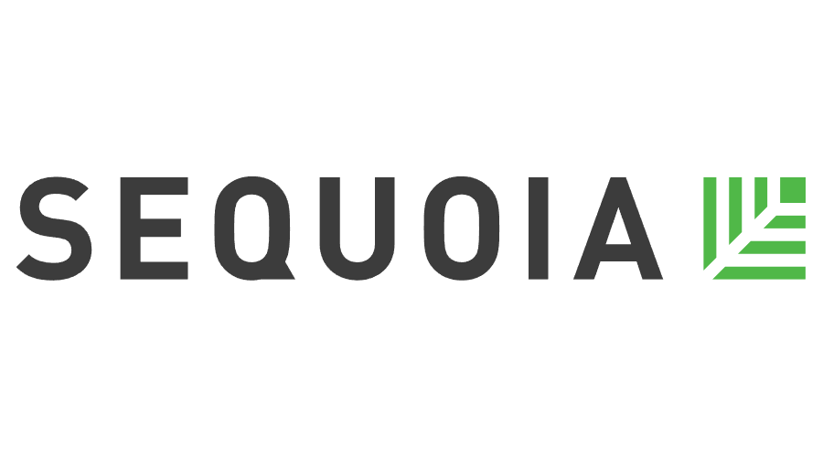
The logo and icon should be vibrant, simple yet instantaneously recognizable and traditional which incorporates all 3 aspects of our business. Please try to stick with clean colours such as blue, black, red etc (unless you think something out of the ordinary would best match). The logo should also portray our roots in Asia while promoting ourselves as a global investment platform.


